Vinnitsa National Pirogov Memorial Medical University
Department of Emergency and Military medicine
“Approved”
The head of the department Of Disaster
Medicine and Military Medicine
___________ass. prof. M.V. Matvichuk
“28” August 2020

THEME 7 for practical lessons of the discipline life safety for first-year students of the pharmaceutical department:
occupational hazards in the performance of the professional duties of medical and pharmaceutical workers

Vinnitsa 2020

Employers have the obligation to insure the safety and health of their employees by preventing the exposure to occupational risks, and thus avoiding the occurrence of occupational accidents and diseases, which are very expensive and have severe direct and indirect effects on the life of workers. To achieve such goal employers have to implement safety and health measures based on risk assessments and legislation. Within the European Community, this obligation was set by the Council Directive of 12 June 1989 on the introduction of measures to encourage improvements in the safety and health of workers at work (Framework Directive 89/391/EEC). Achieving this objective requires also the commitment of workers with occupational safety and health (OSH) principles.
Occupational disease- disease contracted as a result of an exposure over a period of time to risk factors (chemical, physical or biological agents) arising from work activity, that is any chronic ailment that occurs as a result of work or occupational activity. It is typically identified when it is shown that it is more prevalent in a given body of workers than in the general population, or in other worker populations. Examples include respiratory diseases (e.g. asbestosis or occupational asthma), skin diseases, musculoskeletal disorders (e.g. carpal tunnel syndrome) and occupational cancer.
Hazard - source, situation, or act with a potential for harm in terms of human injury or ill health, or a combination of these, i.e. anything present in the workplace that has the potential to cause an injury to workers, either a work accident or an occupational disease.
The meaning of the word hazard can be confusing. Often dictionaries do not give specific definitions or combine it with the term "risk". For example, one dictionary defines hazard as "a danger or risk" which helps explain why many people use the terms interchangeably.
There are many definitions for hazard but the more common definition when talking about workplace health and safety is:
A hazard is any source of potential damage, harm or adverse health effects on something or someone under certain conditions at work.
Basically, a hazard can cause harm or adverse effects (to individuals as health effects or to organizations as property or equipment losses).
Sometimes a hazard is referred to as being the actual harm or the health effect it caused rather than the hazard. For example, the disease tuberculosis (TB) might be called a hazard by some but in general the TB-causing bacteria would be considered the "hazard" or "hazardous biological agent".

A common way to classify hazards is by category:
- biological - bacteria, viruses, insects, plants, birds, animals, and humans, etc.,
- chemical - depends on the physical, chemical and toxic properties of the chemical.
- ergonomic - repetitive movements, improper set up of workstation, etc.,
- physical - radiation, magnetic fields, pressure extremes (high pressure or vacuum), noise, etc,
- psychosocial - stress, violence, etc.,
- safety - slipping/tripping hazards, inappropriate machine guarding, equipment malfunctions or breakdowns

Risk is the chance or probability that a person will be harmed or experience an adverse health effect if exposed to a hazard. It may also apply to situations with property or equipment loss.
For example: The risk of developing cancer from smoking cigarettes could be expressed as "cigarette smokers are 12 times (for example) more likely to die of lung cancer than non-smokers". Another way of reporting risk is "a certain number, "Y", of smokers per 100,000 smokers will likely develop lung cancer" (depending on their age and how many years they have been smoking). These risks are expressed as a probability or likelihood of developing a disease or getting injured, whereas hazards refer to the possible consequences (e.g., lung cancer, emphysema and heart disease from cigarette smoking).
Factors that influence the degree of risk include:
- how much a person is exposed to a hazardous thing or condition,
- how the person is exposed (e.g., breathing in a vapour, skin contact), and how severe are the effects under the conditions of exposure.
Risk assessment is the process where you:
- identify hazards,
- analyze or evaluate the risk associated with that hazard, and determine appropriate ways to eliminate or control the hazard.

Principles of prevention and control
Prevention means the act or practice of stopping something bad from happening. It means the avoidance of the risk or hazard at work. In contrast to prevention, control is the term to describe mitigation activities where the risk cannot be prevented. The general principles are:
  - avoiding risks;
  - evaluating the risks which cannot be avoided;
  - combating the risks at source;
  - adapting the work to the individual, especially as regards the design of work places, the choice of work equipment and the choice of working and production methods, with a view, in particular, to alleviating monotonous work and work at a predetermined work rate and to reducing their effect on health;
  - adapting to technical progress;
  - replacing the dangerous by the non-dangerous or the less dangerous;
  - developing a coherent overall prevention policy which covers technology, organization of work, working conditions, social relationships and the influence of factors related to the working environment;
  - giving collective protective measures priority over individual protective measures;
  - giving appropriate instructions to the workers.

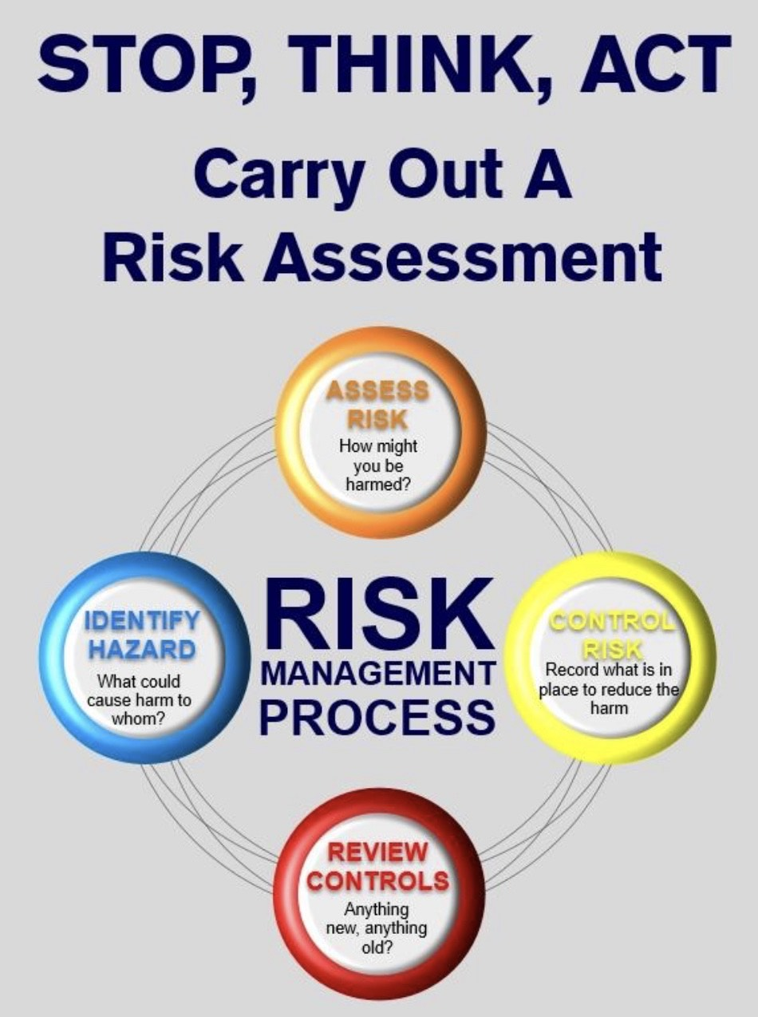

Dangerous and hazard industrial factors
Physical factors, among which most frequent is unfavorable microclimate. Surgeonsundergo the action of this factor during their work for a long time in the operating room, as well asdistrict therapeutics and pediatricians, doctors of ambulance. Radiologists, radiologists, surgeons, traumatic surgeons, therapeutics, undergo the action of ionizing radiation duringroentgenological examinations of patients. Surgeons undergo the action of higher atmosphericpressure during carrying out operations on the heart, large vessels and other operations, connectedwith high risk in the bar operating rooms. Pressure in bar operating room is about 2-3 atmospheres.Surgeons work in atmosphere, which contains pure oxygen.
Noise connected with work of different apparatus and machines (for example, apparatus ofmechanical lung ventilation) is a factor of doctors' labor. Sometimes noise reaches 60-70 dB.Physiatrists undergo the action of ultra-violet radiation. Laser-radiation is widely used insurgery, ophthalmology and other branches of medicine. Electro-magnetic fields influencesurgeons, physiatrists during their work.
Chemical factors influence the doctors' organism. Air of hospital rooms is polluted by chemicalsubstances (ozone, nitrogen oxides, antibiotics, narcotic substances). Sixty per cent of allprofessional diseases of doctors are connected with chemical substances. Chemical substances cancause allergic diseases, bronchial asthma, rhinitis, bronchitis, allergic myocarditis, dermatitis, etc.Surgeons, anesthesiologists, physiatrists, dentists are very frequently exposed to the action ofchemical factors.
Behind a method of penetration into an organism: through respiratory ways, throughdigestive system, through a leather(skin) (chemical burns);
By the level of toxic :very high (MPC at air < 0,1 mg/m3), highly toxic (MPC 0,1 - 1,0mg/m3), average high (MPC 1,0- 10,0 mg /m3), hardly toxic (MPC > 10,0 mg / m3).
Biological factors. Infectious danger is peculiar to all doctors, especially infectionists, phthisiatricians, pediatricians. Diseases of doctors connected with biological factors make up 30 %from total number of diseases; the other diseases make up 10%.The influence of negative factors causes a specific picture of doctors' morbidity. Very often doctorshave diseases of respiratory system, circulatory system, alimentary canal, urogenital system, etc.
The group of psychophysiological factors:
Physical overstrain: static (keeping of the big cargoes); dynamic (a raising and moving of the big cargoes) hypodinamic, forced position of a body, overstraining organs of body. Nervous -psychological overstain: mind overstrain, an overstrain of attention, intensive change workprocesses, monotony of work, emotional pressure.

Occupational and work-related diseases

An “occupational disease” is any disease contracted primarily as a result of an exposure to risk factors arising from work activity. “Work-related diseases” have multiple causes, where factors in the work environment may play a role, together with other risk factors, in the development of such diseases.
Classifications of occupational diseases have been developed mainly for two purposes: (1) notification for labour safety and health surveillance and (2) compensation. The absence of unified diagnosticcriteria, coding systems and classifications reduce the compatibility and comparability of nationalstatistics on occupational diseases.
An occupational disease is not characterised merely by the disease itself, but by a combination of adisease and an exposure, as well as an association between these two. Classifications of occupationaldiseases have been developed mainly for two purposes: (A) surveillance and notification for labour inspection purposes and (B) social security (compensation) purposes.
The majority of the classification systems have the following hierarchy:
1. Diseases caused by agents
1.1Diseases caused by chemical agents
1.2Diseases caused by physical agents
1.3Diseases caused by biological agents
2. Diseases by target organ
2.1Occupational respiratory diseases
2.2Occupational skin diseases
2.3Occupational musculoskeletal diseases
3. Occupational cancer
4. Others
The classifications contain both categories defined by the causative agent and categories defined by themedical diagnosis. Cases of a given disease may therefore fall into several categories. The absence ofunified diagnostic criteria, coding system and classification reduce the compatibility and comparabilityof national statistics on occupational diseases. Even for classical occupational diseases like asbestosis,there is heterogeneity in the national statistics and clinical practice in what kind of conditions are codedunder the general heading of asbestosis.

Separate sharp and chronic professional diseases
Sharp professional disease (intoxication) occurs suddenly, after disposable influenceconcerning high concentration of chemical substances, which is in the air of working zones.
Chronic diseases arise in consequence of long but low influence (not more than MPC, MPL,MPD) concentration, levels, dozes harmful industrial - professional factors.
In daily professional work of the doctor his organism can undergoes the influence of professionalharmful factors of different direction actions:
Physical nature:
- microclimatic conditions,
- illumination,
- noise,
- ultrasound,
- different kinds electromagnet radiation - ultra-violet, infra-red, ionizing kinds
Chemical nature:
- medicine of a chemical origin,
- disinfectants,
- solvents and others.
Biological nature:
- microorganisms,
- medicine of a biological origin.
The psychological nature:
- The high level of responsibility for consequences of your professional activity,
- Constant contact to the patient and others .
Сharacteristics of occupational hazards for different medical personnel
The occupational exercise load and hazards of the surgical specialties doctors include:
1.the number of surgical interventions is up to 150 per year in general surgery, 170 – inotorhinolaryngology, 370 – in obstetrics and gynecology. The number and complexity of theoperations increase with the raising level of the surgeon’s skill;
2.the forced body position with the trunk frontal bending and the prolonged static tension ofmuscles of the shoulder girdle, back and stretched forward arms;
3.the hot microclimate of the operating room with high streams of the radioactive heat fromthe artificial lighting sources (shadow less lamp);
4.the ionizing radiation during the X-ray examinations, especially in traumatology, vascularsurgery, neurosurgery;
5.the toxic effect of the narcosis agents (nitrogen, halothane, chloroform, diethyl ether) andanesthetics;
6.high mental and nervous-emotional exertion, connected with the complexity and durationof the surgical intervention, possible post-operative complications and responsibility for patient’slife.
Among the diseases afflicting the surgical specialties doctors with temporary disability thediseases of nervous system, cardio-vascular system, digestive system and acute respiratory diseasesare the most widespread.
Among chronic diseases of these specialists such diseases, as the diseases of cardio-vascularsystem, connected with high psycho-emotional and physical load should be mentioned. They are: angina pectoris, hypertension, vegeto-vascular dystonia.
There are frequent diseases due to the prolonged standing at the surgical table: radiculitis,osteochondrosis, dyskinesia, varix dilatation of the lower extremities.
Surgeons’ disabilty or necessity to change their occupation in 60 – 80 % cases can beexplained by chronic intoxication with narcotic agents and anesthetics, in 11 – 20 % cases - by theinfectious diseases, 9 – 10 % cases - by physical and nervous overexertion.
Hygienic peculiarities of labour conditions and health status of the therapeutic doctorsdepend on the patient service forms. In case of polyclinic, district service, the leading role belongsto the excess physical load, which depends on the year season (amount of calls), the size of thedoctor’s district and the type of the buildings (detached houses or many-storied buildings, elevator’spresence or absence). These specialists may also suffer from psycho-emotional exertion anddifferent physical factors’ unfavorable effect – X-ray, ultrasound, laser and other diagnostic andphysiotherapeutic measures, chemical harmful substances – the pharmacological preparations, fromwhich nurses suffer more frequently.
Occupational diseases of therapeutic doctors, first of all of the phthisiatricians, infectiologists, dermatologists, helminthologists, the laboratory assistants at the bacteriological, virological, helminthological laboratories include the corresponding infections; phthisiatricians, X-Ray doctors, radiologists suffer from dermatitis, exzemas, toxicodermia, melanomas, leucosis, skincancer, radiation sickness; psychiatrists from psychoneurosis.
One of the main occupational hazards for dental doctors is their forced standing with thebending and turning trunk position which leads to the prolonged static tension of the correspondingmuscles groups; noise and vibration due to drilling machines, sight exertion, blinding effect of thephotopolymer lamp, penetration of mercury from the mercury amalgam into the respiratory organs,fumes of the polymer materials solvents, danger of infection from the patient with the upperrespiratory tract diseases during the incubation or convalescence stage, while performing themanipulations connected with the patient’s mucosal membrane or blood contact.
Abovementioned hazards can result in bearing disorder (34 – 45%), varix dilatation of thelower extremities (19 – 49%), signs of the vibration diseases (paresthesia, loss of hands’temperature sensibility and perceptibility, Dupuytren's contracture).
The visual analyzer exertion can lead to the accommodation spasm, so-called false myopia,and sore eye.
Notification
In addition to the diagnosis of occupational disease, additional information should be included in the notification.

ILO has defined the minimum information to be included:
1. enterprise, establishment and employer
    - name and address of the employer
    - name and address of the enterprise
    - name and address of the establishment
    - economic activity of the establishment
    - number of workers (size of the establishment)
2. person affected by the occupational disease
    - name, address, sex and date of birth
    - employment status
    - occupation at the time when the disease was diagnosed
    - length of service with the present employer
3. occupational disease
    - name and nature of the occupational disease
    - harmful agents, processes or exposure to which the occupational disease is attributable
    - description of work which gave rise to the condition
    - length of exposure to harmful agents and processes
    - date of diagnosis of the occupational disease
Occupational safety objectives are primarily addressed through the National Occupational Research Agenda (NORA). NORA was established by the Centers for Disease Control and Prevention (CDC) National Institute for Occupational Safety and Health (NIOSH) and its partners to stimulate research and improve workplace practices. NORA focuses on occupational safety and health in 10 sectors:
- Agriculture, Forestry, and Fishing
- Construction
- Health Care and Social Assistance
- Manufacturing
- Mining
- Oil and Gas Extraction
- Public Safety
- Services
- Transportation, Warehousing, and Utilities Wholesale and Retail Trade

Maintenance of radiating safety of the personnel at radiological researches
Radiological researches as an additional method of diagnostics are widely used in medicalpractice. Decrease(reductions) in the beam loading received by the personnel at radiologicalresearches, can be achieved by the rational antiradiation protection. It is organized by system, whichbase on the following principles.
Principle of correctness:
The irradiation should be proved and be appointed exclusively by the doctor for achievementdiagnostic and therapeutic effect which cannot be received by other methods of diagnostics andtreatment.
Principle of optimization:
Collective dozes which are received with the population at carrying out of radiological andradiological procedures, should be so low as far as it is possible with taking into account economical and social factors.
Principle of not excess:
Sizes of dozes of an irradiation should be established only by the doctor for each patientindividually proceeding from the prevention(warning) of occurrence effects which determine inhealthy fabrics and an organism as a whole.
Norms of radiating safety establish such categories of people which can give in to antirradiation:
• category А(Personnel) people who work with sources of ionizing radiation constant ortemporarily
• category B (personnel) - People which don’t work with sources of ionizing radiation butlocation of their working places in premises(rooms) and on industrial platforms of objects withradiation-nuclear technologies can receive additional radiation.
• category C- all population.

Radiating safety of the personnel of radiological departments
As well as in X-Ray room, a source of harmful factors of radiological branches is ionizingradiation.As against operating conditions of doctors - radiologists ionizing radiation in radiologicalbranches can create not only the closed sources of ionizing radiation but also open.
«Closed» Such sources, which radioactive substance does not get into an environment (X-ray,scale cobalt guns, B - thrones). Principles of radiating protection of the personnel are based onactions of protection against external radiation.
«Open» such sources, which radioactive substance get into an environment (using of radioactiveiodine - 131). Principles radiation protection of the personnel are based on actions of protectionagainst internal and external radiation.
According to use of a source of ionizing radiation exist features of radiation protection
 | Kind of a source
 | «Closed» sources (external radiation) | «Open» sources (internal and external  radiation)
Principles of radiating protection of the personnel | 1. Protection by the screen.  2. Protection by the distance.  3. Protection by time.  4. Protection by doze. | 1. Use radiating aseptic. 2. Protection by the screen.  3. Protection by the distance.  4. Protection by time.  5. Protection by doze.

Principles of antiradiative protection of the personnel against an internal irradiation first ofall include measures for prevention of hit of radio isotopes in an organism of the personnel any ofpossible way - through respiratory ways, through a gastro enteric tract, through mucous membranes,through skin.
To be protected from the ionizing and non-ionizing electromagnetic radiation, methodsbased on physical laws of radiation decay, which are stated in the legislative and organizationdirection are used. They include the protection by means of the radiation sources capacitylimitation, distance, time, and shielding.
Thus, the legislation implies limit doses of the ionizing radiation, maximum allowableconcentrations of radionuclides in the air of working zone (Norms of radiation safety of Ukraine(NRSU)-97), their maximal allowable activities at the working place and other.
In order to keep health of medical personnel with harmful labour conditions, the legislation establishes the half day are:
- 4-hour-day – for medical workers directly connected with the open sources ofradionuclides;
- 5-hour-day – for personnel connected with closed sources of the ionizing radiation(gamma-, X-ray), also for morbid anatomists, prosectors, forensic medical experts, anatomists;
- 5.5-hour-day – for doctors of the tuberculosis, psycho-neurological centers, physiotherapeutists, dentists;
- 6-hour-day – at the infectious, tuberculosis, psychiatric, narcological, balneal, radon,laboratory departments.

Inadmissible influence of ultrasound and maintenance of protection of the doctor ofultrasonic diagnostics
At the present stage of development of medicine ultrasonic diagnostics are widely used invarious in the direction: in therapy, neurology, urology, obstetrics, stomatology. But the ultrasoundis not absolutely safe for the person, therefore its professional using demands methods of protectionof the personnel from its harmful influence.
Ultrasound is the sound fluctuations from 20000 up to 109 Hz. Ultrasound is absorbedfabrics of a human body with allocation thermal energy. Can cause by damage the central nervoussystem, defeat of ears, the vestibular organs.
Protection against negative influence of ultrasonic fluctuations passes by hermetic sealingsources, using absorbed materials, reduction of contact of the personnel with ultrasound.

Key concepts in OSH are:
- Hazard –- source, situation, or act with a potential for harm in terms of human injury or ill health, or a combination of these, i.e. anything present in the workplace that has the potential to cause an injury to workers, either a work accident or an occupational disease.
- Risk – combination of the likelihood of an occurrence of a hazardous event or exposure and the severity of injury or ill health that can be caused by the event or exposure.
- Risk assessment– is the process of evaluating risks to workers’ safety and health from workplace hazards. It is a systematic examination of all aspects of work that considers:
  - what could cause injury or harm
  - whether the hazards could be eliminated and, if not,
  - what preventive or protective measures are, or should be, in place to control the risks.
- Safety – it is very difficult to define. Safety is the state of being "safe" i.e. free from harm or risk, but in practice this state is never obtained. Therefore safety must be seen as a value judgment regarding the level of risk of being injured which is considered to be acceptable.
- Health – in relation to work, indicates not merely the absence of disease or infirmity; it also includes the physical and mental elements affecting health which are directly related to safety and hygiene at work.
- Occupational disease – disease contracted as a result of an exposure over a period of time to risk factors (chemical, physical or biological agents) arising from work activity, that is any chronic ailment that occurs as a result of work or occupational activity. It is typically identified when it is shown that it is more prevalent in a given body of workers than in the general population, or in other worker populations. Examples include respiratory diseases (e.g. asbestosis or occupational asthma), skin diseases, musculoskeletal disorders (e.g. carpal tunnel syndrome) and occupational cancer.
- Work accident – is a discrete occurrence in the course of work (even if the accident happens off the company’s premises, or if it is caused by third parties), which leads to physical or mental harm.
- Prevention – all the steps or measures taken or planned at all stages of work in the undertaking to prevent or reduce occupational risks.

