First aid in special circumstances. Lesson 2.

- Acute abdomen
- Poisoning
- Bites: insect bites, animal bites (dogs), snake bites.
- Drowning
- Electrocution. Lightning strike.

- Acute abdomen.
Acute abdominal distress or acute abdomen is characterized by the sudden onset of severe abdominal pain and discomfort. Many people associate acute abdominal symptoms to simple indigestion that would resolve and “go away.” Although most cases of acute abdominal distress are temporary, some people may experience pain that does not go away or that becomes so severe.
The abdominal cavity houses a number of organs and tissues where the pain may originate. Aside from indigestion, which is the most common cause of abdominal distress, other possible problems include:
- Appendicitis
- Inflammation of the gallbladder (cholecystitis)
- Inflammation of the pancreas (pancreatitis)
- Inflammation of abdominal cavity membranes (peritonitis)
- Intestinal obstruction
- Kidney stones
- Perforated ulcer
- Strangulated hernia
- Ectopic pregnancy
- Aneurysm or rupture of an abdominal blood vessel
Acute abdomen may result in general signs and symptoms that include:
- Pain (widespread or generalized)
- Diarrhea or constipation
- Low blood pressure
- Rapid pulse
- Abdominal distention
- Fever
- Rigid abdomen
- Tenderness
- Guarding behavior
- Fear
- Signs of shock (if there is internal bleeding or a major infection)
- Possible bleeding from the rectum or blood in the urine.
Some individuals may report other symptoms that include weakness, restlessness, pain at movement, and assuming curled position.
Signs and symptoms of abdominal distress should not be taken lightly. The initial emergency care you provide can be critical for the condition of the patient. In case the symptoms continue to get worse, do not try to diagnose or guess the nature of the problem, instead transport the individual or call for emergency help.
First aid:
- Maintain an open airway. Prepare for possible vomiting.
- Monitor for signs of shock and be ready to provide first aid.
- Assist the individual to his side with knees flexed. Stay alert for vomiting.
- Provide reassurance.
- If supplemental oxygen is available, provide oxygen if there are symptoms of difficulty breathing or shallow breathing.
- Do not give anything by mouth.
- If possible, get details about the symptoms of the patient such as the time of onset, the nature of pain (sharp, gnawing, stabbing), if it was sudden or gradual, any changes in bowel movement and characteristic of stool (dark, tarry stool), any fever or chills, and if there are signs of bleeding. Find out what was last consumed and when the patient last ate.
- Try save vomitus for possible laboratory test. However, make sure to avoid contact with ALL discharges and body fluids to prevent contracting communicable diseases.
Although most cases of abdominal distress end up as indigestion, they should be thoroughly diagnosed to prevent misdiagnosis. Physical examination and laboratory tests are necessary for the accurate diagnosis of abdominal distress. It is important to take the patient to the nearest medical facility for complete medical evaluation.

Poisoning
A poison is any substance that causes injury, illness or death if it enters the body. In 2008 in USA over 93 percent of poisonings took place in the home. Fifty percent involved children younger than 6 years. Poisoning deaths in children younger than 6 years represented about 2 percent of the total deaths from poisoning. The 20- to 59-year-old age group represented about 76 percent of all deaths from poisoning.
In recent years there has been a decrease in child poisonings. This is due partly to child-resistant packaging for medications. The decrease also is a result of preventive actions by parents and others who care for children. At the same time, there has been an increase in adult poisoning deaths. This increase is linked to an increase in both suicides and drug-related poisonings.
Types of Poisoning
A person can be poisoned by swallowing poison, breathing it, absorbing it through the skin and by having it injected into the body.
Swallowed Poisons
Poisons that can be swallowed include foods, such as certain mushrooms and shellfish; an overdose of drugs, such as sleeping pills, tranquilizers and alcohol; medications, such as a high quantity of aspirin; household items, such as cleaning products and pesticides; and certain plants. Many substances that are not poisonous in small amounts are poisonous in larger ones. Combining certain substances can result in poisoning, although if taken by themselves they might not cause harm.
Inhaled Poisons
A person can be poisoned by breathing in (inhaling) toxic fumes. Examples of poisons that can be inhaled include:
- Gases, such as:
      - Carbon monoxide from an engine or car exhaust.
      - Carbon dioxide from wells and sewers.
      - Chlorine, found in many swimming pools.
- Fumes from:
      - Household products, such as glues and paints.
- Drugs, such as crack cocaine.
Absorbed Poisons
Poisons that can be absorbed through the skin come from many sources including plants, such as poison ivy, poison oak and poison sumac, and fertilizers and pesticides.
Injected Poisons
Injected poisons enter the body through the bites or stings of insects, spiders, ticks, some marine life, snakes and other animals or through drugs or medications injected with a hypodermic needle.
Signs and symptoms.
How will you know if someone who is ill has been poisoned? Look for clues about what has happened. Try to get information from the person or from by standers. As you check the scene, be aware of unusual odors, flames, smoke, open or spilled containers, an open medicine cabinet or an overturned or a damaged plant. Also, notice if the person is showing any of the following signals of poisoning:
- Nausea and vomiting
- Diarrhea
- Chest or abdominal pain
- Trouble breathing
- Sweating
- Changes in consciousness
- Seizures
- Headache
- Dizziness
- Weakness
- Irregular pupil size
- Burning or tearing eyes
- Abnormal skin color
- Burns around the lips, tongue or on the skin
You also may suspect a poisoning based on information from or about the person. If you suspect someone has swallowed a poison, try to find out:
- The type of poison.
- The quantity taken.
- When it was taken.
- How much the person weighs.
This information can help you and others to give the most appropriate care.
For life-threatening conditions (such as if a person is unconscious s or is not breathing or if a change in the level of consciousness occurs), CALL local emergency number. If the person is conscious and alert, CALL the National Poison Control Center (PCC) hotline and follow the advice given.
First aid.
After you have checked the scene and determined that there has been a poisoning, follow the general care guidelines (DR CAB):
- Remove the person from the source of poison if the scene is dangerous. Do this only if you are able to without endangering yourself.
- Check the person's level of consciousness and breathing.
- Care for any life-threatening conditions.
- If the person is conscious, ask questions to get more information.
- Look for any containers and take them with you to the telephone.
- Call the National Poison Control Center Hotline at
- Follow the directions of the Poison Control Center.
If the person becomes violent or threatening, move to safety and wait for help to arrive. Do not give the person anything to eat or drink unless medical professionals tell you to do so. If you do not know what the poison was and the person vomits, save some of the vomit.
The hospital may analyze it to identify the poison.

- Bites: snakebites, animal bites, insect bites.
General information.
Snakebites, insect bites, or stings can cause intense pain and/or swelling. If not treated promptly and correctly, they can cause serious illness or death. The severity of a snakebite depends upon: whether the snake is poisonous or nonpoisonous, the type of snake, the location of the bite, and the amount of venom injected. Bites from humans and other animals, such as dogs, cats, bats, raccoons, and rats, can cause severe bruises and infection and tears or lacerations of tissue. Awareness of the potential sources of injuries can reduce or prevent them from occurring. Knowledge and prompt application of first-aid measures can lessen the severity of injuries from bites and stings and keep the service member from becoming a serious casualty.
Types of Snakes
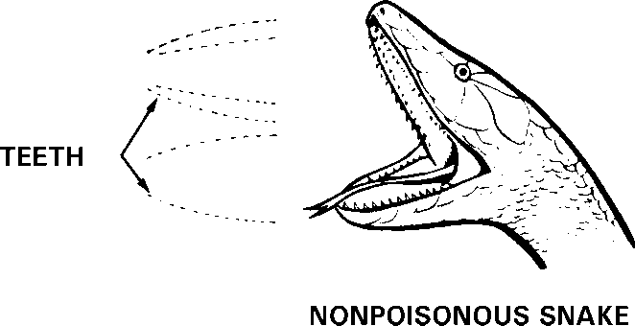
- Nonpoisonous Snakes. They have oval- shaped heads and round eyes. Unlike poisonous snakes, discussed below, nonpoisonous snakes do not have fangs with which to inject venom. Figure depicts the characteristics of a nonpoisonous snake.

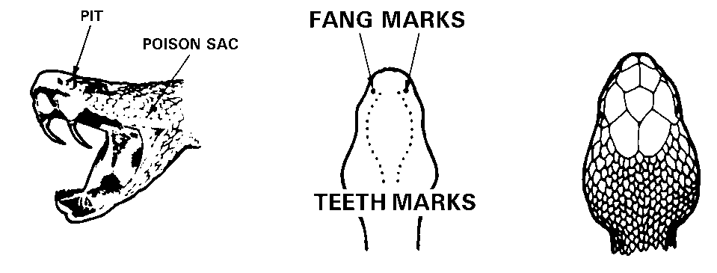
- Poisonous Snakes. Poisonous snakes are found throughout the world, primarily in tropical to moderate climates.

- Pit Vipers (Poisonous). Figure below depicts a variety of poisonous snakes.
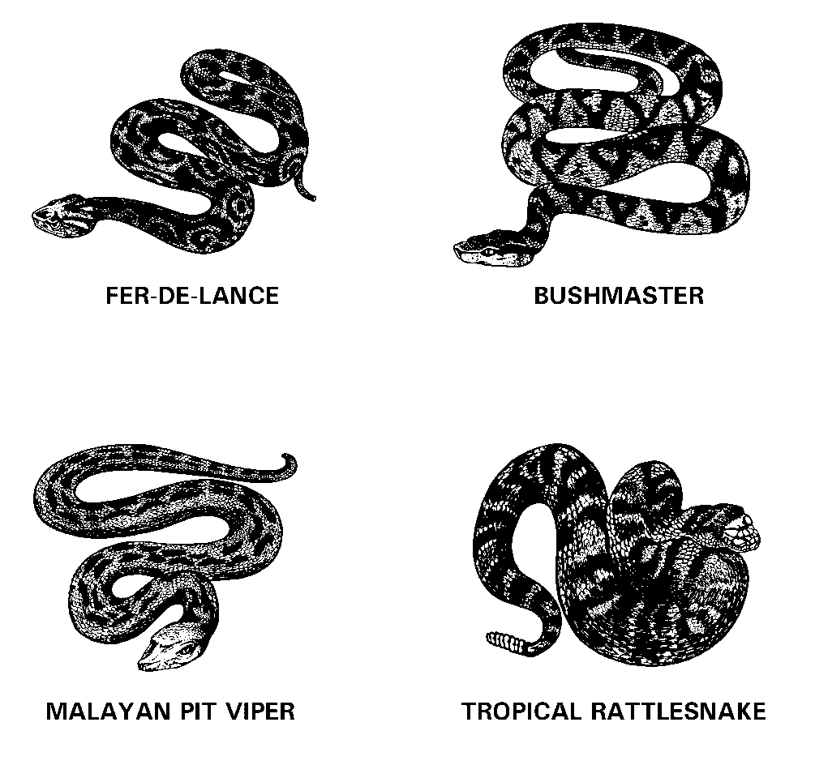
Rattlesnakes, bushmasters, copperheads, fer-de-lance, Malayan pit vipers, and water moccasins (cottonmouth) are called pit vipers because of the small, deep pits between the nostrils and eyes on each side of the head (Figure). In addition to their long, hollow fangs, these snakes have other identifying features: thick bodies, slit-like pupils of the eyes, and flat, almost triangular-shaped heads. Color markings and other identifying characteristics, such as rattles or a noticeable white interior of the mouth (cottonmouth), also help distinguish these poisonous snakes.
Further identification is provided by examining the bite pattern of the wound for signs of fang entry. Occasionally there will be only one fang mark, as in the case of a bite on a finger or toe where there is no room for both fangs, or when the snake has broken off a fang.
  - The casualty’s condition provides the best information about the seriousness of the situation, or how much time has passed since the bite occurred. Pit viper bites are characterized by severe burning pain. Discoloration and swelling around the fang marks usually begins within 5 to 10 minutes after the bite. If only minimal swelling occurs within 30 minutes, the bite will almost certainly have been from a nonpoisonous snake or possibly from a poisonous snake which did not inject venom. The venom destroys blood cells, causing a general discoloration of the skin. Blisters and numbness in the affected area follow this reaction. Other signs, which can occur, are weakness, rapid pulse, nausea, shortness of breath, vomiting, and shock.
- Corals, Cobras, Kraits, and Mambas. Corals (Figure 6-4), cobras (Figure 6-5), kraits, and mambas all belong to the same group even though they are found in different parts of the world. All four inject their venom through short, grooved fangs, leaving a characteristic bite pattern.
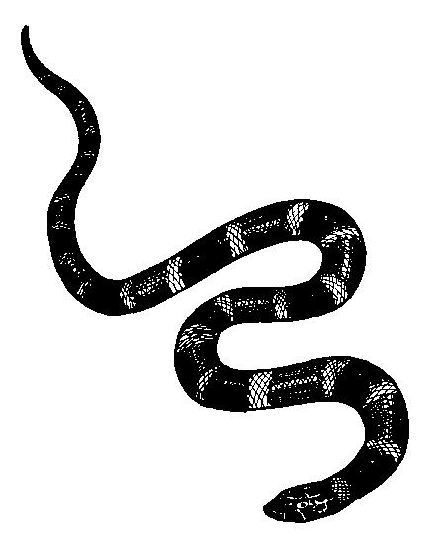
Figure 6-4. Coral snake.
  - The small coral snake, found in the Southeastern US, is brightly colored with bands of red, yellow (or almost white), and black completely encircling the body. Other nonpoisonous snakes have the same coloring, but on the coral snake found in the US, the red ring always touches the yellow ring. To know the difference between a harmless snake and the coral snake found in the United States, remember the following:
“Red on yellow will kill a fellow, Red on black, venom will lack.”
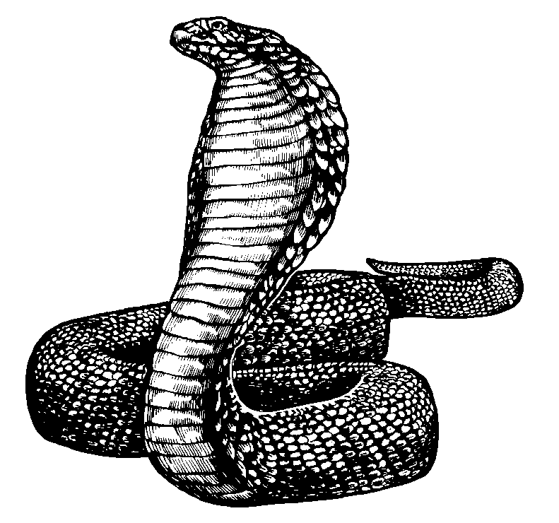
Figure 6-5. Cobra snake.
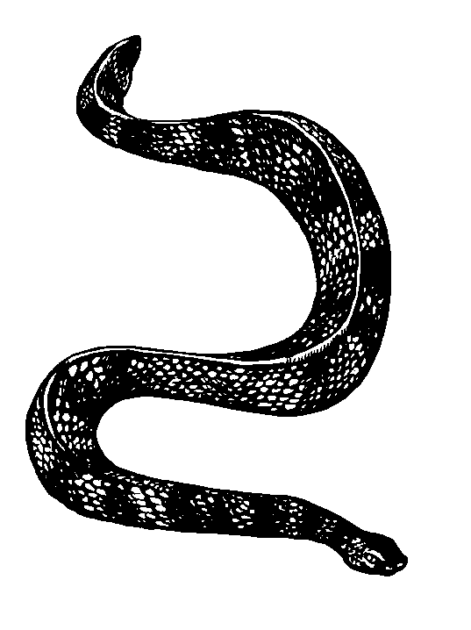
  - The venom of corals, cobras, kraits, and mambas produces symptoms different from those of pit vipers. Because there is only minimal pain and swelling, many people believe that the bite is not serious. Delayed reactions in the nervous system normally occur between 1 to 7 hours after the bite. Symptoms include blurred vision, drooping eyelids, slurred speech, drowsiness, and increased salivation and sweating. Nausea, vomiting, shock, respiratory difficulty, paralysis, convulsions, and coma will usually develop if the bite is not treated promptly.
- Sea Snakes. Sea snakes (Figure) are found in the warm water areas of the Pacific and Indian oceans, along the coasts, and at the mouths of some larger rivers. Their venom is VERY poisonous, but their fangs are only 1/4 inch long. The first aid outlined for land snakes also applies to sea snakes.
Sea snake.

Snakebites
- Poisonous snakes DO NOT always inject venom when they bite or strike a person. However, all snakes may carry tetanus (lockjaw); anyone bitten by a snake, whether poisonous or nonpoisonous, should immediately seek medical attention.
  - Poison is injected from the venom sacs through grooved or hollow fangs. Depending on the species, these fangs are either long or short. Pit vipers have long hollow fangs. These fangs are folded against the roof of the mouth and extend when the snake strikes. This allows them to strike quickly and then withdraw. Cobras, coral snakes, kraits, mambas, and sea snakes have short, grooved fangs. These snakes are less effective in their attempts to bite, since they must chew after striking to inject enough venom (poison) to be effective. Figure 6-7 depicts the characteristics of a poisonous snakebite.
  - In the event you are bitten, attempt to identify and/or kill the snake. Take it to medical personnel for inspection/identification. This provides valuable information to medical personnel who deal with snakebites. TREAT ALL SNAKEBITES AS POISONOUS.
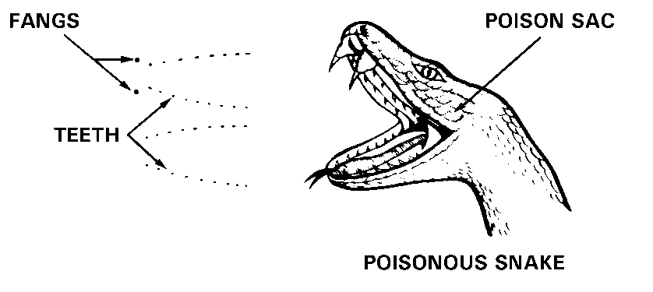
Figure 6-7. Characteristics of poisonous snakebite.
- The venoms of different snakes cause different effects. Pit viper venom (hemotoxin [blood toxin]) destroys tissue and blood cells. Cobras, adders, and coral snakes inject powerful venom (neurotoxin [nerve toxin]) which affect the central nervous system, causing respiratory paralysis. Water moccasins and sea snakes have venom that is both hemotoxic and neurotoxic.
- The identification of poisonous snakes is very important since medical treatment will be different for each type of venom. Unless it can be positively identified, the snake should be killed and saved. When this is not possible or when doing so is a serious threat to others, identification may sometimes be difficult since many venomous snakes resemble harmless varieties. When dealing with snakebite problems in foreign countries, seek advice, professional or otherwise, which may help identify species in the particular area of operations.
- Get the casualty to an medical facility as soon as possible and with minimum movement. Until evacuation or treatment is possible, have the casualty lie quietly and not move any more than necessary. If the casualty has been bitten on an extremity, DO NOT elevate the limb; keep the extremity level with the body. Keep the casualty comfortable and reassure him. If the casualty is alone when bitten, he should go to the medical facility himself rather than wait for someone to find him. Unless the snake has been positively identified, attempt to kill it and send it with the casualty. Be sure that retrieving the snake does not endanger anyone or delay transporting the casualty.
- If the bite is on an arm or leg, place a constricting band (narrow cravat [swathe], or narrow gauze bandage) one to two fingerbreadths above and below the bite (Figure 6-8). If the bite is on the hand or foot, place a single band above the wrist or ankle. The band should be tight enough to stop the flow of blood near the skin, but not tight enough to interfere with circulation. In other words, it should not have a tourniquet- like affect. If no swelling is seen, place the bands about 1 inch from either side of the bite. If swelling is present, put the bands on the un swollen part at the edge of the swelling. If the swelling extends beyond the band, move the band to the new edge of the swelling. (If possible, leave the old band on, place a new one at the new edge of the swelling, and then remove and save the old one in case the process has to be repeated.)

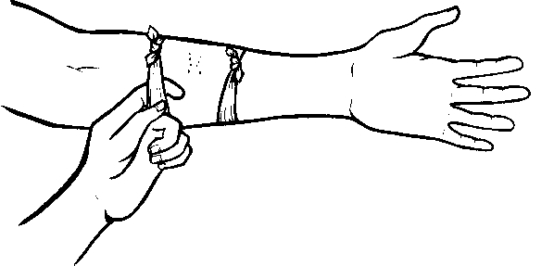
Figure 6-8. Constricting band.
CAUTION
DO NOT attempt to cut open the bite nor suck out the venom. If the venom should seep through any damaged or lacerated tissues in your mouth, you could immediately lose consciousness or even die.
- If the bite is located on an arm or leg, immobilize it at a level below the heart. DO NOT elevate an arm or leg even with or above the level of the heart.
CAUTION
When a splint is used to immobilize the arm or leg, take EXTREME care to ensure the splinting is done properly and does not bind. Watch it closely and adjust it if any changes in swelling occur.
- When possible, clean the area of the bite with soap and water. DO NOT use ointments of any kind.
- NEVER give the casualty food, alcohol, stimulants (coffee or tea), drugs, or tobacco.
- Remove rings, watches, or other jewelry from the
affected limb.
Human or Animal Bites
Human or other land animal bites may cause lacerations or bruises. In addition to damaging tissue, bites always present the possibility of infection.
- Human Bites. Human bites that break the skin may become seriously infected since the mouth is heavily contaminated with bacteria. Medical personnel MUST treat all human bites.
- Animal Bites. Land animal bites can result in both infection and disease. Tetanus, rabies, and various types of fevers can follow an untreated animal bite. Because of these possible complications, the animal causing the bite should, if possible, be captured or killed (without damaging its head) so that it can be tested for disease.
- First Aid.
    - Cleanse the wound thoroughly with soap.
    - Flush it well with water.
    - Cover it with a sterile dressing.
    - Immobilize the injured arm or leg, if appropriate.
    - Transport the casualty immediately to a medical facility.
NOTE: If unable to capture or kill the animal, provide medical personnel with any information that will help identify it.
Insect (Arthropod) Bites and Stings
An insect bite or sting can cause great pain, allergic reaction, inflammation, and infection. If not treated correctly, some bites/stings may cause serious illness or even death. When an allergic reaction is not involved, first aid is a simple process. In any case, medical personnel should examine the casualty at the earliest possible time.
It is important to properly identify the spider, bee, or creature that caused the bite/sting, especially in cases of allergic reaction.
- Types of Insects. The insects found throughout the world that can produce a bite or sting are too numerous to mention in detail. Commonly encountered stinging or biting insects include brown recluse spiders (Figure 6-9), black widow spiders (Figure 6-10), tarantulas (Figure 6-11), scorpions (Figure 6-12), urticating caterpillars, bees, wasps, centipedes, conenose beetles (kissing bugs), ants, and wheel bugs. Upon being reassigned, especially to overseas areas, take the time to become acquainted with the types of insects to avoid.
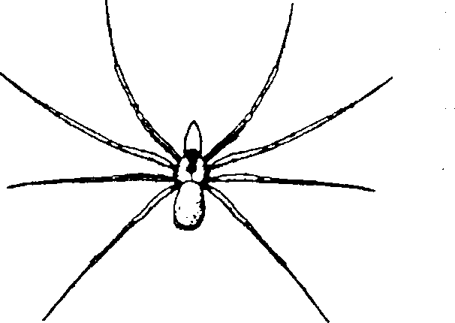  Figure 6-9. Brown recluse spider. | 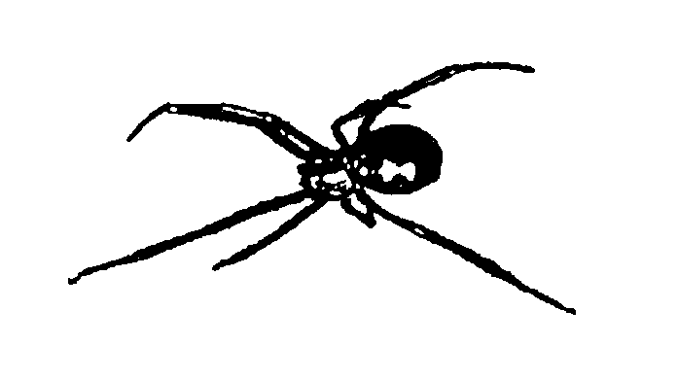  Figure 6-10. Black widow spider.
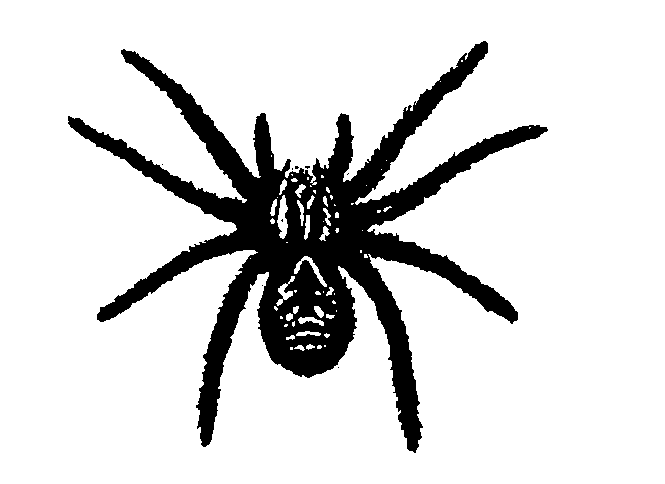  Figure 6-11. Tarantula. | 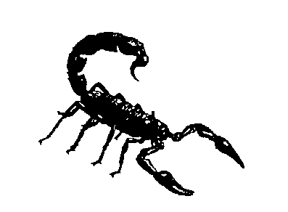  Figure 6-12. Scorpion.
- Signs and Symptoms. Discussed in paragraphs (1) and (2) below are the most common effects of insect bites/stings. They can occur alone or in combination with the others.
  - Less serious. Commonly seen signs/symptoms are pain, irritation, swelling, heat, redness, and itching. Hives or wheals (raised areas of the skin that itch) may occur. These are the least severe of the allergic reactions that commonly occur from insect bites/stings. They are usually dangerous only if they affect the air passages (mouth, throat, nose, and so forth), which could interfere with breathing. The bites/stings of bees, wasps, ants, mosquitoes, fleas, and ticks are usually not serious and normally produce mild and localized symptoms. A tarantula’s bite is usually no worse than that of a bee sting. Scorpions are rare and their stings (except for a specific species found only in the Southwest desert) are painful but usually not dangerous.
  - Serious. Emergency allergic or hypersensitive reactions sometimes result from the stings of bees, wasps, and ants. Many people are allergic to the venom of these particular insects. Bites or stings from these insects may produce more serious reactions, to include generalized itching and hives, weakness, anxiety, headache, breathing difficulties, nausea, vomiting, and diarrhea. Very serious allergic reactions (called anaphylactic shock) can lead to complete collapse, shock, and even death. Spider bites (particularly from the black widow and brown recluse spiders) can also be serious. Venom from the black widow spider affects the nervous system. This venom can cause muscle cramps, a rigid, nontender abdomen, breathing difficulties, sweating, nausea, and vomiting. The brown recluse spider generally produces local rather than system-wide problems; however, local tissue damage around the bite can be severe and can lead to an ulcer and even gangrene.
  - First Aid. There are certain principles that apply regardless of what caused the bite/sting. Some of these are—
- If there is a stinger present (for example, from a bee), remove the stinger by scraping the skin’s surface with a fingernail or knife. DO NOT squeeze the sac attached to the stinger because it may inject more venom.
  - Wash the area of the bite/sting with soap and water (alcohol or an antiseptic may also be used) to help reduce the chances of an infection and remove traces of venom. Remove jewelry from bitten extremities because swelling may occur.
  - In most cases of insect bites the reaction will be mild and localized; use ice or cold compresses (if available) on the site of the bite/ sting. This will help reduce swelling, ease the pain, and slow the absorption of venom. Meat tenderizer (to neutralize the venom) or calamine lotion (to reduce itching) may be applied locally. If necessary, seek medical assistance.
  - In more serious reactions (severe and rapid swelling, allergic symptoms, and so forth) treat the bite/sting like you would treat a snakebite; that is, apply constricting bands above and below the site.
  - Be prepared to perform basic life-support measures, such as rescue breathing.
  - Reassure the casualty and keep him calm.
  - In serious reactions, attempt to capture the insect for positive identification; however, be careful not to become a casualty yourself.
  - If the reaction to the bite/sting appears serious, seek medical assistance.
WARNING
Insect bites/stings may cause anaphylactic shock (a shock caused by a severe allergic reaction). This is a life-threatening event and a TRUE MEDICAL EMERGENCY. Be prepared to perform the basic life-support measures and to immediately transport the casualty to an MTF.
NOTE: Be aware that some allergic or hypersensitive individuals may carry identification or emergency insect bite treatment kits. If the casualty is having an allergic reaction and has such a kit, administer the medication in the kit according to the instructions which accompany the kit.
Table 6-1. First Aid Measures for Bites and Stings
TYPES | FIRST AID MEASURES
SNAKEBITE | - Move casualty away from the snake.  - Remove jewelry from the affected area, if applicable.  - Reassure casualty and keep him quiet.  - Apply constricting band, 1-2 fingerbreadths from the bite. You should be able to insert a finger between the band and the skin.  - Arm or leg bite. Place one band above and one band below the bite site.  - Hand or foot bite. Place one band above the wrist or ankle.  - Immobilize the affected part in a position below the level of the heart.  - Kill the snake (if possible, without damaging its head or endangering yourself) and send it with the casualty.  - Seek medical assistance immediately.
BROWN RECLUSE SPIDER OR  BLACK WIDOW SPIDER BITE | - Keep casualty quiet.  - Remove all jewelry from affected part, if applicable.  - Wash the area.  - Apply ice or freeze pack, if available.  - Seek medical assistance.
TARANTULA BITE OR  SCORPION STING OR  ANT BITE | - Wash the area.  - Remove all jewelry from affected part, if applicable.  - Apply ice or freeze pack, if available.  - Apply baking soda, calamine lotion, or meat tenderizer (if available) to bite site to relieve pain and itching.  - If the site of the bite is on the face, neck (possible airway problems), or genital area, or if local reaction seems severe, or if the sting is by the dangerous type of scorpion found in the southwest united states desert, keep the casualty as quiet as possible. Seek medical assistance.
BEE STING | - If the stinger is present, remove by scraping with a knife or fingernail. Do not squeeze venom sac on stinger; more venom may be injected.  - Remove all jewelry from affected part, if applicable.  - If the stinger is present, remove by scraping with a knife or fingernail. Do not squeeze venom sac on stinger; more venom may be injected.  - Remove all jewelry from affected part, if applicable.

Drowning
Drowning is a common cause of accidental death in Europe. After drowning the duration of hypoxia is the most critical factor in determining the victim’s outcome; therefore, oxygenation, ventilation, and perfusion should be restored as rapidly as possible. Immediate resuscitation at the scene is essential for survival and neurological recovery after a drowning incident. This will require provision of CPR by a bystander and immediate activation of the EMS system. Victims who have spontaneous circulation and breathing when they reach hospital usually recover with good outcomes.
Drowning is death through respiratory impairment from submersion/immersion in liquid. It occurs more frequently in males and the young.
Immersion means to be covered in water or other ﬂuid. Submersion implies that the entire body, including the airway, is under the water or other ﬂuid.
Classification
Due to the temperature of the water:
- Warm-water drowning occurs at water temperatures of 20°C or higher
- Cold-water drowning occurs at water temperatures of less than 20°C
Due to type of the water:
- Freshwater drowning
- Saltwater drowning
Classification (no longer used)
- Wet and dry (acute respiratory distress syndrome that developed in children hours after swimming) drowning
- Active (people such as non-swimmers and the exhausted or hypothermic at the surface, who are unable to hold their mouth above water and are suffocating due to lack of air. Instinctively, people in such cases perform well known behaviors in the last 20–60 seconds before being submerged, representing the body's last efforts to obtain air) and passive drowning (people who suddenly sink or have sunk due to a change in their circumstances. Examples include people who drown in an accident, or due to sudden loss of consciousness or sudden medical condition)
- Secondary drowning ("drowning in their own body fluid“ due to pulmonary edema)
- Drowning and near-drowning (is the survival of a drowning event involving unconsciousness or water inhalation and can lead to serious secondary complications or death, possibly up to 72 hours after the event)
The pathophysiology of drowning : in brief, after submersion, the victim initially breath holds before developing laryngospasm. During this time the victim frequently swallows large quantities of water. As breath holding/laryngospasm continues, hypoxia and hypercapnia develops. Eventually these reﬂexes abate and the victim aspirates water into their lungs leading to worsening hypoxaemia. Without rescue and restoration of ventilation the victim will become bradycardic before sustaining a cardiac arrest. The key feature to note in the pathophysiology of drowning is that cardiac arrest occurs as a consequence of hypoxia and correction of hypoxaemia is critical to obtaining a return of spontaneous circulation.
First Aid
Treatment of a drowning victim involves four distinct but interrelated phases. These comprise (i) aquatic rescue, (ii) basic life support, (iii) advanced life support, and (iv) post-resuscitation care. The initial rescue from the water is usually undertaken either by bystanders or those with a duty to respond such as trained lifeguards or lifeboat operators. Basic life support is often provided by the initial responders before arrival of the emergency medical services. Resuscitation frequently continues into hospital
Basic life support
Aquatic rescue and recovery from the water. Always be aware of personal safety and minimize the danger to yourself and the victim at all times. Whenever possible, attempt to save the drowning victim without entry into the water. Talking to the victim, reaching with a rescue aid (e.g., stick or clothing), or throwing a rope or buoyant rescue aid may be effective if the victim is close to dry land. Alternatively, use a boat or other water vehicle to assist with the rescue. Avoid entry into the water whenever possible. If entry into the water is essential, take a buoyant rescue aid or ﬂotation device. It is safer to enter the water with two rescuers than alone. Never dive head ﬁrst in the water when attempting a rescue. You may lose visual contact with the victim and run the risk of a spinal injury.
Remove all drowning victims from the water by the fastest and safest means available and resuscitate as quickly as possible. The incidence of cervical spine injury in drowning victims is very low (approximately 0.5%). Spinal immobilisation can be difﬁcult to perform in the water and can delay removal from the water and adequate resuscitation of the victim. Cervical spine immobilisation is not indicated unless signs of severe injury are apparent or the history is consistent with the possibility of severe injury. These circumstances include a history of diving, water-slide use, signs of trauma or signs of alcohol intoxication. If the victim is pulseless and apnoeic remove them from the water as quickly as possible (even if a back support device is not available), while attempting to limit neck ﬂexion and extension.
Rescue breathing. The ﬁrst and most important treatment for the drowning victim is alleviation of hypoxaemia. If possible supplement rescue breaths/ventilations with oxygen. Give ﬁve initial ventilations/rescue breaths as soon as possible.
Rescue breathing can be initiated whilst the victim is still in shallow water provided the safety of the rescuer is not compromised. It is likely to be difﬁcult to pinch the victim’s nose, so mouth-to- nose ventilation may be used as an alternative to mouth-to-mouth ventilation.
If the victim is in deep water, open their airway and if there is no spontaneous breathing start in-water rescue breathing if trained to do so. In-water resuscitation is possible, but should ideally be performed with the support of a buoyant rescue aid. Give 10–15 rescue breaths over approximately 1 min. If normal breathing does not start spontaneously, and the victim is <5 min of from land, continue rescue breaths while towing. If more than an estimated 5 min from land, give further rescue breaths over 1 min, then bring the victim to land as quickly as possible without further attempts at ventilation.
Chest compression. The victim should be placed on a ﬁrm surface before starting chest compressions as compressions are ineffective in the water. Conﬁrm the victim is unresponsive and not breathing normally and then give 30 chest compressions. Continue CPR in a ratio of 30:2. Most drowning victims will have sustained cardiac arrest secondary to hypoxia. In these patients, compression-only CPR is likely to be less effective and should be avoided.
Automated external deﬁbrillation. Once CPR is in progress, if an AED is available, dry the victim’s chest, attach the AED pads and turn the AED on. Deliver shocks according to the AED prompts.
Regurgitation during resuscitation. Although rescue breathing is difﬁcult to perform perfectly on a drowning victim because of the need for very high inﬂation pressures or the presence of ﬂuid in the airway, every attempt should be made to continue ventilation until advanced life support providers arrive. Regurgitation of stomach contents and swallowed/inhaled water is common during resuscitation from drowning. If this prevents ventilation completely, turn the victim on their side and remove the regurgitated material using directed suction if possible. Care should be taken if spinal injury is suspected but this should not prevent or delay life-saving interventions such as airway opening, ventilations and chest compressions. Abdominal thrusts can cause regurgitation of gastric contents and other life-threatening injuries and should not be used.

- Electrocution. Lightning strike.
Electric shock injuries are caused by the direct effects of current on cell membranes and vascular smooth muscle. The thermal energy associated with high-voltage electrocution will also cause burns. Factors inﬂuencing the severity of electrical injury include whether the current is alternating (AC) or direct (DC), voltage, magnitude of energy delivered, resistance to current ﬂow, pathway of current through the patient, and the area and duration of contact. Skin resistance is decreased by moisture, which increases the likelihood of injury. Electric current follows the path of least resistance; conductive neurovascular bundles within limbs are particularly prone to damage.
Contact with AC may cause tetanic contraction of skeletal muscle, which may prevent release from the source of electricity. Myocardial or respiratory failure may cause immediate death.
Lightning strike
Lightning strikes deliver as much as 300 kV over a few milliseconds. Most of the current from a lightning strike passes over the surface of the body in a process called ‘external ﬂashover’. Both industrial shocks and lightning strikes cause deep burns at the point of contact. For industrial shocks the points of contact are usually on the upper limbs, hands and wrists, whereas for lightning they are mostly on the head, neck and shoulders. Injury may also occur indirectly through ground current or current “splashing” from a tree or other object that is hit by lightning. Explosive force may cause blunt trauma. The pattern and severity of injury from a lightning strike varies considerably, even among affected individuals from a single group. As with industrial and domestic electric shock, death is caused by cardiac or respiratory arrest. Lightning can also cause central and peripheral nerve damage; brain haemorrhage and oedema, and peripheral nerve injury are common.
The circumstances surrounding the incident are not always known. Unconscious patients with linear or punctuate burns or feathering should be treated as a victims of lightning strike.
Rescue
Ensure that any power source is switched off and do not approach the casualty until it is safe. High-voltage (above domestic mains) electricity can arc and conduct through the ground for up to a few metres around the casualty. It is safe to approach and handle casualties after lightning strike, although it would be wise to move to a safer environment, particularly if lightning has been seen within 30 min.
Resuscitation
Call an EMS. Start standard basic life support without delay. Take care of wounds.
- Airway management may be difﬁcult if there are electrical burns around the face and neck. Early tracheal intubation is needed in these cases, as extensive soft-tissue oedema may develop causing airway obstruction. Head and spine trauma can occur after electrocution. Immobilise the spine until evaluation can be performed.
- Muscular paralysis, especially after high voltage, may persist for several hours; ventilatory support is required during this period.
- VF is the commonest initial arrhythmia after high-voltage AC shock; treat with prompt attempted deﬁbrillation. Asystole is more common after DC shock; use standard protocols for this and other arrhythmias.
- Remove smouldering clothing and shoes to prevent further thermal injury.
- Consider early surgical intervention in patients with severe thermal injuries.
- Maintain spinal immobilisation if there is a likelihood of head or neck trauma.
- Electrocution can cause severe, deep soft-tissue injury with relatively minor skin wounds, because current tends to follow neurovascular bundles.
Patients struck by lightning are most likely to die if they sustain immediate cardiac or respiratory arrest and are not treated rapidly. When multiple victims are struck simultaneously by lightning, rescuers should give highest priority to patients in respiratory or cardiac arrest. Victims with respiratory arrest may require only ventilation to avoid secondary hypoxic cardiac arrest. Resuscitative attempts may have higher success rates in lightning victims than in patients with cardiac arrest from other causes, and efforts may be effective even when the interval before the resuscitative attempt is prolonged.

