First aid in special circumstances. Lesson 1.

- Fainting
- Unconsciousness. Coma of unknown origin.
- Seizures
- Heart conditions: angina pectoris, heart attack1
- Stroke &TIA

- Fainting
One common signal of sudden illness is a loss of consciousness, such as when a person faints. Fainting is a temporary loss of consciousness. When someone suddenly loses consciousness and then reawakens, he or she may simply have fainted.
Fainting occurs when there is an insufficient supply of blood to the brain for a short period of time. This condition results from a widening of the blood vessels in the body. This causes blood to drain away from the brain to the rest of the body.
Fainting usually is not harmful. The person usually recovers quickly with no lasting effects. However, what appears to be a simple case of fainting actually may be a signal of a more serious condition.
Signs and symptoms
A person who is about to faint often becomes pale, begins to sweat and then loses consciousness and collapses. A person who feels weak or dizzy may prevent a fainting spell by lying down or sitting with his or her head level with the knees.
When to call EMS
Call the local emergency number when in doubt about the condition of a person who has fainted. It is always appropriate to seek medical care for fainting.
First aid
Lower the person to the ground or other flat surface and position him or her on his or her back, lying flat. Loosen any tight clothing, such as a tie or collar. Check that the person is breathing. Do not give the person anything to eat or drink. If the person vomits, roll him or her onto one side.

- Unconsciousness. Coma of unknown origin.
Unconsciousness is when a person is unable to respond to people and activities. It is often called a coma or being in a comatose state.
Coma - from the Greek κῶμα koma, meaning "deep sleep" - is a state of unconsciousness lasting more than six hours, in which a person:
- cannot be awakened;
- fails to respond normally to painful stimuli, light, or sound;
- lacks a normal sleep-wake cycle;
- does not initiate voluntary actions
Coma is caused by dysfunction of either or both the reticular activating system and cerebral cortex.
Other changes in awareness can occur without becoming unconscious. These are called altered mental status or changed mental status. They include sudden confusion, disorientation, or stupor.
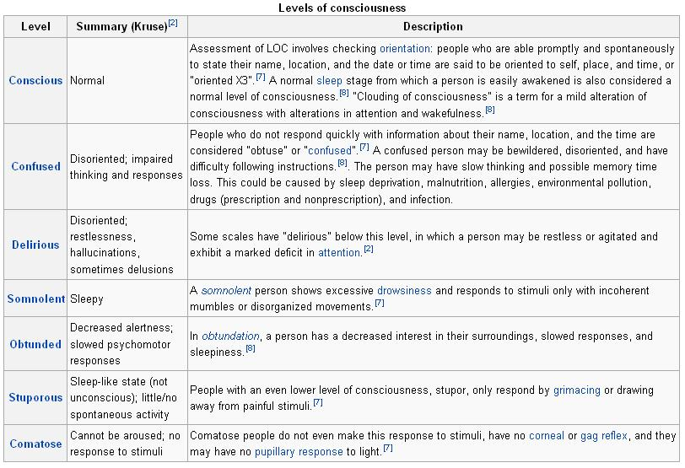
Unconsciousness or any other sudden change in mental status must be treated as a medical emergency.

Causes
Unconsciousness can be caused by nearly any major illness or injury. It can also be caused by substance (drug) and alcohol use. Choking on an object can result in unconsciousness as well.
Brief unconsciousness (or fainting) is often a result from dehydration, low blood sugar, or temporary low blood pressure. It can also be caused by serious heart or nervous system problems.
Other causes of fainting include straining during a bowel movement (vasovagal syncope), coughing very hard, or breathing very fast (hyperventilating).
So, what can cause coma:
- Brain cancer
- Concussion
- Diabetes
- Drug abuse
- Encephalitis
- Kidney failure
- Meningitis
- Pre-eclampsia
- Rabies
- Reyes syndrome
- Stroke
- Vasovagal syncope
- Postural hypotension
- Hyperventilation
- Cardiac arrhythmia
- Hypoxia
- Hypoglycaemia
- Epilepsy
The most common cause of coma are toxic\ metabolic de-arrangement, which are potentially treatable and reversible.
Signs and symptoms.
The signs of coma commonly include:
- Closed eyes
- Depressed reflexes, such as pupils not responding to light
- No responses of limbs, except for reflex movements
- No response to painful stimuli, except for reflex movements
- Irregular breathing
Symptoms of a coma include the following:
- No response to outside stimuli, such as:
  - Pain
  - Sound
  - Touch
  - Sight
- Spontaneous body movements, such as:
  - Jerking
  - Shaking
  - Trembling
  - Eyes opening and closing
  - Irregular breathing
The following symptoms may occur after a person has been unconscious:
- Amnesia for events before, during, and even after the period of unconsciousness
- Confusion
- Drowsiness
- Headache
- Inability to speak or move parts of his or her body (see stroke symptoms)
- Lightheadedness
- Loss of bowel or bladder control (incontinence)
- Rapid heartbeat (palpitations)
- Stupor (profound confusion and weakness)
Being asleep is not the same as being unconscious. A sleeping person will respond to loud noises or gentle shaking. An unconscious person will not.

First Aid
If someone is awake but less alert than usual, ask a few simple questions, such as:
- What is your name?
- What is the date?
- How old are you?
- Wrong answers or not being able to answer the question suggest a change in mental status.
If a person is unconscious or has a change in mental status, follow the first aid steps:
- Call or tell someone to call the local emergency number.
- Check the person's airway, breathing, and pulse frequently. If necessary, begin CPR.
- Evaluate person’s state with AVPU scale.
- If the person is breathing and lying on their back, and you do not think there is a spinal injury, carefully put the person in a recovery position. Gently tilt their head back to keep the airway open. If breathing or pulse stops at any time, roll the person onto their back and begin CPR.
- If you think there is a spinal injury, leave the person where you found them (as long as breathing continues). If the person vomits, roll the entire body at one time to their side. Support their neck and back to keep the head and body in the same position while you roll.
- Keep the person warm until ambulance arrives.
- If you see a person fainting, try to prevent a fall. Lay the person flat on the floor and raise their feet about 30 cm.
- If fainting is likely due to low blood sugar, give the person something sweet to eat or drink when they become conscious.

- Seizures
When the normal functions of the brain are disrupted by injury, disease, fever, infection, metabolic disturbances or conditions causing a decreased oxygen level, a seizure may occur. The seizure is a result of abnormal electrical activity in the brain and causes temporary, involuntary changes in body movement, function, sensation, awareness or behavior.
Risk factors for seizures:
• Head trauma
• Infections of the brain or spinal cord
• Epilepsy
• Stroke
• Drug use or withdrawal
• Hypoglycemia (Low Blood Sugar)
• Heat Stroke
• Fever in infants
Epilepsy is a chronic seizure condition. The seizures that occur with epilepsy usually can be controlled with medication. Still, some people with epilepsy who take seizure medication occasionally have seizures. Others who go a long time without a seizure may think that the condition has gone away and stop taking their medication, thus putting themselves at risk for another seizure.
Febrile Seizures: Young children and infants may be at risk for febrile seizures, which are seizures brought on by a rapid increase in body temperature. They are most common in children younger than 5years.
Febrile seizures often are caused by infections of the ear, throat or digestive system and are most likely to occur when a child or an infant experiences a rapid rise in temperature. A child or an infant experiencing a febrile seizure may experience some or all of the signals listed below.
Signs and symptoms of epileptic seizure include:
- A blank stare.
- A period of distorted sensation during which the person is unable to respond .
- Uncontrolled muscular contractions, called convulsions, which last several minutes.
A person with epilepsy may experience something called an aura before the seizure occurs. An aura is an unusual sensation or feeling, such as a visual hallucination; strange sound, taste or smell; or an urgent need to get to safety. If the person recognizes the aura, he or she may have time to tell bystanders and sit down before the seizure occurs.
Febrile seizures may have some or all of the following signals:
- Sudden risein body temperature
- Change in consciousn ess
- Rhythmic jerking of the head and limbs
- Loss of bladder or bowel control
- Confusion
- Drowsiness
- Crying out
- Becoming rigid
- Holding breath
- Upward rolling of the eyes
Typically seizures usually last no more than three minutes. Some common occurrences during a seizure include stopped or irregular breathing, body rigidness or convulsing, defecation, urination, and drooling.
When to call EMS
Call the local emergency number if:
- The seizure lasts more than 5 minutes.
- The person has multiple seizures with no signs of slowing down.
- The person appears to be injured or fails to regain consciousness after the seizure.
- The cause of the seizure is unknown .
- The person is pregnant.
- The person has diabetes.
- The person is a young child or an infant and experienced a febrile seizure brought on by a high fever.
- The seizure takes place in water.
- The person is elderly and could have suffered a stroke.
- This is the person's first seizure.
If the person is known to have occasional seizures, you may not have to call the local emergency number. He or she usually will recover from a seizure in a few minutes.
First aid
Although it may be frightening to watch, you can easily help to care for a person having a seizure. Remember that he or she cannot control the seizure.
Do not try to stop the seizure. General principles of managing a seizure are to prevent injury, protect the person's airway and make sure that the airway is open after the seizure has ended.
Do not hold or restrain the person.
Do not put anything in the person's mouth or between the teeth. People having seizures rarely bite their tongues or cheeks with enough force to cause significant bleeding; however, some blood may be present.
Make sure that the environment is as safe as possible to prevent injury to the person who is having a seizure. Remove any nearby furniture or other objects that may injure the person.
Give care to a person who has had a seizure the same way you would for an unconscious person. When the seizure is over, make sure that the person's airway is open. Usually, the person will begin to breathe normally. If there is fluid in the person's mouth, such as saliva, blood or vomit, roll him or her on one side so that the fluid drains from the mouth.
If the child or infant has a febrile seizure, it is important to immediately cool the body by giving a sponge bath with lukewarm water.
The person may be drowsy and disoriented or unresponsive for a period of time. Check to see if he or she was injured during the seizure. Be comforting and reassuring. If the seizure occurred in public, the person may be embarrassed and self-conscious. Ask bystanders not to crowd around the person .He or she may be tired and want to rest. Stay on the scene with the person until he or she is fully conscious and aware of the surroundings.

- Heart conditions: angina pectoris, heart attack
Cardiac emergencies are life threatening. Heart attack and cardiac arrest are major causes of illness and death. Recognizing the signals of a heart attack and cardiac arrest, calling the local emergency number and giving immediate care in a cardiac emergency saves lives. Performing CPR and using an automated external defibrillator (AED) immediately after a person goes into cardiac arrest can greatly increase his or her chance of survival.

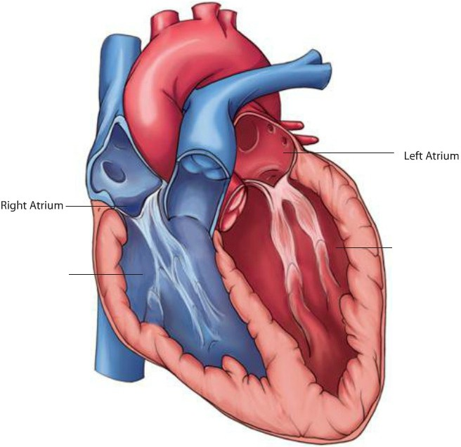
Background
Left Ventricle
Right Ve ntricle
The heart beats more than 3 billion times in an average lifetime. The heart is about the size of a fist and lies between the lungs in the middle of the chest. It pumps blood throughout the body. The ribs, breastbone and spine protect it from injury. The heart is separated into right and left halves.
Blood that contains little or no oxygen enters the right side of the heart and is pumped to the lungs. The blood picks up oxygen in the lungs when you breathe. The oxygen-rich blood then goes to the left side of the heart and is pumped from the heart's blood vessels, called the arteries, to all other parts of the body. The heart and your body's vital organs need this constant supply of oxygen-rich blood.
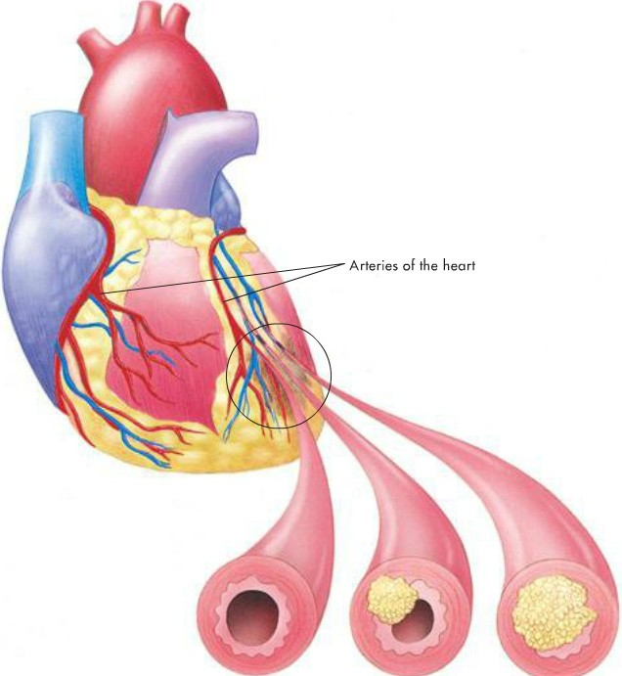
Cardiovascular disease is an abnormal condition that affects the heart and blood vessels. The most common conditions caused by cardiovascular disease include coronary heart disease, also known as coronary artery disease, and stroke, also called a brain attack.
Coronary heart disease occurs when the arteries that supply blood to the heart muscle harden and narrow. This process is called atherosclerosis. The damage occurs gradually, as cholesterol and fatty deposits called plaque build up on the inner artery walls). As this build-up worsens, the arteries become narrower. This reduces the amount of blood that can flow through them and prevents the heart from getting the blood and oxygen it needs. If the heart does not get blood containing oxygen, it will not work properly. When the heart is working normally, it beats evenly and easily, with a steady rhythm. When damage to the heart causes it to stop working effectively, a person can experience an angina, a heart attack or other damage to the heart muscle. A heart attack can cause the heart to beat in an irregular way. This may prevent blood from circulating effectively.
When the heart does not work properly, normal breathing can be disrupted or stopped. A heart attack also can cause the heart to stop beating entirely. This condition is called cardiac arrest. The number one cause of heart attack and cardiac arrest in adults is coronary heart disease. Other significant causes of cardiac arrest are non-heart related (e.g., poisoning or drowning).

Heart conditions.
When blood flow to the heart muscle is reduced, people experience chest pain. This reduced blood flow usually is caused by coronary heart disease. When the blood and oxygen supply to the heart is reduced, a heart attack may result.
Angina (angina pectoris) is a 'miniature heart attack' caused by a short term blockage. Angina almost always occurs after strenuous exercise or periods of high stress for the victim.
The key differentiation between a heart attack and angina is that, in line with their typical onset modes, angina should start to relieve very shortly after resting (a 5 minutes), whereas a heart attack will not relieve with rest. Even after the medication intake.
Signs and symptoms.
A heart attack can be indicated by common signals. Even people who have had a heart attack may not recognize the signals, because each heart attack may not show the same signals.
- Chest pain, discomfort or pressure. The most common signal is persistent pain, discomfort or pressure in the chest that lasts longer than 3 to 5 minutes or goes away and comes back.
Unfortunately, it is not always easy to distinguish heart attack pain from the pain of indigestion, muscle spasms or other conditions. This often causes people to delay getting medical care. Brief, stabbing pain or pain that gets worse when you bend or breathe deeply usually is not caused by a heart problem .
    - The pain associated with a heart attack can range from discomfort to an unbearable crushing sensation in the chest.
    - The person may describe it as pressure, squeezing, tightness, aching or heaviness in the chest.
    - Many heart attacks start slowly as mild pain or discomfort.
    - Often the person feels pain or discomfort in the center of the chest.
    - The pain or discomfort becomes constant. It usually is not relieved by resting, changing position or taking medicine.
    - Some individuals may show no signals at all.
- Discomfort in other areas of the upper body in addition to the chest. Discomfort, pain or pressure may also be felt in or spread to the shoulder, arm, neck, jaw, stomach or back.
- Trouble breathing. Another signal of a heart attack is trouble breathing. The person may be breathing faster than normal because the body tries to get the much-needed oxygen to the heart. The person may have noisy breathing or shortness of breath.
- Other signals. The person's skin may be pale or ashen (gray), especially around the face. Some people suffering from a heart attack may be damp with sweat or may sweat heavily, feel dizzy, become nauseous or vomit. They may become fatigued, lightheaded or lose consciousness. These signals are caused by the stress put on the body when the heart does not work as it should. Some individuals may show no signals at all.
- Differences in signals between men and women. Both men and women experience the most common signal for a heart attack: chest pain or discomfort. However, it is important to note that women are somewhat more likely to experience some of the other warning signals, particularly shortness of breath, nausea or vomiting, back or jaw pain and unexplained fatigue or malaise. When they do experience chest pain, women may have a greater tendency to have atypical chest pain: sudden, sharp but short-lived pain outside of the breastbone.
If you think the person might be having a heart attack call the local emergency number immediately, act quickly.
First aid.
Any heart attack might lead to cardiac arrest, but prompt action may prevent further damage to the heart. Most people who die of a heart attack die within 2 hours of the first signal.
Many people who have heart attacks delay seeking care. Often they do not realize they are having a heart attack. They may say the signals are just muscle soreness, indigestion or heartburn.
Early treatment with certain medications-including aspirin-can help minimize damage to the heart after a heart attack. To be most effective, these medications need to be given within 1hour of the start of heart attack signals.
If you suspect that someone might be having a heart attack, you should:
- Call the local emergency number immediately.
- Have the person stop what he or she is doing and rest comfortably. This will ease the heart's need for oxygen. Many people experiencing a heart attack find it easier to breathe while sitting.
- Loosen any tight or uncomfortable clothing.
- Closely watch the person until advanced medical personnel take over. Notice any changes in the person's appearance or behavior. Monitor the person's condition.
- Be prepared to perform CPR and use an AED, if available, if the person loses consciousness and stops breathing.
- Ask for a history of heart disease. Some people with heart disease take prescribed medication for chest pain. You can help by getting the medication for the person and assisting him or her with taking the prescribed medication.
- Offer aspirin, if medically appropriate and local protocols allow, and if the patient can swallow and has no known contraindications (see the following section). Be sure that the person has not been told by his or her health care provider to avoid taking aspirin.
- Be calm and reassuring. Comforting the person helps to reduce anxiety and eases some of the discomfort.
- Talk to bystanders and if possible the person to get more information.
- Do not try to drive the person to the hospital yourself. He or she could quickly get worse on the way.
Aspirin – to lessen the heart damage.
You may be able to help a conscious person who is showing early signals of a heart attack by offering him or her an appropriate dose of aspirin when the signals first begin. Always call for help as soon as you recognize the signals of a heart attack. Then help the person to be comfortable before you give the aspirin.
If the person is able to take medicine by mouth, ask:
- Are you allergic to aspirin?
- Do you have a stomach ulcer or stomach disease?
- Are you taking any blood thinners, such as warfarin?
- Have you ever been told by a doctor to avoid taking aspirin?
If the person answers no to all of these questions, you may offer him or her two chewable (81mg each) baby aspirins, or one 5-grain (325 mg) adult aspirin tablet with a small amount of water. Do not use coated aspirin products or products meant for multiple uses such as for cold, fever and headache. You also may offer these doses of aspirin if the person regains consciousness while you are giving care and is able to take the aspirin by mouth.

- Stroke
There are two main types of stroke - a CVA (Cardiovascular Attack - sometimes called just a stroke or major stroke) and a TIA (Transient Ischaemic Attack - sometimes called a mini-stroke).
A stroke, also called a brain attack, is caused when blood flow to a part of the brain is cut off or when there is bleeding into the brain. Strokes can cause permanent brain damage, but sometimes the damage can be stopped or reversed.
A stroke usually is caused by a blockage in the arteries that supply blood to the brain. Once the blood flow is cut off, that part of the brain starts to "suffocate" and die unless the blood flow can be restored. Blockages can be caused by blood clots that travel from other parts of the body, like the heart, or they can be caused by slow damage to the arteries over time from diseases such as high blood pressure and diabetes.
In a small percentage of strokes there is bleeding into the brain. This bleeding can be from a broken blood vessel or from a bulging aneurysm that has broken open. There is no way to tell the type of stroke until the person gets to an emergency room and undergoes a thorough medical evaluation.
A mini-stroke is when a person has the signals of a stroke, which then completely go away. Most mini-strokes get better within a few minutes, although they can last several hours. Although the signals of a mini-stroke disappear quickly, the person is not out of danger at that point.
Those, who has a mini-stroke is at very high risk of having a full stroke within the next 2 days.
Risk Factors
The risk factors for stroke are similar to those for heart disease. Some risk factors are beyond one's control, such as age, gender and family history of stroke or cardiovascular disease. Other risk factors can be controlled through diet, changes in lifestyle or medication. With a history of high blood pressure, previous stroke or mini-stroke, diabetes or heart disease one's chances of a stroke increases.
High blood pressure.
Uncontrolled high blood pressure is the number one risk factor for stroke. It puts added pressure on arteries and makes them stiffer. The excess pressure also damages organs, including the brain, heart and kidneys. Even mildly elevated blood pressure can increase one's risk of a stroke. High blood pressure is the most important of the controllable risk factors. It has to be checked regularly and if it is high, it must be controlled by losing weight, changing diet, exercising routinely and managing stress. If those measures are not sufficient, proper medication must be prescribed.
Diabetes
Diabetes is a major risk factor for stroke. If someone has been diagnosed with diabetes, he or she needs to control the level of blood sugar. If uncontrolled, it damage blood vessels throughout the body.
Cigarette Smoking
Cigarette smoking is another major risk factor of stroke. Smoking increases blood pressure, damages blood vessels and makes blood more likely to clot. The damage from smoking actually may be reversible. Approximately 10 years after a person has stopped smoking, their risk of stroke is about the same as the risk for a person who has never smoked. Inhaling smoke from smokers harms your health also. Avoid long-term exposure to cigarette smoke and protect children from this danger as well.
Diet
Diets that are high in saturated fats and cholesterol increases the risk of stroke by causing fatty materials to build up on the walls of blood vessels. Foods high in cholesterol include egg yolks and organ meats, such as liver and kidneys. Saturated fats are found in beef, lamb, veal, pork, ham, whole milk and whole-milk products. Limiting the intake of these foods can help to prevent stroke.
Preventing stroke
You can help prevent stroke if you:
- Control blood pressure.
- Quit smoking.
- Eat a healthy diet.
- Exercise regularly. Regular exercise reduces your chances of stroke by strengthening the heart and improving blood circulation. Exercise also helps in weight control.
- Maintain a healthy weight. Being overweight increases the chance of developing high blood pressure, heart disease and fat deposits lining the arteries.
- Control diabetes.
Signs and symptoms.
As with other sudden illnesses, looking or feeling ill, or behaving in a strange way, are common, general signals of a stroke or mini-stroke . Other specific signals of stroke have a sudden onset, including:
- Weakness or numbness of the face, arm or leg. This usually happens on only one side of the body.
- Facial droop or drooling.
- Trouble with speech. The person may have trouble talking, getting words out or being understood when speaking and may have trouble understanding.
- Loss of vision or disturbed (blurred or dimmed) vision in one or both eyes. The pupils may be of unequal size.
- Sudden severe headache. The person will not know what caused the headache and may describe it as "the worst headache ever."
- Dizziness, confusion, agitation, loss of consciousness or other severe altered mental status.
- Loss of balance or coordination, trouble walking or ringing in the ears.
- Incontinence.
Think FAST for a Stroke
For a stroke, think FAST, which stands for the following:
- Face: Weakness, numbness or drooping on one side of the face. Ask the person to smile. Does one side of the face droop?
- Arm: Weakness or numbness in one arm. Ask the person to raise both arms. Does one arm drift downward?
- Speech: Slurred speech or difficulty speaking. Ask the person to repeat a simple sentence (e.g., Ask the person to say something like, "The sky is blue.") Are the words slurred? Can the person repeat the sentence correctly?
- Time: Try to determine when the signals began. If the person shows any signals of stroke, time is critical.
When to call EMS
Call the local emergency number immediately if you encounter someone who is having or has had a stroke, if you see signals of a stroke or if the person had a mini-stroke (even if the signals have gone away). Note the time of onset of signals and report it to the call taker or EMS personnel when they arrive.
In the past, a stroke usually caused permanent brain damage. Today, new medications and medical procedures can limit or reduce the damage caused by stroke. Many of these new treatments must be given quickly to be the most helpful. It is important for the person to get the best care as quickly as possible.
First aid
Note the time that the signals started. If the person is unconscious, make sure that he or she has an open airway and care for life-threatening conditions. If fluid or vomit is in the person's mouth, put him or her in the recovery position to allow fluids to drain out of the mouth.
Remove any material from the mouth with a finger if the person is unconscious. Stay with the person and monitor breathing and for any changes in the person's condition.
If the person is conscious, check for non-life-threatening conditions. A stroke can make the person fearful and anxious. Often, he or she does not understand what has happened. Offer comfort and reassurance. Have the person rest in a comfortable position. Do not give him or her anything to eat or drink.

