Vinnitsa National Pirogov Memorial Medical University
Department of Emergency and Military medicine
“Approved”
The head of the department Of Disaster
Medicine and Military Medicine
___________ass. prof. M.V. Matvichuk
“28” August 2020

THEME 5 for practical lessons of the discipline life safety for first-year students of the pharmaceutical department:
Safety of nutrition as a component of vital Human functions

Vinnitsa 2020
Food safety is a scientific discipline describing handling, preparation, and storage of food in ways that prevent foodborne illness. This includes a number of routines that should be followed to avoid potentially severe health hazards.
The tracks within this line of thought are safety between industry and the market and then between the market and the consumer. In considering industry to market practices, food safety considerations include the origins of food including the practices relating to food labelling, food hygiene, food additives and pesticide residues, as well as policies on biotechnology and food and guidelines for the management of governmental imported export inspection and certification systems for foods. In considering market to consumer practices, the usual thought is that food ought to be safe in the market and the concern is safe delivery and preparation of the food for the consumer.
Food can transmit disease from person to person as well as serve as a growth medium for bacteria that can cause food poisoning. In developed countries there are intricate standards for food preparation, whereas in lesser developed countries the main issue is simply the availability of adequate safe water, which is usually a critical item.

Key facts of food safety:
- Access to sufficient amounts of safe and nutritious food is key to sustaining life and promoting good health.
- Unsafe food containing harmful bacteria, viruses, parasites or chemical substances, causes more than 200 diseases – ranging from diarrhoea to cancers.
- An estimated 600 million – almost 1 in 10 people in the world – fall ill after eating contaminated food and 420 000 die every year, resulting in the loss of 33 million healthy life years (DALYs).
- Children under 5 years of age carry 40% of the foodborne disease burden, with 125 000 deaths every year.
- Diarrhoeal diseases are the most common illnesses resulting from the consumption of contaminated food, causing 550 million people to fall ill and 230 000 deaths every year.
- Food safety, nutrition and food security are inextricably linked. Unsafe food creates a vicious cycle of disease and malnutrition, particularly affecting infants, young children, elderly and the sick.
- Foodborne diseases impede socioeconomic development by straining health care systems, and harming national economies, tourism and trade.
- Food supply chains now cross multiple national borders. Good collaboration between governments, producers and consumers helps ensure food safety.

In theory, food poisoning is 100% preventable. The five key principles of food hygiene, according to WHO(World Health Organisation), are:
- Prevent contaminating food with pathogens spreading from people, pets, and pests.
- Separate raw and cooked foods to prevent contaminating the cooked foods.
- Cook foods for the appropriate length of time and at the appropriate temperature to kill pathogens.
- Store food at the proper temperature.
- Do use safe water and raw materials.

Five Keys to safer food by WHO (World Health Organisation)

- Keep clean
- Wash your hands with soap before handling food and often during food preparation
- Wash your hands with soap after using the toilets
- Wash and sanitize all surfaces and equipment used for food preparation
- Protect kitchen areas and food from insects, pests and other animals
- Separate raw and cooked
- Separate raw meat, poultry and seafood from other foods
- Use separate equipment and utensils such as knives and cutting boards for handling raw foods
- Store food in containers to avoid contact between raw and prepared foods
- Cook thoroughly
- Cook food thoroughly, especially meat, poultry, eggs and seafood
- Bring foods like soups and stews to boiling to make sure that they have reached 70°C. For meat and poultry, make sure that juices are clear, not pink. Ideally, use a thermometer
- Reheat cooked food thoroughly
- Avoid overcooking when frying, grilling or baking food as this may produce toxic chemicals
4. Keep food at safe temperatures
- Do not leave cooked food at room temperature for more than 2 hours
- Refrigerate promptly all cooked and perishable food (preferably below 5°C)
- Keep cooked food piping hot (more than 60°C) prior to serving
- Do not store food too long even in the refrigerator
- Do not thaw frozen food at room temperature
5. Use safe water and raw materials
- Use safe water or treat it to make it safe
- Select fresh and wholesome foods
- Choose foods processed for safety, such as pasteurized milk
- Wash fruits and vegetables, especially if eaten
- Do not use food beyond its expiry date

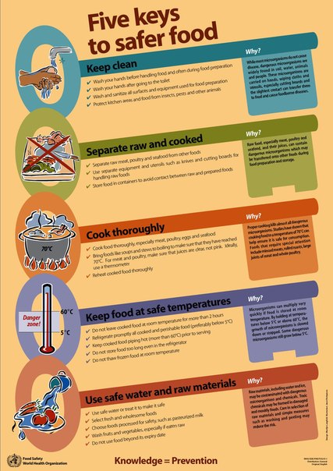
Food and water-borne illnesses can occur in any country. When we are travelling, we are more likely to be unfamiliar with our food – we won’t always know where it came from, how it was prepared, or who handled it. Some of us are also more inclined to take risks by trying local delicacies and eating from various food vendors. You can prevent gastrointestinal infections when you know the risks, make safe choices, and practice good hygiene. The golden rule is: Boil it, Cook it, Peel it, or Forget it!
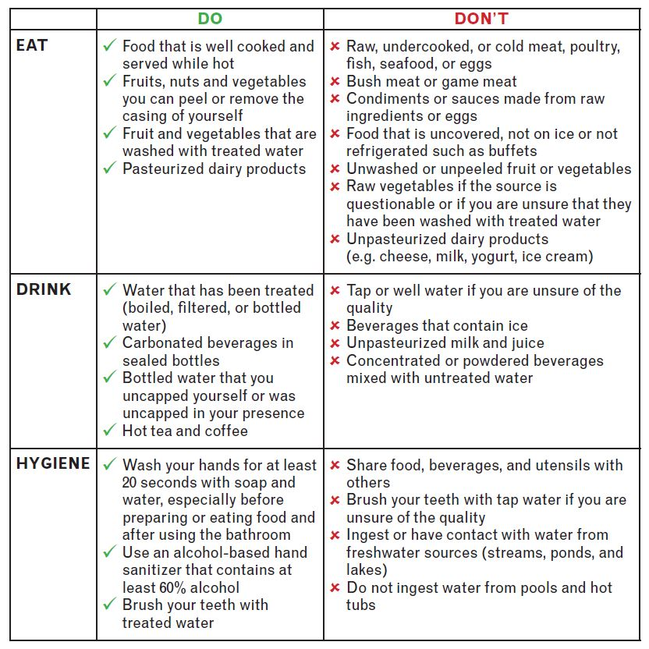

Major foodborne illnesses and causes
Foodborne illnesses are usually infectious or toxic in nature and caused by bacteria, viruses, parasites or chemical substances entering the body through contaminated food or water.Foodborne pathogens can cause severe diarrhoea or debilitating infections including meningitis.Chemical contamination can lead to acute poisoning or long-term diseases, such as cancer. Foodborne diseases may lead to long-lasting disability and death. Examples of unsafe food include uncooked foods of animal origin, fruits and vegetables contaminated with faeces, and raw shellfish containing marine biotoxins.

Bacteria:
- Salmonella, Campylobacter, and Enterohaemorrhagic Escherichia coli are among the most common foodborne pathogens that affect millions of people annually – sometimes with severe and fatal outcomes. Symptoms are fever, headache, nausea, vomiting, abdominal pain and diarrhoea. Examples of foods involved in outbreaks of salmonellosis are eggs, poultry and other products of animal origin. Foodborne cases with Campylobacter are mainly caused by raw milk, raw or undercooked poultry and drinkingwater. Enterohaemorrhagic Escherichia coli is associated with unpasteurized milk, undercooked meat and fresh fruits and vegetables.
- Listeria infection leads to unplanned abortions in pregnant women or death of newborn babies. Although disease occurrence is relatively low, listeria’s severe and sometimes fatal health consequences, particularly among infants, children and the elderly, count them among the most serious foodborne infections. Listeria is found in unpasteurised dairy products and various ready-to-eat foods and can grow at refrigeration temperatures.
- Vibrio cholerae infects people through contaminated water or food. Symptoms include abdominal pain, vomiting and profuse watery diarrhoea, which may lead to severe dehydration and possibly death. Rice, vegetables, millet gruel and various types of seafood have been implicated in cholera outbreaks.
Antimicrobials, such as antibiotics, are essential to treat infections caused by bacteria. However, their overuse and misuse in veterinary and human medicine has been linked to the emergence and spread of resistant bacteria, rendering the treatment of infectious diseases ineffective in animals and humans. Resistant bacteria enter the food chain through the animals (e.g. Salmonella through chickens). Antimicrobial resistance is one of the main threats to modern medicine.

Viruses:
Norovirus infections are characterized by nausea, explosive vomiting, watery diarrhoea and abdominal pain. Hepatitis A virus can cause long-lasting liver disease and spreads typically through raw or undercooked seafood or contaminated raw produce. Infected food handlers are often the source of food contamination.

Parasites:
Some parasites, such as fish-borne trematodes, are only transmitted through food. Others, for example tapeworms like Echinococcus spp, or Taenia solium, may infect people through food or direct contact with animals. Other parasites, such as Ascaris, Cryptosporidium, Entamoeba histolytica or Giardia, enter the food chain via water or soil and can contaminate fresh produce.

Prions:
Prions, infectious agents composed of protein, are unique in that they are associated with specific forms of neurodegenerative disease. Bovine spongiform encephalopathy (BSE, or "mad cow disease") is a prion disease in cattle, associated with the variant Creutzfeldt-Jakob Disease (vCJD) in humans. Consuming bovine products containing specified risk material, e.g. brain tissue, is the most likely route of transmission of the prion agent to humans.
Symptoms may occur very quickly after eating the food, or may take days or even weeks to appear. For most foodborne diseases, symptoms occur 24 -72 hours after the food has been eaten. Foodborne disease can lead to long-term health problems. Very severe diseases, including cancer, arthritis and neurological disorders can be caused by contaminated food.For infants, the sick, pregnant women and the elderly, the consequences of foodborne disease are usually more severe and more often fatal.
Drinking plenty of fluids will maintain hydration during diarrhoea. It is estimated that 3% of cases of foodborne disease can lead to long-term health problems. Mouth masks are recommended for people who may cough or sneeze while handling food. Gloves can be used to cover any cuts or lesions and should be changed frequently. Advice on treatment of foodborne illness differs between countries and should be adapted to the local region.
However, one should seek medical advice when bowel movements are very frequent, very watery or contain blood, or last beyond 3 days.

Chemicals:
- Naturally occurring toxins include mycotoxins, marine biotoxins, cyanogenic glycosides and toxins occurring in poisonous mushrooms. Staple foods like corn or cereals can contain high levels of mycotoxins, such as aflatoxin and ochratoxin, produced by mould on grain. A long-term exposure can affect the immune system and normal development, or cause cancer.
- Persistent organic pollutants (POPs) are compounds that accumulate in the environment and human body. Known examples are dioxins and polychlorinated biphenyls (PCBs), which are unwanted by-products of industrial processes and waste incineration. They are found worldwide in the environment and accumulate in animal food chains. Dioxins are highly toxic and can cause reproductive and developmental problems, damage the immune system, interfere with hormones and cause cancer.
- Heavy metalssuch as lead, cadmium and mercury cause neurological and kidney damage. Contamination by heavy metal in food occurs mainly through pollution of air, water and soil.
Simple measures such as washing and peeling may reduce the risk from chemicals that are found on the surface of foods. Appropriate storage can avoid or reduce the formation of some natural toxins.
The evolving world and food safety
Safe food supplies support national economies, trade and tourism, contribute to food and nutrition security, and underpin sustainable development.
Urbanization and changes in consumer habits, including travel, have increased the number of people buying and eating food prepared in public places. Globalization has triggered growing consumer demand for a wider variety of foods, resulting in an increasingly complex and longer global food chain.
As the world’s population grows, the intensification and industrialization of agriculture and animal production to meet increasing demand for food creates both opportunities and challenges for food safety. Climate change is also predicted to impact food safety, where temperature changes modify food safety risks associated with food production, storage and distribution.
These challenges put greater responsibility on food producers and handlers to ensure food safety. Local incidents can quickly evolve into international emergencies due to the speed and range of product distribution. Serious foodborne disease outbreaks have occurred on every continent in the past decade, often amplified by globalized trade.
Everyone can contribute to making food safe. Here are some examples of effective actions.

Policy - makers can:
- build and maintain adequate food systems and infrastructures (e.g. laboratories) to respond to and manage food safety risks along the entire food chain, including during emergencies;
- foster multi-sectoral collaboration among public health, animal health, agriculture and other sectors for better communication and joint action;
- integrate food safety into broader food policies and programmes (e.g. nutrition and food security);
- think globally and act locally to ensure the food produce domestically be safe internationally.

Food handlers and consumers can:
- know the food they use (read labels on food package, make an informed choice, become familiar with common food hazards);
- handle and prepare food safely, practicing the WHO Five Keys to Safer Food at home, or when selling at restaurants or at local markets;
- grow fruits and vegetables using the WHO Five Keys to Growing Safer Fruits and Vegetables to decrease microbial contamination.

