Vinnitsa National Pirogov Memorial Medical University
Department of Emergency and Military medicine
“Approved”
The head of the department Of Disaster
Medicine and Military Medicine
___________ass. prof. M.V. Matvichuk
“28” August 2020

THEME 4 for practical lessons of the discipline life safety for first-year students of the pharmaceutical department:
ensuring the safety of human life

Vinnitsa 2020
Health is a dynamic condition resulting from a body's constant adjustment and adaptation in response to stresses and changes in the enviroment for maintaining an inner equilibrium called homeostasis

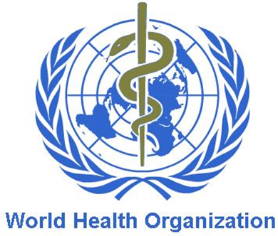
As defined by World Health Oganization (WHO), Health is a "State of complete physical, mental and social well being and not merely the absence of disease or infirmity.“

Six Essential Components of Health

- Physical health
Physical health is defined by what has, can and will affect your physical body such as genetics, diet, exercise, illness, disability, environment (including housing, work/school conditions and pollution), economic status, physical accessibility to resources and medical supplies and any other factors that can damage or improve your physical body.

- Social Health
Social health includes all forms of social interactions with two or more individuals including family, friends, colleagues, team/class mates, strangers, media including social media, internet, television and movies. Social health includes the potential of being influenced by other individuals or groups, either directly or indirectly such as media.

- Cognitive health
Cognitive health includes multiple factors which when combined, create an individuals intelligence. These factors are necessary to develop and/or maintain independence. Important factors include the ability to learn, memory, intuition, judgement, language, reason, concentration, planning and organisation.

- Emotional health
Emotional health is not simply feeling happy all or most of the time but experiencing a large variety of emotions (positive and negative). Positive emotional health requires the appropriate emotion to be experienced according to the event that has occurred i.e. sadness/grief with loss, fear at a time of danger. Emotional health includes the ability to regulate and demonstrate feelings in a safe and healthy manner and that will not result in harm to one self or others.

- Cultural health
Cultural health is a combination of social and physical health as it is influenced by our community laws, beliefs, attitudes, behaviours and values and has the potential to strongly influence emotional, social and physical health. Each culture has strong influence in meeting our physical, social and emotional needs and has great power over our community safety and accessibility to education, medical and other living resources.

- Spiritual health
Spiritual health is the most abstract and difficult to define. It often includes the belief of unity with a greater force, belief of a supreme being and/or a guiding sense of meaning and often includes higher values of hope, purpose, faith and peace. Historically in western society, it is often thought of as organised religion or prayer. Spiritual health is a combination of social, emotional, cognitive and cultural health and has the strong potential to positively and negatively affect emotional and physical health, as spirituality can be a strong motivational factor for improving and/or maintaining all other forms of health.

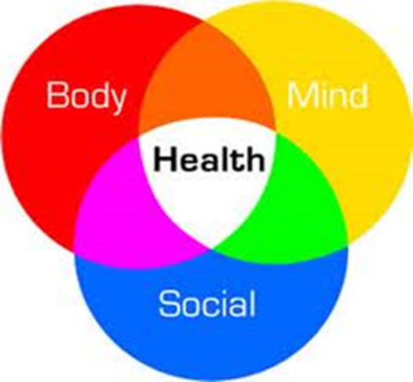
These are three unities:
Morale:
- clarity of mind,
- healthy mentality.
Harmony of a body:
- physical aspect.
Public health: - social aspect.

Parameters of individual health of the person
Individual health reflects the health which is peculiar to the specific person and divided by eight groups of the basic parameters.
It is estimated by subjective and objective criteria.

Eight basic groups of individual health parameters:

1. Genetic | Genotype, absence of disembryogenesis and hereditary defects
2. Biochemical | Parameters of biological fabrics and liquids
3. Metabolic | Level of a metabolism during rest and after duty
4. Morphological | Level of physical progress, type of constitutions morphotype)
5. Functional | Alternate possibilities, functional type
6. Psychological | emotional, cogitative, intellectual areas
7. Sociality-spiritual | Moral values, ideals, level of assertion
8. Clinical | Absence of illness

Subjective criteria concern to a self-assessment of current health of a person. They not always coincide with objective health of the person. State of health is a reflection of condition of many functions of internal organs.
Presence of painful sensations are signals of preillness or illness (headaches, the general weakness, dizziness, sensation of palpitation, a short wind, pains in muscles and other signs).

Objective criteria of a person’s health are expressed in such parameters which are not dependant on the will of the person, they can be detected by other person and they can be compared with the previous condition and with normal characteristics: anthropometry, dynamometry, frequency and rhythm of pulse and breath, body temperature, colour of skin, character of sweating, stability of attention, coordination of movements, etc.

To assess the cardiovascular system analysis of ECG, ultrasound, exercise test are applied.
Respiratory system is evaluated using different sets of breathing apparatus and gas analysis (spirograph).
Metabolism is assessed by complex biochemical methods, radioisotope diagnosis.
A tool to assess the mental and social health is various forms of surveys and questionnaire.

Public Health

Public health is the science of protecting and improving the health of people and their communities. This work is achieved by promoting healthy lifestyles, researching disease and injury prevention, and detecting, preventing and responding to infectious diseases.
Overall, public health is concerned with protecting the health of entire populations. These populations can be as small as a local neighborhood, or as big as an entire country or region of the world.
Public health professionals try to prevent problems from happening or recurring through implementing educational programs, recommending policies, administering services and conducting research—in contrast to clinical professionals like doctors and nurses, who focus primarily on treating individuals after they become sick or injured. Public health also works to limit health disparities. A large part of public health is promoting healthcare equity, quality and accessibility.

Public health is characterized by a complex of medical parameters:
1. Demographic (birth rate, death rate, expected life duration)
2. Disease (general, infectious, hospital)
3. Physical progress (morpho-functional and biological progress, a harmony)
4. Physical inabilities (primary and general)
5. Pre-nosological condition (immunity, resistibility of systems, activity of enzymes)

- most important public health problems and concerns:
- Alcohol-related harms
- Food safety
- Healthcare-associated infections
- Heart disease and stroke
- HIV
- Motor vehicle injury
- Nutrition, physical activity and obesity
- Prescription drug overdose
- Teen pregnancy
- Tobacco use

What are the key components of Health 2020?( World Health Organization)
Values
Health 2020 is based on the values enshrined in the WHO Constitution: the highest attainable standard of health as a human right. It acknowledges the interconnectedness of local, national, regional and global health actors, actions and challenges, and recommends a unity of approach and the adoption of a common outcome-focused Region-wide policy framework. It provides a clear mapping of the options and tradeoffs in taking action to improve health and reduce inequities.

Health development
Health is a resource that enables every person to realize his or her potential and to contribute to the overall development of society. The new policy framework does not imply that health is everything or the only aspect of life to be valued – societies and individuals have many goals. Yet health is crucial as a means to achieve other goals in life. Poor health wastes potential, causes despair and drains resources across all sectors of society.

Problem-solving
The policy framework presents ways in which policy-makers can more effectively and efficiently address today’s social, demographic, epidemiological and financial challenges, by resetting priorities, catalyzing action in other sectors, and adopting new approaches to organizing the health sector with other stakeholders.

Engagement
Many partners need to come together to achieve better and more equitable health and well-being, and health is the responsibility of the whole of society and the whole of government. The policy framework is designed to help overcome some of the principal barriers that have so far held back those with an interest in health. It provides a vision, a strategic path, a set of priorities and a range of suggestions to show what works in engaging stakeholders, based on research and experience in many countries.

Equity focus
The policy framework suggests new ways to identify important health gaps and focus individual and collective efforts on ways to reduce them. It shows how progress has been most successful in countries that provide affordable care and social safety nets through strong public services and sustainable public finances.

Evidence base
Health 2020 builds on the experiences gained from previous health for all policies and is supported by a wealth of evidence gathered in both traditional and emerging health policy areas.

Strategic thinking
The policy framework recognizes that governments can achieve real improvements in health if they work across government to fulfil two linked strategic objectives.
The two strategic objectives are:
- improving health for all and reducing health inequalities
- improving leadership and participatory governance for health.

Protective and adverse factors for health

Psychosocial pathways in part mediate the effects of social determinants on health and may be protective or adverse.

Protective factors:
• These include factors that support or increase the development of individual level attributes such as coping abilities, self-efficacy and resilience, and the ability to learn and to develop social skills – all of which may encourage healthy behaviours and mental health and wellbeing.
• Control is proposed as a mediator in the relationship between social position and health.
• Protective family and community level factors include social support and protective influences organised in schools, neighbourhoods, and work places.

Adverse factors:
• The effects of adverse factors can undermine the development of individual level attributes and reduce the capability to flourish.
• At the individual level, adverse factors include adversity in early life, weak or difficult relationships, adverse life events, financial worries or debt. Traumatic events, such as road accidents, violence/prolonged abuse, natural disasters and serious illnesses are experienced by one in three of the population and can have adverse effects on mental health.
• Family/community-level adverse factors include poor housing, poor quality neighbourhood environment, low social capital, social isolation and working conditions that create stress.

Risk Factors
Risk factors of diseases are the factors increasing probability of occurrence of this or that disease.

According to experts of WHO, health of the person:
on 50 % - depends on a way of life,
on 20 % - from a heredity,
on 20 % - from a condition of an
environment,
on 10 % - from the contribution of
the state to healthcare

System of risk factors effecting health

Predictors | Group of risk factors | density (%)
Way of life | smoking, alcohol abuse, unbalanced diet, stress, bad working conditions, lack of exercise, poor material conditions, drug abuse, low cultural level. | 49-53
Genetics, biology | familial positivity | 18-22
External  environment | contamination by carcinogens and other harmful substances in the air, soil and water, abrupt changes of atmospheric phenomena. | 17-20
Health | ineffectiveness of preventive measures, poor quality and timeliness. | 8-10

By their nature risk factors are primary and secondary.
The category of the primary risk factors include those that normally lead to the development of the disease.
Secondary lead to complications of existing pathological conditions.

Data of WHO on the primary and secondary factors in high-risk health

Primary risk factors | Secondary risk factors
1. Smoking | 1. Diabetes
2. Alcohol abuse | 2. Hypertension
3. Poor nutrition | 3. Lipidemia, holisterinemiya
4. Lack of exercise | 4. Rheumatism
5. Psycho-emotional stress | 5. Allergies, immune deficiencies, etc.

Also, risk factors can be categorised into the following groups:
- Behavioural
- Physiological
- Demographic
- Environmental
- Genetic

- Behavioural risk factors
Behavioural risk factors usually relate to ‘actions’ that the individual has chosen to take. They can therefore be eliminated or reduced through lifestyle or behavioural choices. Examples include:

- smoking tobacco
- drinking too much alcohol
- nutritional choices
- physical inactivity
- spending too much time in the sun without proper protection
- not having certain vaccinations
- unprotected sex

- Physiological risk factors
Physiological risk factors are those relating to an individual’s body or biology. They may be influenced by a combination of genetic, lifestyle and other broad factors. Examples include:

- being overweight or obese
- high blood pressure
- high blood cholesterol
- high blood sugar (glucose)

- Demographic risk factors
Demographic risk factors are those that relate to the overall population. Examples include:
- age
- gender
- population subgroups, such as occupation, religion, or income

- Environmental risk factors
Environmental risk factors cover a wide range of topics such as social, economic, cultural and political factors as well as physical, chemical and biological factors. Examples include:
- access to clean water and sanitation
- risks in the workplace
- air pollution
- social settings

- Genetic risk factors
Genetic risk factors are based on an individual’s genes. Some diseases, such as cystic fibrosis and muscular dystrophy, come entirely from an individual’s ‘genetic make-up’. Many other diseases, such as asthma or diabetes, reflect the interaction between the genes of the individual and environmental factors. Other diseases, like sickle cell anemia, are more prevalent in certain population subgroups.

Income
For high and middle-income countries, the most important risk factors are those related to long-term diseases, whereas in low-income countries, factors such as childhood malnutrition and unprotected sex are much more widespread.

Age
Risk factors also change with age. Some risk factors almost exclusively affect children such as malnutrition and indoor smoke from solid fuels. For adults, there are considerable differences depending on age:

Unprotected sex and addictive substances (e.g. tobacco and alcohol) account for most of the health problems in younger adults. Risk factors for long-term diseases and cancers mainly affect older adults.
Gender
Gender differences also exist. For example, men are much more likely to be at risk of factors associated with addictive substances. Women are prone to suffer from iron deficiency during pregnancy.

Unsafe, At-Risk, Safe Behaviors

Unsafe Behaviors - these are dangerous acts that often result in injuries and can be identified with common sense and experience. When actions are highly probable to result in a negative outcome (i.e., injury) with high severity potential, we view these as unsafe. Think of driving at a high rate of speed while taking your eyes off the road for 30 seconds. It would be hard to argue the likelihood is extremely high this behavior will result in an injury. This behavior should be stopped.

At-Risk Behaviors - these are behaviors with a low probability of injury that most often do not result in injury but occasionally do or at least have the potential to. These behaviors are a problem for individuals and organizations because they are difficult to detect with common sense and experience without more data and sophisticated tools to analyze the data. Think of driving at a low rate of speed while thinking of something else and changing the radio station in your vehicle. While this risk is taken every day by countless drivers, few are involved in collisions. This behavior should be coached.

Safe Behaviors - these are acts with little or no danger, almost never resulting in injury. The known risks are controlled, and everyone observing the action would agree. Think of driving with your hands kept on the steering wheel, eyes focused on the road and constantly scanning for changes in the environment, with your attention focused exclusively on the task at hand. This behavior should be positively reinforced.

Healthy Lifestyle
The basic characteristics of life are:
- work (study),
- social, political and cultural activities of people,
- and various behavioral habits and appearance.

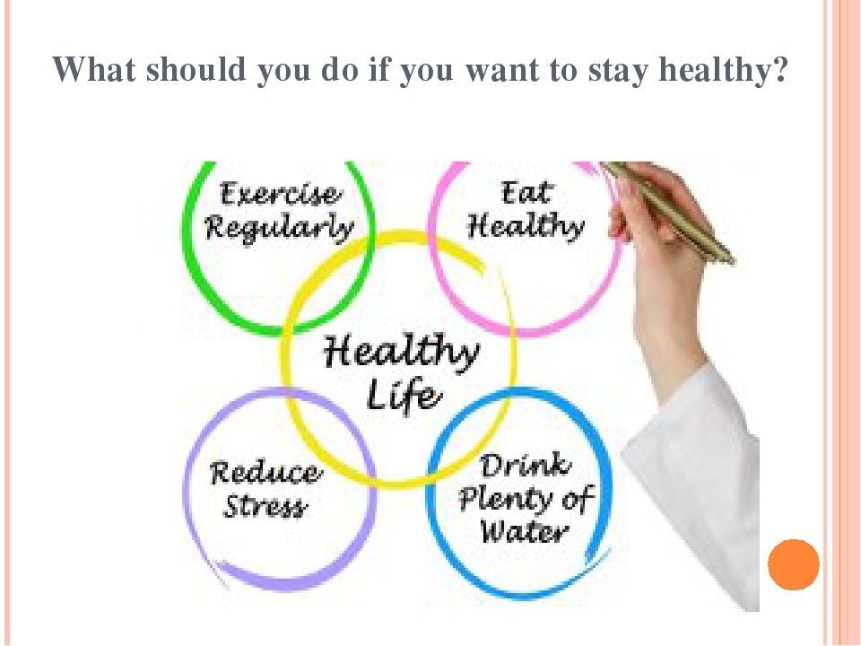

- Maintain a regular exercise routine
No, you do not have to force yourself into intense workouts at the gym but you need to keep as active as possible. You can stick to easy floor exercises, swimming, walking, or simply keep yourself moving by doing some household chores. Do what your body allows you to do.

What is important is that you continue exercising. Give at least twenty to thirty minutes a day to exercise at least three to five times a week. Have a routine; see to it that you have enough physical activity each day.

- Be conscious in your diet
To maintain a healthy lifestyle, you need to keep eating healthy. Add more fruits and vegetables in your diet and eat less carbohydrates, high sodium and unhealthy fat. Avoid eating junk food and sweets.

Avoid skipping a meal—this will only make your body crave more food the moment you resume eating. Remember to burn more calories than you eat.

- Engage in the things you are passionate about
Every now and then, to keep the stress and the demands of life from taking over, take a break to do something you love doing.

- Surround yourself with positive energy
In order to have a sound mental and emotional state, you must surround yourself with positive energy. Yes, not all problems can be avoided. But it helps to face such obstacles with an optimist outlook. Surround yourself with encouraging friends and people that will provide you with constructive criticism every once in a while to help you improve.
Make it a habit to always look at the brighter side of life. Even if you find yourself in the worst situation, there is always an upside to it—something good and positive. Dwell on these things instead.
Maintaining a healthy lifestyle is not that difficult, nor does it require a lot of work. Just keep doing what you do and apply the staying healthy tips listed above—surely you will be a well-rounded individual in no time.

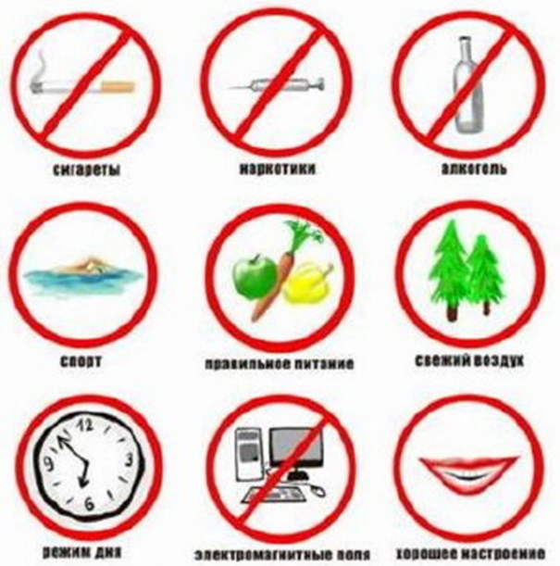

Structure of the healthy way of life
1. Strict control over your health
2. Optimal physical activity
3. Active work
4. Training of immunity
5. Balanced diet
6. Avoiding harmful habits
7. Hygienic behavior validity

Systems and methods of recreation
Recreation system is a system of knowledge and practical methodologies to ensure the formation of health.
Recreation system began to emerge from the birth of human civilization and naturally belong to the culture of humanity.

Modern ways of recreation
- improvement of spirituality
- physical improvement
- dreathing techniques and their use nutrition
- managing emotions
- management of thoughts
- bioenergetics
Known health systems can be divided into traditional and non-traditional

Non-traditional health systems:
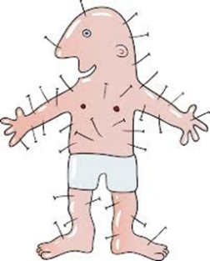
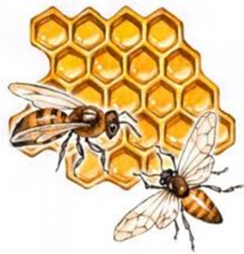
- aroma and light therapy,
- apitherapy,
- animaloterapiya,
- acupuncture,
- hardening,
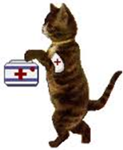
- homeopath,
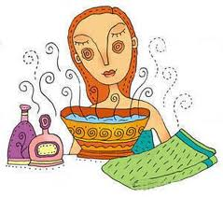
- yoga,
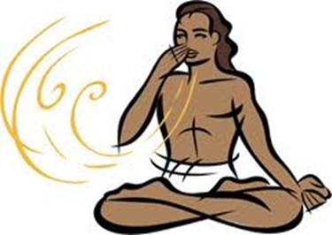
- massage.

