Vinnitsa National Pirogov Memorial Medical University
Department of Emergency and Military medicine

“Approved”
The head of the department Of Disaster
Medicine and Military Medicine
___________ass. prof. M.V. Matvichuk
“28” August 2020

THEME 2 for practical lessons of the discipline life safety for first-year students of the pharmaceutical department:
A modern man in the human-environment system

Vinnitsa 2020
Body Functions
Body functions are the physiological or psychological functions of the body systems. The body's functions are ultimately its cells' functions. Survival is the body's most important business. Survival depends on the body's maintaining or restoring homeostasis, a state of relative constancy, of its internal environment.
More than a century ago, French physiologist, Claude Bernard (1813-1878), made a remarkable observation. He noted that body cells survived in a healthy condition only when the temperature, pressure, and chemical composition of their environment remained relatively constant. Later, an American physiologist, Walter B. Cannon (1871-1945), suggested the name homeostasis for the relatively constant states maintained by the body. Homeostasis is a key word in modern physiology. It comes from two Greek words - "homeo," meaning the same, and "stasis," meaning standing. "Standing or staying the same" then is the literal meaning of homeostasis. However, as Cannon emphasized, homeostasis does not mean something set and immobile that stays exactly the same all the time. In his words, homeostasis "means a condition that may vary, but which is relatively constant."
Homeostasis depends on the body's ceaselessly carrying on many activities. Its major activities or functions are responding to changes in the body's environment, exchanging materials between the environment and cells, metabolizing foods, and integrating all of the body's diverse activities.
The body's ability to perform many of its functions changes gradually over the years. In general, the body performs its functions least well at both ends of life - in infancy and in old age. During childhood, body functions gradually become more and more efficient and effective. During late maturity and old age the opposite is true. They gradually become less and less efficient and effective. During young adulthood, they normally operate with maximum efficiency and effectiveness.
Life Process
All living organisms have certain characteristics that distinguish them from non-living forms. The basic processes of life include organization, metabolism, responsiveness, movements, and reproduction. In humans, who represent the most complex form of life, there are additional requirements such as growth, differentiation, respiration, digestion, and excretion. All of these processes are interrelated. No part of the body, from the smallest cell to a complete body system, works in isolation. All function together, in fine-tuned balance, for the well being of the individual and to maintain life. Disease such as cancer and death represent a disruption of the balance in these processes.
The following are a brief description of the life process:
Organization
At all levels of the organizational scheme, there is a division of labor. Each component has its own job to perform in cooperation with others. Even a single cell, if it loses its integrity or organization, will die.
Metabolism
Metabolism is a broad term that includes all the chemical reactions that occur in the body. One phase of metabolism is catabolism in which complex substances are broken down into simpler building blocks and energy is released.
Movement
There are many types of movement within the body. On the cellular level, molecules move from one place to another. Blood moves from one part of the body to another. The diaphragm moves with every breath. The ability of muscle fibers to shorten and thus to produce movement is called contractility.
Reproduction
For most people, reproduction refers to the formation of a new person, the birth of a baby. In this way, life is transmitted from one generation to the next through reproduction of the organism. In a broader sense, reproduction also refers to the formation of new cells for the replacement and repair of old cells as well as for growth. This is cellular reproduction. Both are essential to the survival of the human race.
Growth
Growth refers to an increase in size either through an increase in the number of cells or through an increase in the size of each individual cell. In order for growth to occur, anabolic processes must occur at a faster rate than catabolic processes.
Differentiation
Differentiation is a developmental process by which unspecialized cells change into specialized cells with distinctive structural and functional characteristics. Through differentiation, cells develop into tissues and organs.

Respiration
Respiration refers to all the processes involved in the exchange of oxygen and carbon dioxide between the cells and the external environment. It includes ventilation, the diffusion of oxygen and carbon dioxide, and the transport of the gases in the blood. Cellular respiration deals with the cell's utilization of oxygen and release of carbon dioxide in its metabolism.
Digestion
Digestion is the process of breaking down complex ingested foods into simple molecules that can be absorbed into the blood and utilized by the body.
Excretion
Excretion is the process that removes the waste products of digestion and metabolism from the body. It gets rid of by-products that the body is unable to use, many of which are toxic and incompatible with life.
The ten life processes described above are not enough to ensure the survival of the individual. In addition to these processes, life depends on certain physical factors from the environment. These include water, oxygen, nutrients, heat, and pressure.
Responsiveness
Responsiveness or irritability is concerned with detecting changes in the internal or external environments and reacting to that change. It is the act of sensing a stimulus and responding to it.
Information processes are executed by information processors. For a given information processor, whether physical or biological, a token is an object, devoid of meaning, that the processor recognizes as being totally different from other tokens. A group of such unique tokens recognized by a processor constitutes its basic “alphabet”; for example, the dot, dash, and space constitute the basic token alphabet of a Morse-code processor. Objects that carry meaning are represented by patterns of tokens called symbols. The latter combine to form symbolic expressions that constitute inputs to or outputs from information processes and are stored in the processor memory.
Information processors are components of an information system, which is a class of constructs. An abstract model of an information system features four basic elements: processor, memory, receptor, and effector (Figure 1). The processor has several functions: (1) to carry out elementary information processes on symbolic expressions, (2) to store temporarily in the processor’s short-term memory the input and output expressions on which these processes operate and that they generate, (3) to schedule execution of these processes, and (4) to change this sequence of operations in accordance with the contents of the short-term memory.
The memory stores symbolic expressions, including those that represent composite information processes, called programs. The two other components, the receptor and the effector, are input and output mechanisms whose functions are to receive symbolic expressions or stimuli from the external environment for manipulation by the processor and to emit the processed structures back to the environment.
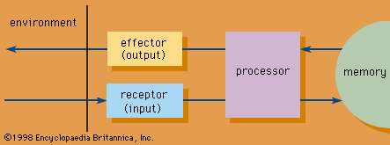

Environmental Health
All organisms depend on their environments for energy and materials needed to sustain life: clean air, potable water, nutritious food, and safe places to live. For most of human history, increases in longevity were due to improved access to these necessities. Advances in agriculture, sanitation, water treatment, and hygiene have had a far greater impact on human health than medical technology.
Although the environment sustains human life, it can also cause diseases. Lack of basic necessities is a significant cause of human mortality. Environmental hazards increase the risk of cancer, heart disease, asthma, and many other illnesses. These hazards can be physical, such as pollution, toxic chemicals, and food contaminants, or they can be social, such as dangerous work, poor housing conditions, urban sprawl, and poverty.
Unsafe drinking water and poor sanitation and hygiene are responsible for a variety of infectious diseases, such as schistosomiasis, diarrhea, cholera, meningitis, and gastritis. In 2015, approximately 350,000 children under age 5 (mostly in the developing world) died from diarrheal diseases related to unsafe drinking water, and approximately 1.8 billion people used drinking water contaminated with feces. More than 2 billion people lacked access to basic sanitation.

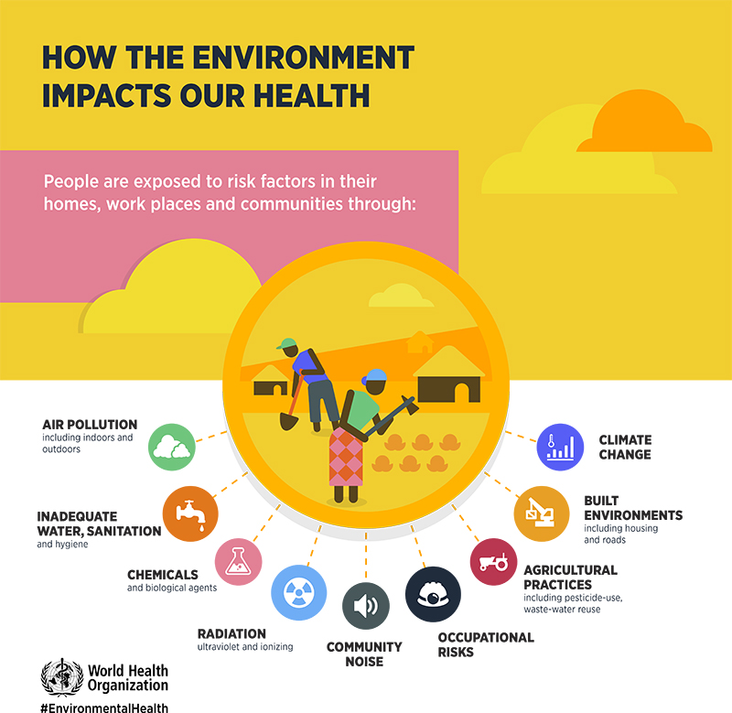

Environmental Risk Factors for Disease
- Pollution
- Microbes in air, water, or soil
- Contaminants in food
- Weather conditions (e.g. droughts, heat waves)
- Natural disasters (e.g. hurricanes, earthquakes, floods)
- Pesticides and other chemicals
- Pests and parasites
- Radiation
- Poverty
- Lack of access to health care

Environment-Related Illnesses
- Cancer
- Heart disease
- Diabetes
- Asthma
- Chronic obstructive pulmonary disease
- Obesity
- Occupational injuries
- Arthritis
- Parkinson’s disease
- Malaria
- Dysentery
- Depression

Emerging Issues in Environmental Health
Environmental health is a dynamic and evolving field. While not all complex environmental issues can be predicted, some known emerging issues in the field include:
- Climate Change

Climate change is projected to impact sea level, patterns of infectious disease, air quality, and the severity of natural disasters such as floods, droughts, and storms.

- Disaster Preparedness

Preparedness for the environmental impact of natural disasters as well as disasters of human origin includes planning for human health needs and the impact on public infrastructure, such as water and roadways.

- Nanotechnology

The potential impact of nanotechnology is significant and offers possible improvements to:

- Disease prevention, detection, and treatment
- Electronics
- Clean energy
- Manufacturing
- Environmental risk assessment

