3.2 Topic “Bleeding and hemorrhage control”

- COLLAPSE (FAINTING) AND SHOCK: CAUSES, RECOGNITION, FIRST AID.
Minor internal bleedings, especially visible with blood loss less than 50 ml, will stop by themselves and do not need anything but observation. Major bleedings can outcome into collapse, syncope and shock.
Collapse is a sudden and often unannounced loss of postural tone (going weak), often but not necessarily accompanied by loss of consciousness. Syncope refers to a sudden loss of consciousness often accompanied with collapse, more commonly known as a blackout or faint. It is caused by a lack of blood or oxygen to the brain. When this happens, the brain attempts to increase blood flow to itself by diverting blood away from the rest of the body. This causes pale skin and a white face, rapid heart rate (tachycardia), rapid breathing (hyperventilation) and weakness of the limbs, particularly the legs. Eventually collapse occurs.
There are a number of situations that can induce collapse and syncope. Too little food or water, low blood sugar (hypoglycaemia), intense physical exercise, and standing up too quickly can all cause an episode of fainting. Additionally, low blood pressure (hypotension) – due to blood loss in case of injury, and an abnormal heart rhythm (arrhythmia) can also cause a lack of blood to the brain.
Recurrent episodes of syncope may be a sign of a more serious underlying condition and require further investigation.
Simple syncope episodes can be diagnosed fairly easily by a doctor without complicated tests. However, recurrent episodes may be a symptom of another condition and a specialist doctor may order some tests to investigate what could be the cause of syncope.
It is treated at the time of fainting by lying down and raising the legs in order to improve blood flow to the brain. Treatment for an underlying cause may be necessarys.
Shock is a life-threatening condition characterized by multi-organ dysfunction and tissue hypoxemia caused by a decrease in oxygen delivery or impaired oxygen utilization.
Hypotension is a drop in systolic blood pressure of > 40-50 mm HG from baseline. Systolic < 90 mm Hg MAP < 65 mm Hg.
Several indicators can be used to assess volume status, including mean blood pressure, heart rate, respiratory rate, peripheral perfusion and urine output. While most patients in shock are hypotensive, a minority may have a normal blood pressure, likely due to a compensatory peripheral vascular constriction. Clinical hypotension is usually found, i.e., mean arterial pressure <60 mmHg or systolic blood pressure < 90 mmHg in previously normotensive persons.
Many conditions, including blood loss but also including nonhemorrhagic states such as dehydration, sepsis, impaired autoregulation, obstruction, decreased myocardial function, and loss of autonomic tone, may produce shock or shocklike states.
Shock is classified into 4 major categories, of which most patients may present with more than one type:
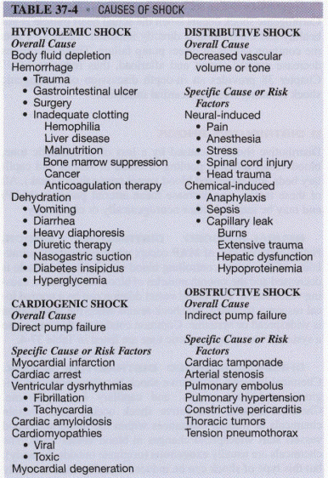
1.Hypovolemic – due to intravascular volume loss (hemorrhagic and non-hemorrhagic intravascular volume depletion)
2.Distributive - vasodilation, which is a hyperdynamic process (septic, anaphylactic, adrenal crisis, and neurogenic)
3.Cardiogenic - pump failure (myocardial infarction, cardiomyopathy, valvular heart disease)
4.Obstructive - physical obstruction of blood circulation and inadequate blood oxygenation (pulmonary embolism, tension pneumothorax, cardiac tamponade)

Stages of shock
  - Initial : The cells become leaky and switch to anaerobic metabolism.
  - Non-progressive:(compensated stage) Attempt to correct the metabolic upset of shock.
  - Progressive: (decompensated stage ) Eventually the compensation will begin to fail.
  - Refractory : Organs fail and the shock can no longer be reversed
The symptoms and signs of shock are those of tissue hypoperfusion and of physiological compensatory mechanisms. Compensation is a condition where these latter mechanisms temporarily stabilize shock. It should always be recognized and never left untreated. These compensatory mechanisms may be quickly depleted and lead to sudden cardiovascular collapse.
Signs and symptoms of shock (hypoperfusion)
1. Mental states
a. Restlessness
b. Anxiety
c. Altered mental status
2. Peripheral perfusion
a. Delayed capillary refill greater than 2 seconds
b. Weak, thready or absent peripheral pulses
c. Pale, cool, clammy skin
3. Vital signs
a. Decreased blood pressure (late sign)
b. Increased pulse rate (early sign) - weak and thready
c. Increased breathing rate
(1) Shallow
(2) Labored
(3) Irregular
4. Other signs and symptoms
a. Dilated pupils
b. Marked thirst
c. Nausea and vomiting
d. Pallor with cyanosis to the lips
5. Infant and child patients can maintain their blood pressure until their blood volume is more than half gone, so by the time their blood pressure drops they are close to death. The infant or child in shock has less reserve.
Considering that we are studying the topic “Hemorrhage control”, we will pay our attention to the hypovolemic (hemorrhagic) shock.

Hypovolemic or hemorrhagic shock.

Introduction
Shock refers to the inadequate perfusion of tissues due to the imbalance between oxygen demand of tissues and the body’s ability to supply it.
Hypovolemic shock occurs when there is decreased intravascular volume to the point of cardiovascular compromise. The hypovolemic shock could be due to severe dehydration through a variety of mechanisms or from blood loss. The pathophysiology, diagnosis, and treatment of hemorrhagic shock, a subset of hypovolemic shock, will be explored in this article.

Etiology
Though most commonly thought of in the setting of trauma, there are numerous causes of hemorrhagic shock that span many systems. Blunt or penetrating trauma is the most common cause, followed by upper and lower gastrointestinal sources. Obstetrical, vascular, iatrogenic, and even urological sources have all been described. Bleeding may be either external or internal. A substantial amount of blood loss to the point of hemodynamic compromise may occur in the chest, abdomen, or the retroperitoneum. The thigh itself can hold up to 1 L to 2 L of blood. Localizing and controlling the source of bleeding is of utmost importance to the treatment of hemorrhagic shock but beyond the scope of this article

Epidemiology
Trauma remains a leading cause of death worldwide with approximately half of these attributed to hemorrhage. In the United States in 2001, trauma was the third leading cause of death overall, and the leading cause of death in those aged 1 to 44 years. While trauma spans all demographics, it disproportionately affects the young with 40% of injuries occurring in ages 20 to 39 years by one country’s account. Of this 40%, the greatest incidence was in the 20 to 24-year-old range. [5][6][7]

The preponderance of hemorrhagic shock cases resulting from trauma is high. During one year, one trauma center reported 62.2% of massive transfusions occur in the setting of trauma. The remaining cases are divided among cardiovascular surgery, critical care, cardiology, obstetrics, and general surgery, with trauma utilizing over 75% of the blood products.

As patients age, physiological reserves decrease the likelihood of anticoagulant use increases and the number of comorbidities increase. Due to this, elderly patients are less likely to handle the physiological stresses of hemorrhagic shock and may decompensate more quickly.

Pathophysiology
Hemorrhagic shock is due to the depletion of intravascular volume through blood loss to the point of being unable to match the tissues demand for oxygen. As a result, mitochondria are no longer able to sustain aerobic metabolism for the production of oxygen and switch to the less efficient anaerobic metabolism to meet the cellular demand for adenosine triphosphate. In the latter process, pyruvate is produced and converted to lactic acid to regenerate nicotinamide adenine dinucleotide (NAD+) to maintain some degree of cellular respiration in the absence of oxygen.
The body compensates for volume loss by increasing heart rate and contractility, followed by baroreceptor activation resulting in sympathetic nervous system activation and peripheral vasoconstriction. Typically, there is a slight increase in the diastolic blood pressure with narrowing of the pulse pressure. As diastolic ventricular filling continues to decline and cardiac output decreases, systolic blood pressure drops.
Due to sympathetic nervous system activation, blood is diverted away from noncritical organs and tissues to preserve blood supply to vital organs such as the heart and brain. While prolonging heart and brain function, this also leads to other tissues being further deprived of oxygen causing more lactic acid production and worsening acidosis. This worsening acidosis along with hypoxemia, if left uncorrected, eventually causes the loss of peripheral vasoconstriction, worsening hemodynamic compromise, and death.
The body’s compensation varies by cardiopulmonary comorbidities, age, and vasoactive medications. Due to these factors, heart rate and blood pressure responses are extremely variable and, therefore, cannot be relied upon as the sole means of diagnosis.
A key factor in the pathophysiology of hemorrhagic shock is the development of trauma-induced coagulopathy. Coagulopathy develops as a combination of several processes. The simultaneous loss of coagulation factors via hemorrhage, hemodilution with resuscitation fluids, and coagulation cascade dysfunction secondary to acidosis and hypothermia have been traditionally thought to be the cause of coagulopathy in trauma. However, this traditional model of trauma-induced coagulopathy may be too limited. Further studies have shown that a degree of coagulopathy begins in 25% to 56% of patients before initiation of the resuscitation. This has led to the recognition of trauma-induced coagulopathy as the sum of two distinct processes: acute coagulopathy of trauma and resuscitation-induced coagulopathy.
Trauma-induced coagulopathy is acutely worsened by the presence of acidosis and hypothermia. The activity of coagulation factors, fibrinogen depletion, and platelet quantity are all adversely affected by acidosis. Hypothermia (less than 34 C) compounds coagulopathy by impairing coagulation and is an independent risk factor for death in hemorrhagic shock.

History and Physical
Recognizing the degree of blood loss via vital sign and mental status abnormalities is important. The American College of Surgeons Advanced Trauma Life Support (ATLS) hemorrhagic shock classification links the amount of blood loss to expected physiologic responses in a healthy 70 kg patient. As total circulating blood volume accounts for approximately 7% of total body weight, this equals approximately five liters in the average 70 kg male patient.
- Class 1: Volume loss up to 15% of total blood volume, approximately 750 mL. Heart rate is minimally elevated or normal. Typically, there is no change in blood pressure, pulse pressure, or respiratory rate.
- Class 2: Volume loss from 15% to 30% of total blood volume, from 750 mL to 1500 mL. Heart rate and respiratory rate become elevated (100 BPM to 120 BPM, 20 RR to 24 RR). Pulse pressure begins to narrow, but systolic blood pressure may be unchanged to slightly decreased.
- Class 3: Volume loss from 30% to 40% of total blood volume, from 1500 mL to 2000 mL. A significant drop in blood pressure and changes in mental status occur. Heart rate and respiratory rate are significantly elevated (more than 120 BPM). Urine output declines. Capillary refill is delayed.
- Class 4: Volume loss over 40% of total blood volume. Hypotension with narrow pulse pressure (less than 25 mmHg). Tachycardia becomes more pronounced (more than 120 BPM), and mental status becomes increasingly altered. Urine output is minimal or absent. Capillary refill is delayed.
Again, the above is outlined for a healthy 70 kg individual. Clinical factors must be taken into account when assessing patients. For example, elderly patients taking beta blockers can alter the patient’s physiologic response to decreased blood volume by inhibiting mechanism to increase heart rate. As another, patients with baseline hypertension may be functionally hypotensive with a systolic blood pressure of 110 mmHg.

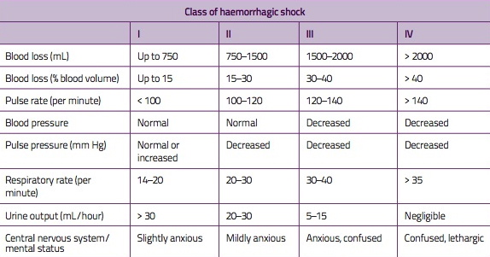

How is it possible to assess the amount of blood loss?
The shock index = Allgower’s index (SI = pulse rate/systolic BP) gives an indication of percentage blood loss:
SI < 1 blood loss < 25%
SI 1 - 1.5 blood loss 25 - 33%
SI 1.5 - 2 blood loss 33 - 50%
SI > 2 blood loss > 50%
Search for possible sources of blood loss:
(One on the floor and four more)
  - On the floor - history from paramedics
  - In the chest - heart, great vessels, or lung laceration : > 2 litres
  - ribs : 100 - 200 ml each
  - In the abdomen - aorta, inferior vena cava, liver or spleen : > 2 litres
  - In the pelvis - pelvic fractures : 1 - 3 litres
  - In the thighs - femur fractures : 1 - 2 litres
  - other long bones : 0.5 - 1 litre

Evaluation
The first step in managing hemorrhagic shock is recognition. Ideally, This should occur before the development of hypotension. Close attention should be paid to physiological responses to low-blood volume. Tachycardia, tachypnea, and narrowing pulse pressure may be the initial signs. Cool extremities and delayed capillary refill are signs of peripheral vasoconstriction.[8][9][10][11]
In the setting of trauma, an algorithmic approach via the primary and secondary surveys is suggested by ATLS. Physical exam and radiological evaluations can help localize sources of bleeding. A trauma ultrasound, or Focused Assessment with Sonography for Trauma (FAST), has been incorporated in many circumstances into the initial surveys. The specificity of a FAST scan has been reported above 99%, but a negative ultrasound does not rule out intra-abdominal pathology.

Treatment / Management
With a broader understanding of the pathophysiology of hemorrhagic shock, treatment in trauma has expanded from a simple massive transfusion method to a more comprehensive management strategy of “damage control resuscitation.” The concept of damage control resuscitation focuses on permissive hypotension, hemostatic resuscitation, and hemorrhage control to adequately treat the “lethal triad” of coagulopathy, acidosis, and hypothermia that occurs in trauma.[12][13][14][15]
Hypotensive resuscitation has been suggested for the hemorrhagic shock patient without head trauma. The aim is to achieve a systolic blood pressure of 90 mmHg in order maintain tissue perfusion without inducing re-bleeding from recently clotted vessels. Permissive hypotension is a means of restricting fluid administration until hemorrhage is controlled while accepting a short period of suboptimal end-organ perfusion. Studies regarding permissive hypotension have yielded conflicting results and must take into account type of injury (penetrating versus blunt), the likelihood of intracranial injury, the severity of the injury, as well as proximity to a trauma center and definitive hemorrhage control.
The quantity, type of fluids to be used, and endpoints of resuscitation remain topics of much study and debate. For crystalloid resuscitation, normal saline and lactated ringers are the most commonly used fluids. Normal saline has the drawback of causing a non-anion gap hyperchloremic metabolic acidosis due to the high chloride content, while lactated ringers can cause a metabolic alkalosis as lactate metabolism regenerates into bicarbonate.
Recent trends in damage control resuscitation focus on “hemostatic resuscitation” which pushes for early use of blood products rather than an abundance of crystalloids in order to minimalize the metabolic derangement, resuscitation-induced coagulopathy, and the hemodilution that occurs with crystalloid resuscitation. The end goal of resuscitation and the ratios of blood products remain at the center of much study and debate. A recent study has shown no significant difference in mortality at 24 hours or 30 days between ratios of 1:1:1 and 1:1:2 of plasma to platelets to packed RBCs. However, patients that received the more balanced ratio of 1:1:1 were less likely to die as a result of exsanguination in 24 hours and were more likely to achieve hemostasis Additionally, reduction in time to first plasma transfusion has shown a significant reduction in mortality in damage control resuscitation.
In addition to blood products, products that prevent the breakdown of fibrin in clots, or antifibrinolytics, have been studied for their utility in the treatment of hemorrhagic shock in the trauma patient. Several antifibrinolytics have been shown to be safe and effective in elective surgery. The CRASH-2 study was a randomized control trial of tranexamic acid versus placebo in trauma has been shown to decrease overall mortality when given in the first eight hours of injury. Follow-up analysis shows additional benefit to tranexamic acid when given in the first three hours after surgery.
Damage control resuscitation is to occur in conjunction with prompt intervention to control the source of bleeding. Strategies may differ depending on proximity to definitive treatment.

Differential Diagnosis
While hemorrhage is the most common cause of shock in the trauma patient, other causes of shock are to remain on the differential. Obstructive shock can occur in the setting of tension pneumothorax and cardiac tamponade. These etiologies should be uncovered in the primary survey. In the setting of head or neck trauma, an inadequate sympathetic response, or neurogenic shock, is a type of distributive shock that is caused by a decrease in peripheral vascular resistance. This is suggested by an inappropriately low heart rate in the setting of hypotension. Cardiac contusion and infarctions can result in cardiogenic shock. Finally, other causes should be considered that are not related to trauma or blood loss. In the undifferentiated patient with shock, septic shock and toxic causes are also on the differential.

Pearls and Other Issues
Trauma is the most common cause of hemorrhagic shock, but causes can span multiple systems.
Tachycardia is typically the first abnormal vital sign of hemorrhagic shock. As the body attempts to preserve oxygen delivery to the brain and heart, blood is shunted away from extremities and nonvital organs. This causes cold and modeled extremities with delayed capillary refill. This shunting ultimately leads to worsening acidosis.
The “lethal triad” of trauma is acidosis, hypothermia, and coagulopathy.
Trauma-induced coagulopathy can occur in the absence of the hemodilution of resuscitation.
Damage control resuscitation is based on three principles: permissive hypotension, hemostatic resuscitation, and damage control surgery. Permissive hypotension targets a systolic blood pressure of 90 mmHg accepting suboptimal perfusion to end organs for a limited time to achieve hemostasis.

Enhancing Healthcare Team Outcomes
There are many causes of shock and it is important to find the cause ASAP. Because shock carries a high morbidity and mortality, the condition is best managed by an interprofessional team that includes a trauma surgeon, emergency department physician, ICU nurses, general surgeon, internist and an intensivist.
With a broader understanding of the pathophysiology of hemorrhagic shock, treatment in trauma has expanded from a simple massive transfusion method to a more comprehensive management strategy of “damage control resuscitation.” The concept of damage control resuscitation focuses on permissive hypotension, hemostatic resuscitation, and hemorrhage control to adequately treat the “lethal triad” of coagulopathy, acidosis, and hypothermia that occurs in trauma.
The outcomes depend on the cause, patient age, associated comorbidity and patient response to treatment.[5][16]

References
1. https://www.ncbi.nlm.nih.gov/books/NBK470382/

Eastridge BJ, Holcomb JB, Shackelford S. Outcomes of traumatic hemorrhagic shock and the epidemiology of preventable death from injury. Transfusion. 2019 Apr;59(S2):1423-1428. [PubMed]
6.
Owattanapanich N, Chittawatanarat K, Benyakorn T, Sirikun J. Risks and benefits of hypotensive resuscitation in patients with traumatic hemorrhagic shock: a meta-analysis. Scand J Trauma Resusc Emerg Med. 2018 Dec 17;26(1):107. [PMC free article] [PubMed]
7.
Scerbo MH, Holcomb JB, Taub E, Gates K, Love JD, Wade CE, Cotton BA. The trauma center is too late: Major limb trauma without a pre-hospital tourniquet has increased death from hemorrhagic shock. J Trauma Acute Care Surg. 2017 Dec;83(6):1165-1172. [PubMed]
8.
Erdman MO, Chardavoyne P, Olympia RP. School Nurses on the Front Lines of Medicine: The Approach to a Student With Severe Traumatic Bleeding. NASN Sch Nurse. 2019 Sep;34(5):280-286. [PubMed]
9.
Nagata N, Ishii N, Manabe N, Tomizawa K, Urita Y, Funabiki T, Fujimori S, Kaise M. Guidelines for Colonic Diverticular Bleeding and Colonic Diverticulitis: Japan Gastroenterological Association. Digestion. 2019;99 Suppl 1:1-26. [PubMed]
10.
Butler FK, Holcomb JB, Shackelford S, Barbabella S, Bailey JA, Baker JB, Cap AP, Conklin CC, Cunningham CW, Davis M, DeLellis SM, Dorlac WC, DuBose JJ, Eastridge B, Fisher AD, Glasser JJ, Gurney J, Jenkins DA, Johannigman J, King DR, Kotwal RS, Littlejohn LF, Mabry RL, Martin MJ, Miles EA, Montgomery HR, Northern DM, O'Connor KC, Rasmussen TE, Riesberg JC, Spinella PC, Stockinger Z, Strandenes G, Via DK, Weber MA. Advanced Resuscitative Care in Tactical Combat Casualty Care: TCCC Guidelines Change 18-01:14 October 2018. J Spec Oper Med. 2018 Winter;18(4):37-55. [PubMed]
11.
Martel MJ. No. 115-Hemorrhagic Shock. J Obstet Gynaecol Can. 2018 Dec;40(12):e874-e882. [PubMed]
12.
Kowalski A, Brandis D. StatPearls [Internet]. StatPearls Publishing; Treasure Island (FL): Nov 12, 2019. Shock Resuscitation. [PubMed]
13.
Valentine SL, Bembea MM, Muszynski JA, Cholette JM, Doctor A, Spinella PC, Steiner ME, Tucci M, Hassan NE, Parker RI, Lacroix J, Argent A, Carson JL, Remy KE, Demaret P, Emeriaud G, Kneyber MCJ, Guzzetta N, Hall MW, Macrae D, Karam O, Russell RT, Stricker PA, Vogel AM, Tasker RC, Turgeon AF, Schwartz SM, Willems A, Josephson CD, Luban NLC, Lehmann LE, Stanworth SJ, Zantek ND, Bunchman TE, Cheifetz IM, Fortenberry JD, Delaney M, van de Watering L, Robinson KA, Malone S, Steffen KM, Bateman ST., Pediatric Critical Care Transfusion and Anemia Expertise Initiative (TAXI). Pediatric Critical Care Blood Research Network (BloodNet), and the Pediatric Acute Lung Injury and Sepsis Investigators (PALISI) Network. Consensus Recommendations for RBC Transfusion Practice in Critically Ill Children From the Pediatric Critical Care Transfusion and Anemia Expertise Initiative. Pediatr Crit Care Med. 2018 Sep;19(9):884-898. [PMC free article] [PubMed]
14.
Tang J, Shi Z, Hu J, Wu H, Yang C, Le G, Zhao J. Optimal sequence of surgical procedures for hemodynamically unstable patients with pelvic fracture: A network meta-analysis. Am J Emerg Med. 2019 Apr;37(4):571-578. [PubMed]
15.
Dickson JM, Wang X, St John AE, Lim EB, Stern SA, White NJ. Damage Control Resuscitation Supplemented with Vasopressin in a Severe Polytrauma Model with Traumatic Brain Injury and Uncontrolled Internal Hemorrhage. Mil Med. 2018 Sep 01;183(9-10):e460-e466. [PubMed]
16.
Hussmann B, Schoeneberg C, Jungbluth P, Heuer M, Lefering R, Maek T, Hildebrand F, Lendemans S, Pape HC. Enhanced prehospital volume therapy does not lead to improved outcomes in severely injured patients with severe traumatic brain injury. BMC Emerg Med. 2019 Jan 23;19(1):13. [PMC free article] [PubMed]

Appendix 1
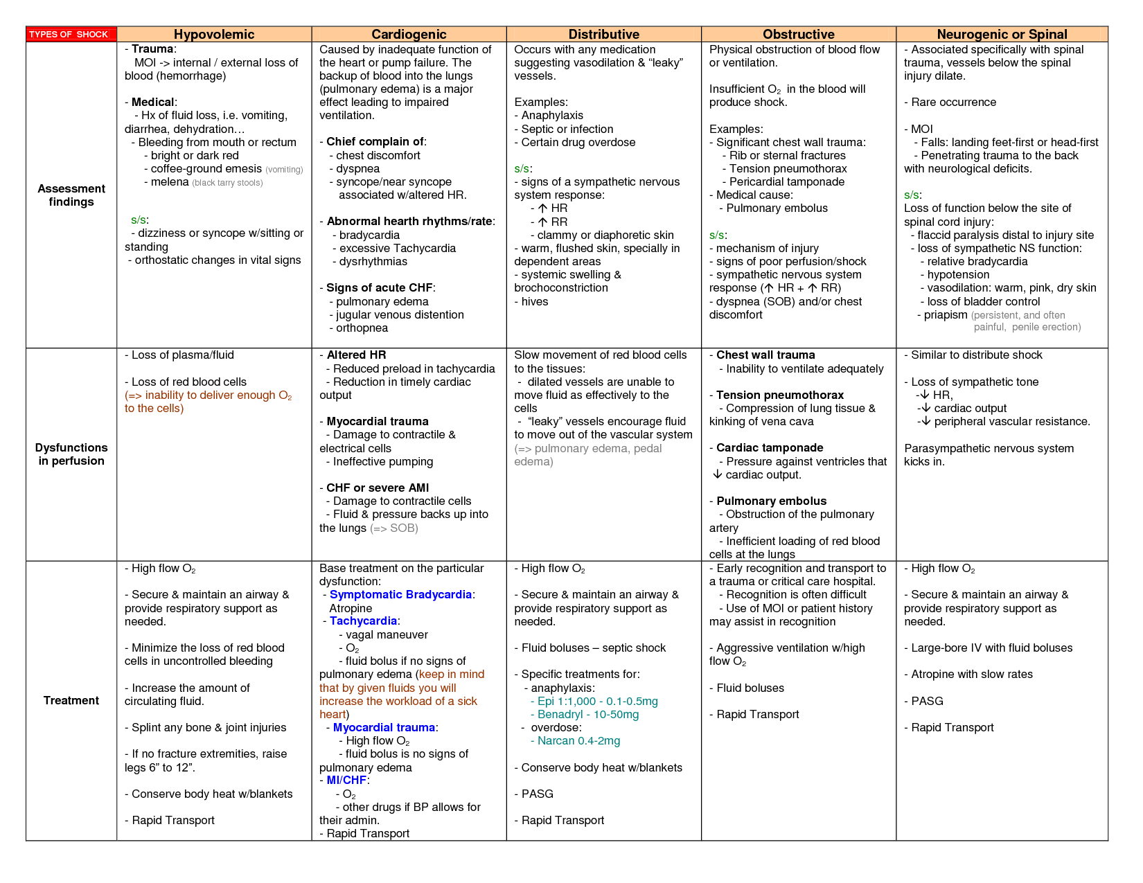

Appendix 2
