Vinnitsa National Pirogov Memorial Medical University

Course of Disaster Medicine and Life Safety

METHODIC ELABORATION
For the practical class’ stady
for the students of the second-year of study of the medical faculty and the 1th year of study of the pharmaceutical and dental faculty
on the discipline «Safety of life activity»

Theme 4: Valeology and sanology basics of providing safety of health and human life

Vinnytsa - 2015

Theme 4: Valeology and sanology basics of providing safety of health and human life

Health is a dynamic condition resulting from a body's constant adjustment and adaptation in response to stresses and changes in the enviroment for maintaining an inner equilibrium called homeostasis

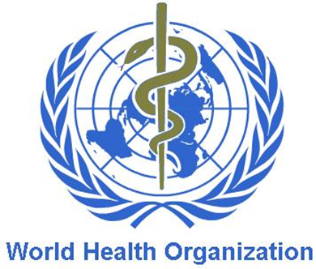
As defined by World Health Oganization (WHO), Health is a "State of complete physical, mental and social well being and not merely the absence of disease or infirmity.“

Public health
Health of the population: conditional statistical concept which is full enough characterized by a complex of medical parameters:
1. Demographic (birth rate, death rate, expected life duration)
2. Disease (general, infectious, hospital)
3. Physical progress (morpho-functional and biological progress, a harmony)
4. Physical inabilities (primary and general)
5. Pre-nosological condition (immunity, resistibility of systems, activity of enzymes)

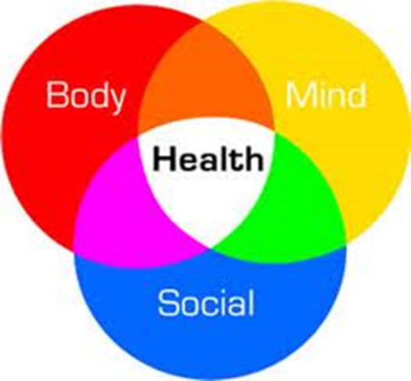
Healthy way of life
These are three unities:
Morale:
- clarity of mind,
- healthy mentality.
Harmony of a body:
- physical aspect.
Public health:
- social aspect.

Mental health - a condition of mental area of the person, described as a general mental comfort, providing adequate regulation of behaviour and dependent on biological and social needs.

Mental health is connected with specific aspect of lifestyle of the person.
Sociability, kindness, mutual aid and support of family members and friends create a positive microclimate, good mood that is necessary for work and its satisfactory results.

The physical health is a natural condition of an organism which depends on normal functioning of all its organs and systems.

Attributes of physical health are:
- stability to damaging factors;
- parameters of growth and progress within the limits of average norm;
- functional condition of an organism within the limits of average norm;
- availability of alternate possibilities of an organism;
- absence of any disease or defects of progress.

Social health is understood as a system of values, directives and motives of behaviour in social environment.
Social health is ability to communicate and socialize with other people.

A deviation from a normal condition or development is called Pathology.
Pathologies are processes of deviation, processes of breaking a homeostasis, illnesses, dysfunctions.
Pathology is a structural and functional manifestation of disease.
Pathologies is synonymous with diseases.
The word pathology is from ancient Greek πάθος, pathos, "feeling, suffering"; and -λογία, -logia, "the study of".

Valeology and sanology.
Definition, essence and matter of studying

Valeology (lat. valeo «to be healthy») — a science using the integrated approach to physical, moral and spiritual health of the person from the point of view of humanities, natural and public sciences.

Valeology for the first time presented the third direction of healthcare (except treatment and preventing of diseases) – monitoring and strengthening of health of the individual.

Primary goals of valeology
Development of theoretical concepts about essence of health.
Development of procedures of health assessment.
Teaching culture of health.
Using of natural means for strengthening health.
Restoration of harmonious attitude to the nature.

Sanology is the section of medicine studying mechanisms and processes of broken functions’ restoration - recovering from illness, traumas and other pathological conditions arising on public level.

Parameters of individual health of the person
Individual health reflects the health which is peculiar to the specific person and divided by eight groups of the basic parameters.
It is estimated by subjective and objective criteria.

Eight basic groups of individual health parameters

1. Genetic | Genotype, absence of disembryogenesis and hereditary defects
2. Biochemical | Parameters of biological fabrics and liquids
3. Metabolic | Level of a metabolism during rest and after duty
4. Morphological | Level of physical progress, type of constitutions morphotype)
5. Functional | Alternate possibilities, functional type
6. Psychological | emotional, cogitative, intellectual areas
7. Sociality-spiritual | Moral values, ideals, level of assertion
8. Clinical | Absence of illness

Subjective criteria concern to a self-assessment of current health of a person. They not always coincide with objective health of the person. State of health is a reflection of condition of many functions of internal organs.
Presence of painful sensations are signals of preillness or illness (headaches, the general weakness, dizziness, sensation of palpitation, a short wind, pains in muscles and other signs).

Objective criteria of a person’s health are expressed in such parameters which are not dependant on the will of the person, they can be detected by other person and they can be compared with the previous condition and with normal characteristics: anthropometry, dynamometry, frequency and rhythm of pulse and breath, body temperature, colour of skin, character of sweating, stability of attention, coordination of movements, etc.

To assess the cardiovascular system analysis of ECG, ultrasound, exercise test are applied.
Respiratory system is evaluated using different sets of breathing apparatus and gas analysis (spirograph).
Metabolism is assessed by complex biochemical methods, radioisotope diagnosis.
A tool to assess the mental and social health is various forms of surveys and questionnaire.

Risk factors for health
Risk factors of diseases are the factors increasing probability of occurrence of this or that disease.
According to experts of WHO, health of the person:
on 50 % - depends on a way of life,
on 20 % - from a heredity,
on 20 % - from a condition of an
environment,
on 10 % - from the contribution of
the state to healthcare

System of risk factors effecting health

Predictors | Group of risk factors | density (%)
Way of life | smoking, alcohol abuse, unbalanced diet, stress, bad working conditions, lack of exercise, poor material conditions, drug abuse, low cultural level. | 49-53
Genetics, biology | familial positivity | 18-22
External  environment | contamination by carcinogens and other harmful substances in the air, soil and water, abrupt changes of atmospheric phenomena. | 17-20
Health | ineffectiveness of preventive measures, poor quality and timeliness. | 8-10

By their nature risk factors are primary and secondary.
The category of the primary risk factors include those that normally lead to the development of the disease.
Secondary lead to complications of existing pathological conditions.

Data of WHO on the primary and secondary factors in high-risk health
Primary risk factors | Secondary risk factors
1. Smoking | 1. Diabetes
2. Alcohol abuse | 2. Hypertension
3. Poor nutrition | 3. Lipidemia, holisterinemiya
4. Lack of exercise | 4. Rheumatism
5. Psycho-emotional stress | 5. Allergies, immune deficiencies, etc.
There are two basic human activities – physical and mental work.

Mental work is an activity to transform reality formed by creating new concepts, conclusions and basing on them - hypotheses and theories.

The result of mental work is
scientific and mental values ​​or decisions.

Permanent neuro-psychological stress and chronic mental fatigue without physical discharge cause severe functional disturbances in the body, reducing the health and premature aging.
Movement is the essence of life. Movement is the foundation of health.
It is known that regular exercise reduces:
- the amount of cholesterol in the bloodstream, allowing the
development of atherosclerosis,
- improving oxygenation of the nerve cells of the brain, thus
increasing not only physical but also mental capacity.

Saving availability and good health is possible only with the right combination of mental and physical work, as well as outdoor activities and sleep.

Way of life is the main factor that determines human health.

The basic characteristics of life are:
- work (study),
- social, political and cultural activities of people,
- and various behavioral habits and appearance.

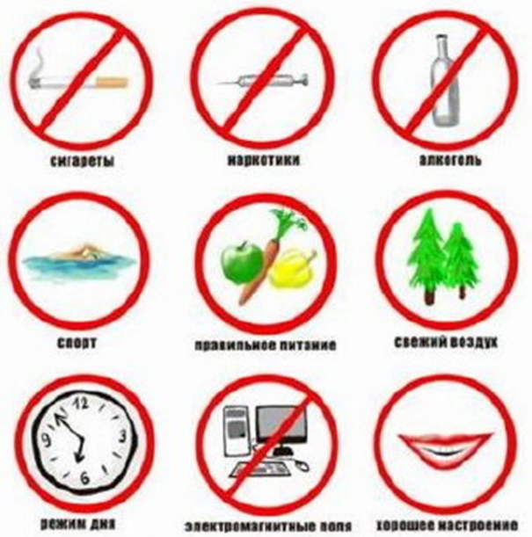
Healthy lifestyle is

- good nutrition,

- sports,

- living without alcohol
and smoking.

Structure of the healthy way of life
1. Strict control over your health
2. Optimal physical activity
3. Active work
4. Training of immunity
5. Balanced diet
6. Avoiding harmful habits
7. Hygienic behavior validity

Systems and methods of recreation
Recreation system is a system of knowledge and practical methodologies to ensure the formation of health.
Recreation system began to emerge from the birth of human civilization and naturally belong to the culture of humanity.

Modern ways of recreation
- improvement of spirituality
- physical improvement
- dreathing techniques and their use nutrition
- managing emotions
- management of thoughts
- bioenergetics

Known health systems can be divided into traditional and non-traditional
Non-traditional health systems:
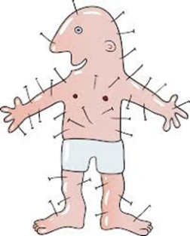
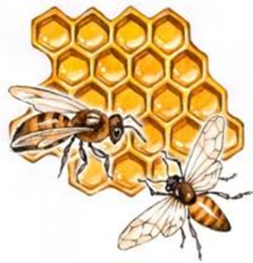
- aroma and light therapy,
- apitherapy,
- animaloterapiya,
- acupuncture,
- hardening,
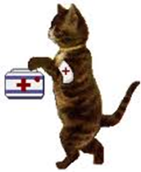
- homeopath,
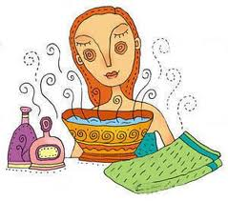
- yoga,
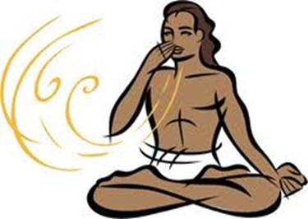
- massage.

