Topic 3: Medical, biological and psychological protection.
Disaster management can be defined as the body of policy and administrative decisions and operational activities which pertain to the various stages of a disaster at various levels.
Planning details.
Healthcare system preparedness is the ability of a community’s healthcare system to prepare, respond, and recover from incidents that have a public health and medical impact in the short and long term. The healthcare system role in community preparedness involves coordination with emergency management, public health, mental/behavioral health providers and community state, local, and territorial governments to do the following:
Provide and sustain a tiered, scalable, and flexible approach to attain needed disaster response and recovery capabilities while not jeopardizing services to individuals in the community
Provide timely monitoring and management of resources
Coordinate the allocation of emergency medical care resources
Provide timely and relevant information on the status of the incident and healthcare system to key stakeholders Healthcare system preparedness is achieved through a continuous cycle of planning, organizing and equipping, training, exercises, evaluations and corrective actions.
Disaster response plans describe how various governmental and private sector entities are supposed to function individually and collaboratively during a disaster in order to protect the public and key infrastructure and continue to perform their missions.
Hospitals, public health agencies and other health entities also have response plans specific for their missions.
Some plans are appropriate for all types of incidents: "all hazard" plans.
Some plans are hazard-specific e.g., chemical, biological, radiological, nuclear, natural disasters
Hazard-specific response plans typically contain the critical elements of "all hazard" plans but also include modifications that address hazard-specific features
Effective plans are:
Developed collaboratively by all potential participants.
Integrated into plans that will be used by others participating in the response.
Communicated to all those who will perform activities specified by the plan.
Practiced in formal drills or exercises.
Updated regularly to reflect lessons learned in formal exercises.
Public awareness and public education for disaster risk reduction
There is currently a strong emphasis on public awareness and public education for disaster risk reduction. This emphasis stems from four major areas of activity:
Public health This area emerged first, boldly demonstrating that human behaviour can be changed and diseases eradicated. The many examples of successful efforts where public education has brought about dramatic changes in human behaviour include: potable water, hydration, hand washing, road safety, waterborne and airborne diseases, medication compliance, smoking cessation, tuberculosis treatment and the wearing of seat belts.
Environmental stewardship has been promoted by activists working to highlight the impact of human activity on the environment. As a result, there is increasingly pro-social behavior, both at household and community level. Education has also influenced policy controls on hazardous materials, safe and renewable energy, recycling and water conservation.
Health protection of the population is part of a complex medical activities. It aims to predict on the basis of the hazards to human health to prevent or reduce an impressive impact of ionizing radiation, toxic substances and bacterial products through special preventive measures, such as special medicines , and anti-epidemic measures.
As demonstrated recently, even small groups of individuals have the ability to cause massive damage and extensive human suffering with little or no warning. Predictably, firefighters, police officers, EMS personnel, and civilian volunteers will respond and be on the scene moments after any attack occurs. For such events in the future, however, rescue and treatment of victims and control or containment of fire and other hazards will be greatly complicated by the fact that the site may also be contaminated with nuclear, chemical, biological or radiological substances that pose an immediate threat to the health and safety of the emergency responders. Also, the immediate impact of such attacks may reach much further than the scene of the disaster. Thousands of injured and potentially contaminated victims may depart the scene, returning to the suburbs and satellite cities where they reside, or privately seeking medical assistance. Emergency responders in metropolitan areas and far beyond will need to move quickly to deal with this predictable exodus from cities following any attack. This primer is an introduction to the types of weapons first responders may be exposed to in a terrorist attack. Responders need to be ready to deal with any possible situation quickly, efficiently and professionally. Knowledge of Chemical, Biological, Radiological, nuclear and Explosive weapons (CBRNE) is needed for every first responder.
CBRN are weaponized or non-weaponized Chemical, Biological, Radiological and Nuclear materials that can cause great harm and pose significant threats in the hands of terrorists. Weaponized materials can be delivered using conventional bombs (e.g., pipe bombs), improved explosive materials (e.g., fuel oil-fertilizer mixture) and enhanced blast weapons (e.g., dirty bombs). Non-weaponized materials are traditionally referred to as Dangerous Goods (DG) or Hazardous Materials (HAZMAT) and can include contaminated food, livestock and crops. What is a CBRN incident An accidental CBRN incident is an event caused by human error or natural or technological reasons, such as spills, accidental releases or leakages. These accidental incidents are usually referred to as DG or HAZMAT accidents. Outbreaks of infectious diseases, such as SARS, or pandemic influenza are examples of naturally occurring biological incidents. An intentional CBRN incident includes:
- criminal acts such as the deliberate dumping or release of hazardous materials to avoid regulatory requirements
- the malicious, but non-politically motivated poisoning of one or more individuals
- terrorist acts that involve serious violence to persons or property for a political, religious or ideological purpose and/or that are a matter of national interest The response to an intentional CBRN incident may be similar to an accidental CBRN incident; however, intentional CBRN incidents differ because there are unique implications relating to federal/provincial/territorial responsibilities, public safety, public confidence, national security and international relations.
CBRN incidents may include all or some of the following characteristics:
- potential for mass casualties
- potential for loss of life
- potential for long term effects
- creation of an extremely hazardous environment
- relative ease and cheapness of production
- initial ambiguity and/or delay in determining the type of material involved
- potential use of a combination of CBRN materials each presenting different response requirements
- narrow time frame in which to administer life saving interventions/treatments;
- need for immediate medical treatment for mass casualties
- need for immediately available specialized pharmaceuticals
- need for specialized detection equipment
- need for timely, efficient and effective mass decontamination systems 2
- need for organized, trained and equipped health service personnel to immediately augment local Fire-HAZMAT teams
- need for pre-coordination within health services to establish medical treatment protocols, to stock pharmaceuticals and to determine treatment requirements
- need to establish coordinated incident management/response procedures for such incidents;
- need to ensure early warning systems for hospitals
- need to establish early those who are affected and those at risk
- need for active case finding versus passive case finding
- need to work closely with Police on site and at health care facilities, as they perform their legal duties in relation to victim identification/registration and evidence gathering
- need for a pro-active media policy to ensure the community is informed and thus its anxiety allayed.
Countermeasures include:
- Technical equipment such as respirators that can detect chemical agents and masks that prevent exposure
- Medical therapy and, for some agents, prophylaxis
- Organizational strategies, such as specially developed intelligence systems, standard operating procedures, and training
- Instruments of international law.
Basic training, rules of protection and skills in first aid
Barrier protection, reducing the time of exposure and distancing yourself from the hazard are the keys to survival for all first responders.
The best available barrier should be put between you and the nuclear, chemical, or biological agent. The only way to protect yourself is to keep the hazard from entering or coming in contact with your body. For most situations, your eyes and all of your skin must be covered quickly before you become contaminated, and you must adequately filter the air you breath
Reduce the time you are exposed to the agent as much as possible. If you are not properly trained and equipped to deal with a hazardous substance, you should not be in a contaminated area.
If you are caught without a mask or other protective equipment, move out of the contamination as quickly as possible, using any expedient means of creating a barrier between yourself and the hazard.
Layers of clothing, rain slickers, hats, ski goggles, wet towels or handkerchiefs over the face may help.
Get away quickly and decontaminate immediately.
Special medicines:
Radioprotective agents -the substances which can reduce mortality when administered to organism prior to exposure to a lethal dose of radiation. This chemicals can reduce the effects of radiation on tissues. Radioprotective agents have been divided into four major groups: the thiol compounds, other sulfur compounds, pharmacological agents (anesthetic drugs, analgesics, tranquilizers, etc.) and other radioprotective agents.
An antidoteis a substance which can counteract a form of poisoning. The term ultimately derives from the Greek αντιδιδοναι- "given against".
Antibacterial agents (antibiotics, vaccines, serums, etc.)
The use of personal health protection prevents damage of a person, decrease the influence of certain factors. For example, personal hygiene and using of antibacterial drugs (antibiotics, vaccines, etc.) protect against infectious diseases.
In time imposed sterile dressing on the wound or burn - not only medical care but also means of preventing complications.
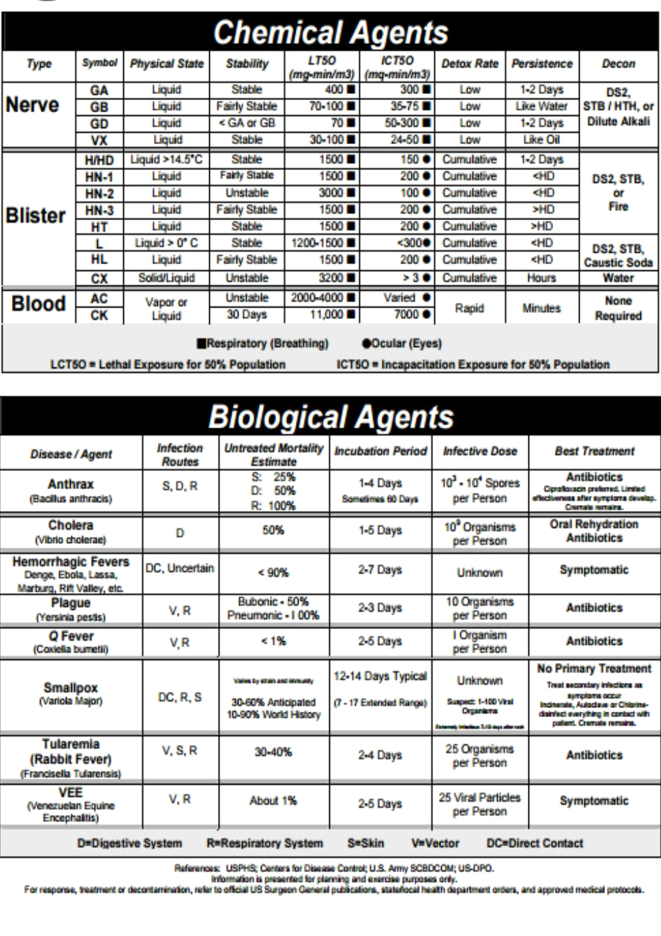

Biological weapons
Biological weapons are weapons that achieve their intended effects by infecting people with disease-causing microorganisms and other replicative entities, including viruses, infectious nucleic acids and prions. The chief characteristic of biological agents is their ability to multiply in a host over time. The disease they may cause is the result of the interaction between the biological agent, the host (including the host’s genetic constitution, nutritional status and the immunological status of the host’s population) and the environment (e.g., sanitation, temperature, water quality, population density). Biological agents are commonly classified according to their taxonomy (e.g., fungi, bacteria, viruses). This classification is important because of its implications for detection, identification, prophylaxis and treatment. Biological agents can also be characterized by other features, such as infectivity, virulence, lethality, pathogenicity, incubation period, contagiousness and mechanisms of transmission, and stability - all of which affect their potential to be used as weapons.
• The infectivity of an agent is its capability to enter, survive and multiply in a host, and may be expressed as the proportion of persons exposed to a given dose who become infected.
• Virulence is the relative severity of the disease caused by a microorganism (i.e., the ratio of clinical cases to the number of infected hosts). Different strains of the same microorganism may cause diseases of different severity. For example, infection due to Brucellamelitensis is usually more severe than infection due to B. suis or to B. abortus.
• Lethality is the ability of an agent to cause death in an infected population. The case-fatality rate (i.e., the proportion of patients clinically recognized as having a specified disease who die as a result of that illness within a specified time) provides useful information on the clinical management of cases.
• Pathogenicity is the capacity of a microorganism to cause disease, and is measured by the ratio of the number of clinical cases to the number of exposed persons.
• The incubation period is the time between exposure to an infective agent and the first appearance of the signs and symptoms of disease. The incubation period can be affected by many variables, such as the initial dose, virulence, route of entry, rate of replication, and the immunological status of the host. • For those infections that are contagious, a measure of their contagiousness is the number of secondary cases following exposure to a primary case in relation to the total number of exposed susceptible secondary contacts. The mechanisms of transmission involved may be direct (i.e., direct contact between an infected and an uninfected person) or indirect. (i.e., through inanimate material that has become contaminated with the agent, such as soil, blood, bedding, clothes, surgical instruments, water, food or milk). Infections may also be through airborne droplets (i.e., through coughing or sneezing) or through vectors, such as biting insects. The distinction between types of transmission is important in selecting control measures. For example, direct transmission can be interrupted by appropriate handling of infected persons, while interrupting indirect transmission requires other approaches, such as adequate ventilation, chlorination of water, or vector control. • Stability is the ability of the agent to survive the influence of environmental factors such as air pollution, sunlight and extreme temperatures or humidity.
Features of Biological Attack (lesion of bacteriological weapons)
Epidemiological features
Rapidly increasing disease incidence (over hours or days) in a normally healthy population Unusual increase in people seeking care, especially with fever, respiratory, or gastrointestinal complaints Endemic disease rapidly emerging at an unusual time or in an unusual pattern Large numbers of patients with rapidly fatal illness (agent dependent) Patients with a relatively uncommon disease that has bioterrorism potential (e.g., pulmonary anthrax, tularemia, plague).
Animal indicators
Sick or dying animals or fish Unusual swarms of insects
Devices
Suspicious devices or packages

Quarantine after an Biological Weapons Attack
Recommendations for containing infection:
- Employing preemptive rather than response measures
- Imposing voluntary quarantine, backed bystress-reducing information supplied by modern electronic communication systems
- Ensuring close international cooperation to implement strategic contingency plans, exchange information freely, and recognize procedures
On 5 November 2003 the Washington Post reported that the World Health Organization had been found unprepared to deal with such an emergency and that more than 100 nations lacked the surveillance capabilities to detect an outbreak of this kind. Countries attempting to address this issue have their own national protocols that might conflict with those of the others and could therefore block or interfere with the success of an international global response in the case of a global emergency. Useful lessons were learned from an exercise code named ``Global Mercury'' that took place in September 2003. It comprised a simulated bioterrorist attack in which a group of ``terrorists'' deliberately infected themselves with smallpox and then traveled to various countries to spread the infection, via their own bodies, on public transport systems and at car shows, and by distributing contaminated business cards. The countries that participated in the exercise were the United States, Britain, France, Germany, Canada, Italy, Japan and Mexico. The conclusions and recommendations of that experiment were that it would be cheaper to build a global network capable of spotting and containing outbreaks at the place and time of inception than to react after they had already spread.
The emergence of SARS during 2003 served as an excellent demonstration of some of the problems associated with containment and control of a highly infectious agent on both the national and international levels. The same principles also apply to smallpox, plague, hemorrhagic viruses, and other highly infectious agents. There can be no doubt whatsoever that containment of an emergency such as the outbreak of an infectious disease - an epidemic - entails the implementation, both nationally and internationally, of a strategic contingency plan.
The provision of facilities for hospitalization and isolation of patients in controlled low pressure rooms is highly recommended. The same applies to the preparation of regional backup medical and nursing teams, as well as suitable backup medical equipment for mechanical ventilation, medicine, and vaccine facilities, etc. This would, of course, be particularly useful in cases of regional or countrywide quarantine. Close cooperation on the national level between the various bodies in the healthcare system are essential: namely, Primary Care, Hospitals, Public Health, and First Responders. This should include timely dissemination of information and guidelines to the public health and healthcare communities as well as to the general public. It should also include training and drilling of all the elements within the healthcare system and the interfacing units outside it.
Containing an epidemic outbreak effectively entails having the capability to carry out a rapid, efficient wide-scale epidemiologic investigation. This includes monitoring patients and their contacts as well as surveillance of patients with suspicious symptoms. Having reliable and comprehensive databases with as near as possible real-time reporting is also crucial. Effective containment of such an emergency is equally dependent on professional management of the incident on the national and regional levels.
Containment by quarantine.
The sudden appearance and spread of an infectious disease poses dilemmas, uncertainties and innumerable difficulties. Quarantine is an effective measure for containing an outbreak. When performed on a voluntary basis and with respect for human dignity, it could be optimally effective, especially if sufficient security margins such as areas suspected of being afflicted are also included. It would not be amiss to say that voluntary quarantine is a primary requisite at times like these, for if it were decided to impose a quarantine it would hardly be possible to keep that decision secret in any country with free and totally involved media. Such a leakage of information could lead to mass flights of people from the afflicted area to avoid confinement under quarantine, thereby facilitating in turn further transmission of the disease. It is doubtful whether it would be possible to impose a quarantine on an entire country or to oblige any country to declare a total quarantine. Enforcing a non-voluntary quarantine might very well be impracticable, especially during the initial stages when the level of panic is at its highest.
Today, Internet and cellular communication infrastructures could serve as very good additional means for containing an infectious outbreak. Timely and reliable dissemination of guidelines as well as instructions sent by Internet and Intranet both to medical teams and to the general public could be extremely helpful in increasing the chances of containment. Coordinating the preparedness and activities of all the bodies within the healthcare system and of those connected to it from the outside would serve to control and monitor an outbreak, disseminate information, and reduce the incidence of panic, thereby bolstering the public's confidence in the professional organizations. Cellular communication and Internet chats could also, by means of quasi-virtual family reunion processes, somewhat decrease the distress that quarantine might engender.
International cooperation, exchange of information and experience, recognition of procedures, preparedness and planning of strategies should be the order of the day in every country. These steps could make an immense contribution towards raising the global level of response to the major challenge of an international biological weapons attack.
Psychological Preparedness for Disaster.
When disaster strikes, individuals and organizations must not be only logistically ready, but psychologically prepared. Public and emergency responders can better prepare for the psychological impact of disaster. Disaster research studies find that accounting for the misperceptions and the psychological aspect of disaster is vital for an effective response and recovery. Implementing this strategies may limit the psychological impact of disaster.
How does one psychologically prepare for disaster? Experts in the field of crisis management have proposed various strategies to help the public better prepare for the psychological consequences of disaster.
These strategies are intended to enhance resilience and limit the psychological impact of disaster. However, they are not always incorporated into disaster response initiatives. This impact needs to be factored into emergency plans. Preparing for and mitigating the emotional effects of disaster may be approached in the following way. First, it is important that emergency planners understand that the reactions to a terrorist attack and natural disaster may differ.
Acknowledging these differences and understanding why they exist will allow planners to form realistic expectations about the responses and recovery period of affected individuals and organizations. Second, emergency planners can addressthe common myths and misperceptions of disaster response behavior; this will promote active participation in psychological preparedness activities.
Third, rescue and relief workers can be trained to recognize the early psychological responses to disaster; this will help both the public and responders deal with the immediate trauma of an event, and may help to minimize the long-term effects.
Finally, emergency responders and health professionals can use disaster intervention strategies to mitigate the psychological effects of disaster; this will facilitate the recovery of the public and first responders.
For psychological preparedness strategies to be effective there must be better use of mental health resources and improved lines of communication between the public and private sectors.
People form personal definitions about risk based on what they hear, understand, believe, and personalize. This information is then used to make decisions about what actions to take. Therefore, it is important that emergency planners understand and address these perceptions and other common disaster myths. However, many people comfortably believe that disasters are events that happen to others. When people are in denial of certain threats, they can become complacent and less likely to prepare. It is essential that these perceptions be eliminated, “since it is not if, but when” a disaster will occur. Psychological preparedness as a disaster management strategy can only be effective with the public’s support and participation.
What types of behaviors can be expected in a disaster situation? It is a common belief that survivors will flee in panic, be incapacitated by fear, or be too disoriented to know what to do—this is not always the case. Misinformation can cause false expectations about what to expect during a disaster and put a strain on response efforts. The next section explores common myths and misperceptions of disaster response behavior, and how they could be addressed by emergency planners.
Panic Flight
Panic flight refers to the belief that people will panic and be have irrationally in a disaster situation. While this is often the scene in Hollywood films, in reality, it is not very common. Panic flight behaviors only occur during extraordinary disaster situations, such as evidenced on 9/11 when people trapped in the World Trade Center towers jumped out of windows to their deaths in a desperate attempt to escape. Panic behaviors are not the norm for most disaster situations.
Disaster Shock
It is often believed that during a disaster, people will be too dazed and disoriented to function or know what to do. Due to this misperception, victims are thought to be in need of direction. However, it is quite common for disaster victims to guide themselves and others to safety. Disaster response studies show that survivors are often active in assisting the injured, assessing damages, and initiating search and recovery efforts before emergency workers arrive and takeover.
DISASTER INTERVENTION STRATEGIES
Preparing for the psychological consequences of terrorism and other disasters includes emphasizing and developing new coping skills in individuals and in the community. The best strategy for limiting the responses to traumatic events is to implement preventive disaster-intervention strategies. Preventive approaches are effective because they can enhance resilience or prevent the responses caused by traumatic events. The three phases of preventive care that provide the blue-print for disaster care delivery include primary prevention, secondary prevention, and tertiary prevention. (Rosenfeld et al., 2005) Figure 3 illustrates how the stages of disaster correspond to the phases of preventive care. This section will discuss how these preventive intervention strategies can be employed during the pre-event, event, and post-event stages of a disaster.
Preventive measures.
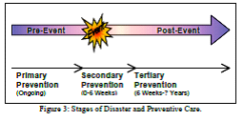
During the pre-event stage, there is a focus on primary preventive care. Primary care involves cognitive and organizational preparation for a traumatic event, the promotion of mental health, and risk mitigation. Primary prevention strategies include the following:
• Training in psychological first aid Psychological first aid (PFA) training provides people with skills they can use to help limit the psychological consequences of a traumatic event. PFA training comprises the basics of arousal, behavior, and cognition. This training includes learning about the normal psychological responses to disaster, and provides instruction in how to comfort, reassure, and communicate with survivors. (IOM, 2003) The coping skills learned through PFA training may especially benefit first responders, given that they can be required to perform for 48 hours without outside assistance, and may be more susceptible to job burnout. (Bullock et al., 2005; Kahn, 2005) What is more, PFA training can help individuals cope with the stresses of everyday life, or smaller-scale acts of violence. As a national strategy or community program, PFA can be used to help enhance resiliency and as a vehicle for promoting mental health. It would be beneficial for all relevant health care professionals to receive training in disaster mental health.
• Psychological immunization Psychological immunization or “stress inoculation,” refers to interventions that minimize the psychological impact of an impending trauma. (Rosenfeld et al., 2005) The process involves exposure to powerful stressors that arouse the psychological defenses. This form of primary prevention not only simulates traumatic events, but also invokes the “physical, cognitive, and emotional responses” that often accompany them; this process is conducted in times of normal stress, so as to avoid causing actual psychological harm.
Learning to successfully cope with manageable levels of stress helps build the resistance, or “psychological antibodies” needed to enhance resilience and psychological readiness for disasters. Psychological immunization can take the form of functional simulations such as drills; full scale simulations which simulate a real-life situation, including simulated victims; and even virtual reality simulations that use a head-mounted display (HMD). Virtual reality simulations, such as ones that use HMDs, make it possible for the user to experience a multitude of disaster scenarios and environments, without the limits of space, physical resources, and the financial cost of running a full-scale simulation.
• Preparing adaptive employee family crisis plans Employees can focus on business operations and disaster response during an event only when they are assured of the safety and wellbeing of their family and loved ones. (Chandler, 2004) Organizations can address these concerns in their emergency plans by requiring that employees create a family crisis plan that can adapt to changes in a situation. Having a plan can help reduce the stress and confusion of employees and their families during a disaster, and facilitate disaster response.
• Integrating mental health into public health planning To ensure that the public health infrastructure is better able to address the psychological trauma caused by disaster, there must be an integration of mental health issues into public health planning. This process involves integrating prevention, health care, and promotional needs, into national, state, and local emergency plans. Figure 5 is a model for integration, which indicates areas in which the mental health and public health community may collaborate; they include community health monitoring, health screening and behavioral health intervention, disaster response training (e.g., PFA and simulations), policy development, public health education, and disaster communication. Furthermore, the model includes research activities as a central aspect of health assessment, response assurance, and policy development. These actions can strengthen the public health infrastructure in its capacity to respond to the psychological impact of disaster.
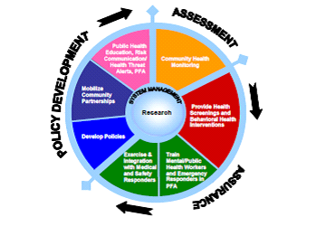
Preparing information materials for the public and media.
It is important that the public feel they are an active participant in preparedness. This can be done by providing the public with basic preparedness information on what to expect and actions they can take to protect themselves in the event of a disaster. Moreover, explanations as to why these strategies were chosen should also be included. Preparedness information can be made available on websites; in newspapers; and through television reports and advertisements, radio announcements, and information hotlines. Furthermore, emergency planners can prepare information materials for the media, as they are an effective vehicle for disseminating information to the public.
During the event stage (also known as the response stage), there is a focus on secondary preventive care. Secondary care occurs during and immediately after a disaster, and involves implementing the planning strategies discussed for the previous stage. The first six weeks following a disaster are critical for secondary preventive intervention. (Rosenfeld et al., 2005) Secondary prevention strategies include the following:
• Triage The triage process links those who are distressed or “demonstrate a disturbed mental state, cognitive impairment, or behavioral disturbance” to emergency or mental health care professionals. Individuals receive supportive counseling, reassurance, or specific treatment to alleviate and limit the psychological impact of the traumatic event.
• Implementing psychological first aid. During this stage, the affected population uses the PFA skills learned and information provided during the pre-event stage. PFA can be implemented by those directly affected by the disaster and other disaster affected individuals.
• Distributing appropriate information. The public is provided with information that will facilitate their immediate safety and ease feelings of frustration and helplessness. (IOM, 2003) Informational materials may contain information such as evacuation route maps and steps to help contain agents. The media can disseminate this information on the radio, television, internet, and by way of cell phone textmessages; this could be done in cooperation with cellular service providers. Furthermore, this information should communicate risk, proposed response, and most importantly, be actionable; this will help survivors recover a sense of control following the event.
During the post-event stage (also known as the recovery stage), there is a focus on tertiary preventive care. The aims of tertiary prevention are to minimize the emotional suffering and enhance better long-range coping. (Rosenfeld, 2005) Tertiary prevention strategies include the following:
Post-event interventions for the community include promoting family and community cohesion and support, being familiar with the warning signs that indicate a person needs help, limiting secondary exposure by avoiding images of the attack or disaster, and emphasizing the positive. These strategies limit the psychological impact of disaster, help survivors recover faster, and boost resilience.
The employee assistance programs offer counselors to employees and first responders to help “address workplace fears”. This programs include the involvement of priests, rabbis, and psychologists in the community. They are able to debrief and counsel disaster survivors, and help them to cope with bereavement over the long term.
When disaster strikes, individuals, companies, and responders should not only be logistically ready, but psychologically prepared. How well one psychologically prepares for an event can have a bearing on the success of response and recovery efforts. Therefore, it is vital that psychological preparedness be factored into emergency plans. The strategies that have been provided can make the public and responders more resilient in the face of everyday crises, and better able to deal with the psychological impact of disaster. In addition, the misperceptions of disaster have to be countered by educating the public on the facts of disaster. By clearing up these misperceptions, individuals can make informed decisions in the event of a disaster. This in turn will facilitate evacuation and response. Moreover, emergency response organizations should consider training rescue and relief health workers. This training can benefit disaster survivors and responders by helping them to cope with the immediate psychological effects, and to get them into the mental and public health system if needed. An early response of this type may also mitigate the long-term psychological effects of a disaster. Finally, it is important that emergency planners include the mental health issues in the planning process. This requires better coordination of public health agencies and services, and increased funding of public healthcare programs that address mental health needs. Increased communication between researchers and emergency response and relief workers will give researchers the opportunity share new findings with practitioners, and for practitioners to relate field experience and provide new directions for further research. Implementing these actions will help prepare individuals, organizations, and responders psychologically for disaster.

Personal Protective Equipment (PPE)
Personal protective equipment, or PPE, is designed to provide protection from serious injuries or illnesses resulting from contact with chemical, radiological, physical, electrical, mechanical, or other hazards. Careful selection and use of adequate PPE should protect individuals involved in chemical emergencies from hazards effecting the respiratory system, skin, eyes, face, hands, feet, head, body, and hearing. No single combination of protective equipment and clothing is capable of protecting against all hazards. Thus PPE should be used in conjunction with other protective methods, including exposure control procedures and equipment.
Classification of PPE
Byselection PPE:
- For First Responder
- For Hospital Providers
By the Levels of PPE
Personal protective equipment is divided into four categories based on the degree of protection afforded.
- Level A protection should be worn when the highest level of respiratory, skin, eye and mucous membrane protection is needed. A typical Level A ensemble includes:
Positive pressure (pressure demand), self contained breathing apparatus (SCBA) (NIOSH approved), or positive-pressure supplied air respirator with escape SCBA.
Fully encapsulating chemical protective suit.
Gloves, inner, chemical resistant.
Gloves, outer, chemical resistant.
Boots, chemical resistant, steel toe and shank; (depending on suit boot construction, worn over or under suit boot.)
- Level B protection should be selected when the highest level of respiratory protection is needed, but a lesser level of skin and eye protection is needed.
Level B protection is the minimum level recommended on initial site entries until the hazards have been further identified and defined by monitoring, sampling, and other reliable methods of analysis, and equipment corresponding with those findings utilized. A typical Level B ensemble includes:
Positive-pressure (pressure-demand), self-contained breathing apparatus, or positive-pressure supplied air respirator with escape SCBA.
Chemical resistant clothing (overalls and long-sleeved jacket, coveralls, hooded two-piece chemical splash suit, disposable chemical resistant coveralls.)
Gloves, outer, chemical resistant.
Gloves, inner, chemical resistant.
Boots, outer, chemical resistant, steel toe and shank.
- Level C protection should be selected when the type of airborne substance is known, concentration measured, criteria for using air-purifying respirators met, and skin and eye exposure is unlikely. Periodic monitoring of the air must be performed. A typical Level C ensemble includes:
Full-face or half-mask, air-purifying respirator (NIOSH approved).
Chemical resistant clothing (one piece coverall, hooded two piece chemical splash suit, chemical resistant hood and apron, disposable chemical resistant coveralls.)
Gloves, outer, chemical resistant.
Gloves, inner, chemical resistant.
Boots, steel toe and shank, chemical resistant.
- Level D protection is primarily a work uniform and is used for nuisance contamination only. It requires only coveralls and safety shoes/boots. Other PPE is based upon the situation (types of gloves, etc.). It should not be worn on any site where respiratory or skin hazards exist.
Types of Protection
There are many types of protective equipment, each with specific applications and use requirements. Information on common elements of the PPE ensemble include:
- Respiratory
Responders should use appropriate respirators to protect against adverse health effects caused by breathing contaminated air.
- Eye & Face
Eye and face protection should protect responders from the hazards of flying fragments, hot sparks, and chemical splashes.

- Skin
Skin protection should be used when responders may be exposed to harmful substances.
- Noise
Earplugs or earmuffs can help prevent damage to hearing. Exposure to high noise levels can cause irreversible hearing loss or impairment as well as physical and psychological stress.
Respiratory Protective Equipment
Respiratory Protective Equipment (RPE) not worn or selected appropriately is totally ineffective and may give the user a false sense of protection.
Respiratory Protective Equipment (RPE) is a particular type of Personal Protective Equipment (PPE), used to protect the individual wearer against inhalation of hazardous substances in the workplace air. RPE should only be used where adequate control of exposure cannot be achieved by other means, in other words, as a last resort on the hierarchy of control measures. Employers are required to firstly attempt to eliminate the hazard at source. RPE should only be used after all other reasonably practicable control measures have been taken. PPE is considered a last resort because it only protects individual workers, is prone to failure or misuse, such as wearing the wrong RPE for the job, and employees wearing RPE may get a false sense of security when using RPE.
A range of different types exist, dust masks, half mask respirators, full face mask respirators and powered (fan assisted) respirators. These use filters to remove the contaminants in the workplace air. In a negative pressure device one or more air purifying filters are attached via an inhalation valve to a tight fitting face piece. The negative pressure relative to the ambient air outside the respirator is created by inhalation of air, drawing the contaminated air through the purifying filter.
Breathing Apparatus (BA) types (positive respirators) A range of different types exist, fresh air hose, airline, and demand valve; use an independent supply of breathing quality air, for example an air cylinder or compressor. Powered air purifying respirators, supplied air and self containing breathing apparatus are all positive pressure devices. The pressure on the inside of the respiratory inlet exceeds the ambient air pressure outside the respirator. As a general rule, positive pressure devices are used for more hazardous exposures. Surgical masks are not considered RPE. Nuisance dust masks are excluded from this guidance.
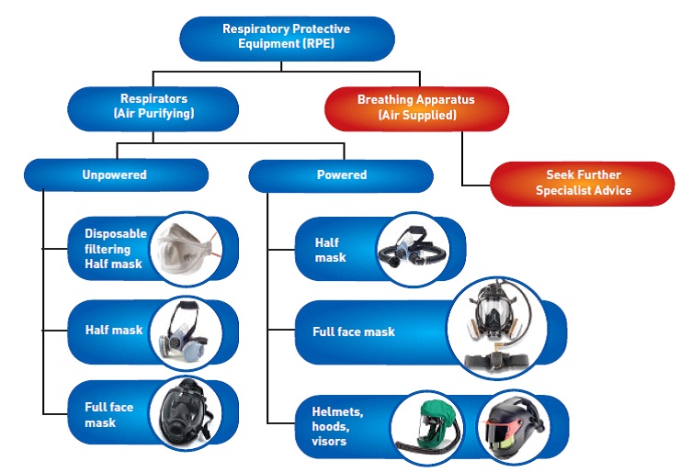

There are 3 main filter types:
- Particle filter
- Gas/vapour filter
- Combined filters (for particles, gases & vapours)
Checks should be undertaken prior to use of the RPE to ensure it has not been damaged or deteriorated since the last use. Certain physical checks can be carried out by the employee using the RPE such as:
• Are there any signs of wear and tear or damage?
• Are the all the components within expiry dates?
• Are valves and seals fully intact if present?
• Ensure the RPE works properly by performing a fit check, the RPE manufacturer should provide instructions on how to carry out a pre-use fit check of the face piece. If any problems are found, these should be reported to the employer.
Skin Protective Equipment
The selection of appropriate protective gear is based on the hazards anticipated or recognized. Complete protection calls for assembling a set of gear including respirator, hardhat, safety glasses or face shield (preferably both), body covering (coveralls, pants and jacket), gloves and safety boots/shoes (steel toe and shank). Omitting one item may compromise the individual's safety. Some pieces of protective equipment, such as hardhats and boots, have specific standards for manufacture and only those items meeting these standards should be used. However, there are no such standards for chemical protective clothing.
Head Protection Manufacturers have adapted hardhats so that ear protection and face shields may be easily attached. Hardhats are adjustable so a liner can be worn during cold weather. A chin strap is advantageous when work involves bending and ducking. It also helps secure the hardhat to the head when full-face masks are worn. Face shields that attach to hardhats provide added protection. A combination that leaves no gap between the shield and the brim of the cap is best because it prevents overhead splashes from running down inside the face shield.
Eye Protection They should be standard safety gear when the respiratory protection is a half-face mask with no faceshield. Both safety glasses/goggles and a faceshield are advisable as long as they do not impair visibility. Safety glasses should be worn whenever physical hazards exist and/or where they are required by the site plan governing the area in which ER Staff are working. Safety glasses should be worn where there is a chance of flying objects or where splash hazards exist.
Foot Protection. The material used to make the boots is not subject to any standards. Protection against liquid hazardous chemicals requires a boot of neoprene, butyl rubber, or some other chemical resistant material. Boots are available in two styles: pullover and shoeboot. Pullovers may be inexpensive enough to be considered disposable; otherwise they must be completely decontaminated. With chemical resistant boots, the pant leg should be outside and over the boots to prevent liquids from entering.
Hand Protection The hands are as susceptible to contamination as the feet. Gloves must resist puncturing and tearing as well as provide the necessary chemical resistance. The gloves provide a better holding surface while working but do not protect the worker from chemical exposure. If they become contaminated, they should be discarded because leather and cotton are difficult to decontaminate.
Jacket cuffs should be worn over glove cuffs to prevent any liquid from spilling into the gloves.
Body Protection Clothing to protect the body against hazardous liquids, gases, or vapors is available in a variety of styles and materials. If the hazard present is known to be minor or simply a nuisance, minimal protection is warranted. A splash suit made of PVC is suitable for a liquid such as an acid or base or when there will be minimal contact with organic materials. Some are inexpensive enough to be disposable. The suit must not allow any penetration or permeation. Zippers must be properly sealed and seams properly connected and sealed to protect against vapors. Fully encapsulating suits also require the basic safety items such as safety boots and hardhat, along with a source of breathing air.
Orange safety vest. It is to be used in situations where visibility is necessary.
Cloth coveralls. They have an open weave that allows particles, liquids and vapors to pass through easily. Cloth coveralls are useful only to protect street clothes from getting soiled and are not to be used as protection against exposure to hazardous material.
Chemical splash suits. They can be selected according to the hazard.
Once a contaminant contacts a protective material, the garment must be decontaminated. With many materials, it is impossible to completely remove all contamination. In some situations disposable clothing may be advantageous.
When considering strategies for preparedness against CBRN incidents, the possibility of a low probability catastrophic outcome must be weighed against public health hazards of higher probability but smaller magnitude. It would be irresponsible to be complacent about the possible effects of deliberately released biological or chemical agents, but it would also be prudent to not overestimate them. Given the emotional shock of an alleged biological or chemical threat, jurisdictions must at least consider how to address such dangers, should they occur, as part of preparing for threats to public health and well-being.

