Theme № 2: Defence of the population in the extraordinary situations
Civil defense, civil defence or civil protection is an effort to protect the citizens of a state (generally non-combatants) from military attackor emergency situations, desasters. It uses the principles of emergency operations: prevention, mitigation, preparation, response, or emergency evacuation and recovery.
An emergency population warning is a method whereby local, regional, or national authorities can contact members of the public en masse to warn them of an impending emergency. These warnings may be necessary for a number of reasons, including:
- weather emergencies such as tornadoes, hurricanes, and ice storms;
- geological disasters such as earthquakes, landslides, volcanic eruptions, and tsunamis;
- industrial disasters such as the release of toxic gas or contamination of river water;
- radiological disasters such as a nuclear plant disaster;
- medical emergencies such as an outbreak of a fast-moving infectious disease; and
- warfare or acts of terrorism.
Many local areas use emergency population warnings to advise of prison escapes, abducted children, emergency telephone number outages, and other events.
Be prepared
For many events you need to be prepared at all times, as there is no warning. For some, there is a possibility of advanced warning, allowing you time to take precautionary action. Should you become aware of an emergency, make sure your neighbours and family are also aware.
Rain, wind and snow
The Metservice issues severe weather warnings when it predicts the weather is likely to pose a risk. Radio and television stations usually advise when severe weather warnings have been issued, or you can subscribe to receive warnings at no cost through the Metservice website.
Flooding
If it has been raining for an extended period of time, monitor your drains and local waterways for signs of flooding. Monitoring the rainfall and flow in major waterways can be done by checking the Otago Regional Council's Water Info website and signing up to the Otago Regional Council Twitter flood alert service.
Tsunami
Locally generated tsunami won't be large. If you're on a beach and feel a strong earthquake move away from the beach.For tsunami from further away there may be enough time for media announcements and public warnings. Closely monitor the media for information and instructions once you become aware of the possibility of a tsunami. For high risk communities, the public warning system may be activated if there is an assessed risk of a tsunami from a distant source earthquake hitting our shores.
Technological hazard
Emergency services will respond to the emergency event. If you notice an unusual amount of emergency response activity in your area it may mean they are dealing with a situation that may pose a hazard to you. Listen to a local radio station and wait to follow instructions from emergency service personnel.
Public warning system
Official warnings of possible emergency events may be alerted to the public by:
- Broadcast media releases
- Web page notices
- Social media
- People becoming aware of official warnings are encouraged to share this information with others.
- Local media sources
Here Is Very Good Sample Of Public Warning
RARE 1961 CIVIL DEFENSE RADIO RECORDINGS

Red Alert Message for Los Angeles Civil Defense (1950s)

A civil defense siren (also colloquially referred to as an air-raid siren or tornado siren) is a siren used to provide emergency population warning of approaching danger and sometimes to indicate when the danger has passed. Some (that are mostly located in small towns) are also used to call the volunteer fire department to go fight a fire. Initially designed to warn of air raidsin World War II, they were adapted to warn of nuclear attack and of natural destructive weather patterns such as tornadoes. The generalized nature of the siren led to many of them being replaced with more specialized warnings, such as theEmergency Alert System.

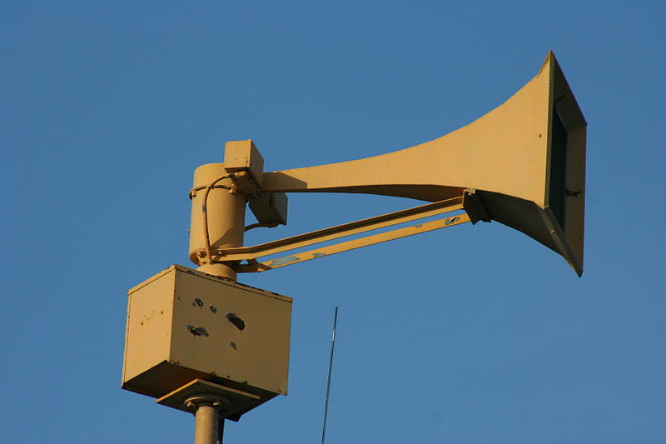

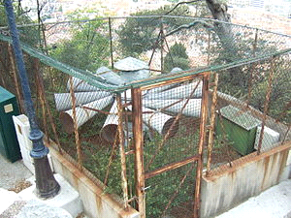
An air-raid siren in Nice, France, is still operational.

A shelter is an enclosed space specially designed to protect occupants
Many such shelters were constructed as civil defense measures during the Cold War. During a nuclear explosion, matter vaporized in the resulting fireball is exposed to neutrons from the explosion, absorbs them, and becomes radioactive. When this material condenses in the rain, it forms dust and light sandy materials that resembles ground pumice. The fallout emits alpha and beta particles, as well as gamma rays.
Much of this highly radioactive material falls to earth, subjecting anything within the line of sight to radiation, becoming a significant hazard. A fallout shelter is designed to allow its occupants to minimize exposure to harmful fallout until radioactivity has decayed to a safer level.

Details of shelter construction
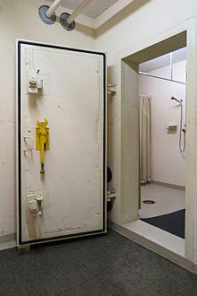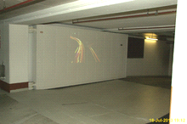
Concrete door of a public fallout shelter in Switzerland (2014).
Large fire door, sealing a fallout and air raid shelter inside the basement parking garage of a hotel in Germany.
Shielding
A basic fallout shelter consists of shields that reduce gamma ray exposure by a factor of 1000. The required shielding can be accomplished with 10 times the thickness of any quantity of material capable of cutting gamma ray exposure in half. Shields that reduce gamma ray intensity by 50% (1/2) include 1 cm (0.4 inch) of lead, 6 cm (2.4 inches) of concrete, 9 cm (3.6 inches) of packed earth or 150 m (500 ft) of air. When multiple thicknesses are built, the shielding multiplies. Thus, a practical fallout shield is ten halving-thicknesses of packed earth, reducing gamma rays by approximately 1024 times (2¹⁰).
Usually, an expedient purpose-built fallout shelter is a trench; with a strong roof buried by c. 1 m (3 ft) of earth. The two ends of the trench have ramps or entrances at right angles to the trench, so that gamma rays cannot enter (they can travel only in straight lines). To make the overburden waterproof (in case of rain), a plastic sheet may be buried a few inches below the surface and held down with rocks or bricks.
Blast doors are designed to absorb the shock wave of a nuclear blast, bending and then returning to their original shape.
Climate control
Dry earth is a reasonably good thermal insulator, and over several weeks of habitation, a shelter will become dangerously hot. The simplest form of effective fan to cool a shelter is a wide, heavy frame with flaps that swing in the shelter's doorway and can be swung from hinges on the ceiling. The flaps open in one direction and close in the other, pumping air. (This is a Kearny Air Pump, or KAP, named after the inventor, Cresson Kearny)
Unfiltered air is safe, since the most dangerous fallout has the consistency of sand or finely ground pumice. Such large particles are not easily ingested into the soft tissues of the body, so extensive filters are not required. Any exposure to fine dust is far less hazardous than exposure to the fallout outside the shelter. Dust fine enough to pass the entrance will probably pass through the shelter. Some shelters, however, incorporate NBC-filters for additional protection.
Locations
Effective public shelters can be the middle floors of some tall buildings or parking structures, or below ground level in most buildings with more than 10 floors. The thickness of the upper floors must form an effective shield, and the windows of the sheltered area must not view fallout-covered ground that is closer than 1.5 km (1 mi). One of Switzerland's solutions is to utilise road tunnels passing through the mountains, with some of these shelters being able to protect tens of thousands.
Fallout shelters are not always underground. Above ground buildings with walls and roofs dense enough to afford a meaningful protection factor can be used as a fallout shelter.
Contents
A battery-powered radio may be helpful to get reports of fallout patterns and clearance. However, radio and other electronic equipment may be disabled byelectromagnetic pulse. For example, even at the height of the cold war, EMP protection had been completed for only 125 of the approximately 2,771 radio stations in the United States Emergency Broadcast System. Also, only 110 of 3,000 existing Emergency Operating Centers had been protected against EMP effects. The Emergency Broadcast System has since been supplanted in the United States by the Emergency Alert System.
Inhabitants should have water on hand, 1-2 gallons per person per day. Water stored in bulk containers requires less space than water stored in smaller bottles.
Kearny fallout meter
Commercially made Geiger counters are expensive and require frequent calibration. It is possible to construct an electrometer-type radiation meter called theKearny fallout meter, which does not require batteries or professional calibration, from properly-scaled plans with just a coffee can or pail, gypsum board, monofilament fishing line, and aluminum foil. Plans are freely available in the public domain in the reference Nuclear War Survival Skills by Cresson Kearny.
Inhabitants should plan to remain sheltered for at least two weeks (with an hour out at the end of the first week – see Swiss Civil Defense guidelines (which was once part of Swiss Zivilschutz)), then work outside for gradually increasing amounts of time, to four hours a day at three weeks. The normal work is to sweep or wash fallout into shallow trenches to decontaminate the area. They should sleep in a shelter for several months. Evacuation at three weeks is recommended by official authorities]

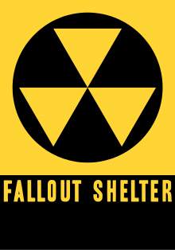
Fallout shelter sign of the United States.
The international distinctive sign of civil defense personnel and infrastructures.
Emergency Shelter
An emergency shelter is a place for people to live temporarily when they cannot live in their previous residence, similar to homeless shelters. The main difference is that an emergency shelter typically specializes in people fleeing a specific type of situation, such as natural or man-made disasters, domestic violence, or victims of sexual abuse. A more minor difference is that people staying in emergency shelters are more likely to stay all day, except for work, school, or errands, while homeless shelters usually expect people to stay elsewhere during the day, returning only to sleep or eat. Emergency shelters sometimes facilitate support groups, and/or provide meals.
Post-disaster emergency shelter is often provided by organizations or governmental emergency management departments, in response to natural disasters, such as a flood or earthquake. They tend to use tents or other temporary structures, or buildings normally used for another purpose, such as a church or school. These settlements may be inhabited for the entire duration of the reconstruction process and should be thought of more as settlements than shelter, and need to be planned with respect to water / sanitation, livelihoods.
A newer category of emergency shelter is the warming center. Warming centers typically open during particularly cold or rainy nights. They are available to persons who decline to accept homeless shelters, are not allowed to use homeless shelters, or are not homeless but have inadequate or malfunctioning heat in their homes.

Emergency evacuation

is the immediate and urgent movement of people away from the threat or actual occurrence of a hazard. Examples range from the small scale evacuation of a building due to a storm or fire to the large scale evacuation of a district because of a flood, bombardment or approaching weather system. In situations involving hazardous materials or possible contamination, evacuees may be decontaminated prior to being transported out of the contaminated area.
Reasons for evacuation[edit]
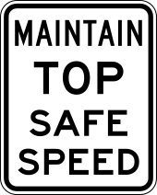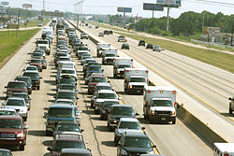
Special speed limit sign in the United States for evacuation routes, requiring drivers to maintain the maximum safe speed
Evacuations may be carried out before, during or after disasters such as:
- Natural disasters
- eruptions of volcanoes,
- cyclones
- floods,
- hurricanes,
- earthquakes
- tsunamis or
- bushfire
- Other reasons include:
- industrial accidents,
- chemical spill
- nuclear accident
- traffic accidents, including train or aviation accidents,
- fire,
- military attacks,
- bombings,
- terrorist attacks
- military battles
- structural failure
- viral outbreak
Planning
Emergency evacuation plans are developed to ensure the safest and most efficient evacuation time of all expected residents of a structure, city, or region. A benchmark "evacuation time" for different hazards and conditions is established. These benchmarks can be established through using best practices, regulations, or using simulations, such as modeling the flow of people in a building, to determine the benchmark. Proper planning will use multiple exits, contra-flow lanes, and special technologies to ensure full, fast and complete evacuation. Consideration for personal situations which may affect an individual's ability to evacuate is taken into account, including alarm signals that use both aural and visual alerts, and also evacuation equipment such as sleds, pads, and chairs for non-ambulatory people. Regulations such as building codes can be used to reduce the possibility of panic by allowing individuals to process the need to self-evacuate without causing alarm. Proper planning will implement an all-hazards approach so that plans can be reused for multiple hazards that could exist.
Evacuation sequence
The sequence of an evacuation can be divided into the following phases:
- detection
- decision
- alarm
- reaction
- movement to an area of refuge or an assembly station
- transportation
The particular phases are different for different objects, e.g., for ships a distinction between assembly and embarkation (to boats or rafts) is made. These are separate from each other. The decision whether to enter the boats or rafts is thus usually made after assembly is completed.
Small scale evacuations
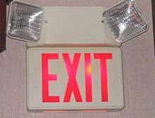
An exit sign mandatory for buildings, showing the way to the nearest exit, with two emergency lights for electrical failure.
The strategy of individuals in evacuating buildings was investigated by John Abrahams in 1994. The independent variableswere the complexity of the building and the movement ability of the individuals. With increasing complexity and decreasing motion ability, the strategy changes from "fast egress", through "slow egress" and "move to safe place inside building" (such as a staircase), to "stay in place and wait for help". The last strategy is the notion of using a designated Safe Haven on the floor. This is a section of the building that is reinforced to protect against specific hazards, such as fire, smoke or structural collapse. Some hazards may have Safe Havens on each floor, while a hazard such as a tornado, may have a single Safe Haven or safe room. Typically persons with limited mobility are requested to report to a Safe Haven for rescue by first responders. In most buildings, the Safe Haven will be in the stairwell.
The most common equipment in buildings to facilitate emergency evacuations are fire alarms, exit signs, and emergency lights. Some structures need special emergency exit or fire escapes to ensure the availability of alternative escape paths. Commercial passenger vehicles such as buses, boats, and aircraft also often have evacuation lighting and signage, and in some cases windows or extra doors that function as emergency exits. Commercial emergency aircraft evacuation is also facilitated by evacuation slides and pre-flight safety briefings. Military aircraft are often equipped with ejection seats orparachutes. Water vessels and commercial aircraft that fly over water are equipped with personal flotation devices and life rafts.
Large scale evacuations
The evacuation of districts is part of disaster management. Many of the largest evacuations have been in the face of war-time military attacks. Modern large scale evacuations are usually the result of natural disasters. The largest peace-time evacuations in the United States to date occurred during Hurricane Gustav and the category-5 Hurricane Rita (2005) in a scare one month after the flood-deaths of Hurricane Katrina.
Hurricane evacuations
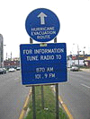
Evacuation route sign on Tulane Avenue in New Orleans.

Despite mandatory evacuation orders, many people did not leave New Orleans, United States, as Hurricane Katrina approached. Even after the city was flooded and uninhabitable, some people still refused to leave their homes.
The longer a person has lived in a coastal area, the less likely they are to evacuate. A hurricane's path is difficult to predict. Forecasters know about hurricanes days in advance, but their forecasts of where the storm will hit are only educated guesses. Hurricanes give a lot of warning time compared to most disasters humans experience. However, this allows forecasters and officials to "cry wolf," making people take evacuation orders less seriously. Hurricanes can be predicted to hit a coastal town many times without the town ever actually experiencing the brunt of a storm. If evacuation orders are given too early, the hurricane can change course and leave the evacuated area unscathed. People may think they have weathered hurricanes before, when in reality the hurricane didn't hit them directly, giving them false confidence. Those who have lived on the coast for ten or more years are the most resistant to evacuating.^{[4]}
Public transportation
Since Hurricane Katrina, there has been an increase in evacuation planning. Current best practices include the need to use multi-modal transportation networks.Hurricane Gustav used military airlift resources to facilitate evacuating people out of the affected area. More complex evacuation planning is now being considered, such as using elementary schools as rally points for evacuation. In the United States, elementary schools are usually more numerous in a community than other public structures. Their locations and inherent design to accommodate bus transportation makes it an ideal evacuation point.
Registries
Most local communities maintain registries for special needs individuals. These opt-in registries help with planning, as those that need government evacuation assistance are identified before the disaster. Registries used after a disaster are being used to help reunite families that have become separated after a disaster.
Enforcing evacuation orders
In the United States a person cannot be forced to evacuate under most conditions. To facilitate voluntary compliance with mandatory evacuation orders first responders and disaster management officials have used creative techniques such as asking people for the names and contact of their next of kin, writing their Social Security Numbers on their limbs and torso so that their remains can be identified,^{[5]} and refusing to provide government services in the affected area, including emergency services.
Personal Evacuation Kits
In case of an emergency evacuation situation, it is important to have an individual emergency evacuation kit prepared and on hand prior to the emergency. An emergency evacuation kit is a container of food, clothing, water, and other supplies that can be used to sustain an individual during lag time. Lag time is the period between the actual occurrence of an emergency and when organized help becomes available, generally 72 hours, though this can vary from a few hours to several days. It may take this long for authorities to get evacuation shelters fully up and functional. During this time, evacuees may suffer fairly primitive conditions; no clean water, heat, lights, toilet facilities, or shelter. An emergency evacuation kit, or 72-hour kit, can help evacuees to endure the evacuation experience with dignity and a degree of comfort.
Because individual household sizes and specific needs might vary, recommendations are not item specific, the list includes:
- Three-day supply of non-perishable food.
- Three-day supply of water – one gallon of water per person, per day.
- Portable, battery-powered radio or television and extra batteries.
- Flashlight and extra batteries.
- First aid kit and manual.
- Sanitation and hygiene items (moist towelettes and toilet paper).
- Matches and waterproof container.
- Whistle.
- Extra clothing.
- Kitchen accessories and cooking utensils, including a can opener.
- Photocopies of credit and identification cards.
- Cash and coins.
- Special needs items, such as prescription medications, eyeglasses, contact lens
- solutions, and hearing aid batteries.
- Items for infants, such as formula, diapers, bottles, and pacifiers.
- Other items to meet unique family needs.
- Along similar lines, but not exactly the same, disaster supply kit
- Water—one gallon per person, per day
- Food—nonperishable, easy-to-prepare items
- Flashlight
- Battery powered or hand crank radio (NOAA Weather Radio, if possible)
- Extra batteries
- First aid kit
- Medications (7-day supply), other medical supplies, and medical paperwork (e.g., medication list and pertinent medical information)
- Multipurpose tool (e.g., Swiss army knife)
- Sanitation and personal hygiene items
- Copies of personal documents (e.g., proof of address, deed/lease to home, passports, birth certificates, and insurance policies)
- Cell phone with chargers
- Family and emergency contact information
- Extra cash
- Emergency blanket
- Map(s) of the area
- Extra set of car keys and house keys
- Manual can opener

Usfull video
https://www.youtube.com/watch?v=d5rseP40-3w

Israelis Run To Bomb Shelter During Drill

Thunderbolt 1003 Sounding ''HI-LO'' (Fire) Signal - Silverstreet, SC 11/17/12 (HD)

Hurricane Ignacio - Civil Defense Message (Aug. 29 - 11 am)

Reference:
- Treaster, Joseph B. "Superdome: Haven Quickly Becomes an Ordeal". New York Times. Retrieved 27 May 2014.
- Jump up^ Associated Press. "Superdome evacuation disrupted after shots fired". ESPN. Retrieved 27 May 2014.
- Jump up^ Fan Shu-Yang, Bill Freedman, and Raymond Cote (2004). "Principles and practice of ecological design". Environmental Reviews. 12: 97–112. link
- Jump up^ Meinhold, Bridgette. Urgent Architecture: 40 Sustainable Housing Solutions for a Changing World. W. W. Norton & Company, Inc. Retrieved 26 May 2014.
- Jump up^ Vidal, John. "Humanitarian intent: Urgent Architecture from ecohomes to shelters – in pictures". theguardian.com. Retrieved 26 May 2014.
- Jump up^ "URGENT ARCHITECTURE: Inhabitat Interviews Author Bridgette Meinhold About Her New Book". YouTube.com. Retrieved 26 May 2014.
- Richard Pipes (1977). "Why the Soviet Union Thinks It Could Fight and Win a Nuclear War" (PDF). Commentary Reed College. Retrieved September 4, 2013
- Smith, Cleveland (1942). United States Service Symbols. p. 98. Retrieved7 May 2015.

