Topic 1: Legal and organizational questions of сivil defence.

Defence of the population in emergencies (extreme situations - ES) is a collection of associate measures by time, resources and place of actions realization directed to prevention or maximum decrease of population losses, life and health threat from the striking factors of ES.
The citizens of Ukraine have a right to:
- defence of their life, health and private property;
- use of available facilities of the collective and individual protection;
- information about a possible risk and necessary safety ES measures.
The citizens of Ukraine are bound:
- to follow the safety measures, to not violate productive and technological discipline, requirements of the ecological safety;
- to know the methods of defence and rendering of the first medical aid, rules of using collective and individual facilities of defence (fig. 1), to take active part in realization of measures in relation to protection of the population in ES.
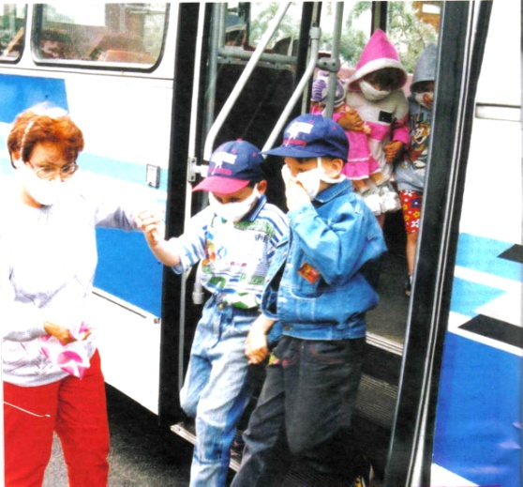

Fig. 1. Application of individual facilities of defence

Defence is possible through the realization of the next measures before and after ES:
- prognosis of the possible ES and their consequences for a population;
- constant observation and control of the state of environment;
- notification (warning) of the population about the threat of ES origin;
- evacuation of people from dangerous areas and districts;
- engineering, medical, radiation and chemical defence;
- application of the special procedures of population defence on the contaminated (infected) territory;
- operative and reliable informing of the population about state of protection in ES, accepted measures on providing of safety, forecast and present ES, the order of actions;
- preparation of the population to the ES actions, leaders of all levels, personnel of enterprises, organizations and establishments, and also organs of the Ministry of Extreme Situations management and forces;
- realization of wrecking and other urgent works in the ES districts and places of destruction;
- providing of the food and water protection from the striking factors of ES;
- creation of financial and material resources in case of ES appearance;
- the population´s and rescuers´ training with the rules of protection from the dangers caused by accidents, catastrophes, natural calamities, epidemics, epizootics, the methods of the first medical aid rendering and prophylaxis measures of the infectious diseases;
- the use of protective infrastructures (refuges, radiation shelters, adjusted apartments) as collective defence facilities of the population, including also for development and providing of medical establishments work in the conditions of radio-, chemical contamination of the territory;
- the use of the individual defence measures of respiratory organs, skin from the radionuclide’s and chemical contamination, bacterial facilities.
Basic methods of population defence in ES are:
- notice (timely notification) of the population;
- use of the protective building;
- use of the individual defence facilities ( particularly medical);
- evacuation of the population.

Notification is the urgent message of the notification signs and corresponding information about ES to the management organs, forces of Ministry of Extraordinary Situations and population.
The notification signs and information about a real situation are passed by means of the centralized notification systems that are based on communication network, radio, networks- and television broadcasting and the special apparatus. Signals are also passed by means of electro-sirens (sounding of that means a signal «Attention all!») and forego a report using radio and television. This signal is given for bringing of people´s attention in a foresight or in case of ES occurring. After this signal it is necessary immediately to switch on all technical information equipments (television, radio receiver, loud speaker of broadcasting network) and expect the report of local government.
Notification of population about the origin of ES has to satisfy the next basic requirements:
- to be timely in order to give the population the time for preparation to protection;
- to eliminate panic, assist in clearing and organized realization of measures;
- to conduct only when character of danger is set for certain;
- to deal with that part of the population that can run the danger of striking factors in this ES;
- to be performed centrally (by higher executive power or the emergencies commissions of all levels).

Description of the protective measures
Protective building is the engineering building, specially intended for the collective protecting of workers and enterprises office workers and also population from the ES striking factors.
A depository is engineering building that provides people defence from all striking factors of ES: light radiation, penetrating radiation, shock wave, poisonous substances (PS) , dangerous chemical substances, bacteriological substances (BS), high temperature in the zone of fire, wreckages of the destroyed building.
Radiation shelter is protective building that provides defence of people from a light radiation, small shock wave (up 0,2 kg/ cm ) and considerably weakens action of penetrating radiation.
Simple shelters are protective building that provide protection of people from flying wreckages, light radiation and also reduce the action of ionizing radiation and shock wave. Cracks (open and recovered), trenches, underground passages of streets belong to them.
Depending on the place of location depositories are built-in in the building and stand separately.

